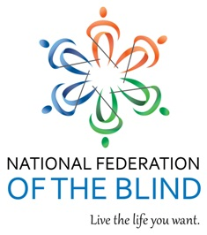

Who: National Federation of the Blind Wild West Metro Chapter

What: Chapter meeting

Why: to reach out to our blind community and family and friends of blind individuals of all ages

When: Saturday, April 2, 2016 at 12 PM High Noon – 2PM (This meeting will be every 1st Saturday of each month, unless otherwise noted)

Where: Carmody Recreation Center
2200 S Kipling st, LAKEWOOD, CO 80227

The National Federation of the Blind knows that blindness is not the characteristic that defines you or your future. Every day we raise the expectations of blind people, because low expectations create obstacles between blind people and our dreams. You can live the life you want; blindness is not what holds you back.

For further information please email Brad at:
mailto:pawcuzinc@gmail.com

