National Federation of the Blind Wild West Metro Chapter 1st Annual Picnic
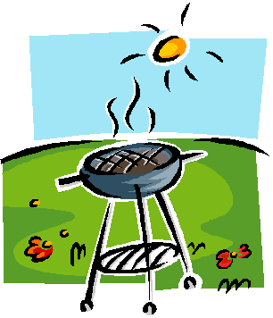
Please join us to mingle and get to know your Blind community. We will have our 1st Annual NFB Wild West Metro Chapter Picnic on Saturday, August 6, 2016.
!!!WE WANT TO MEET ALL OF OUR COMMUNITY!!!
Carmody Recreation Center outdoor picnic area, 2200 S Kipling st., Lakewood CO 80227
Time is 1PM to 4PM. For those who are interested, we will be having a business meeting at the same location from 11AM t0 11:45AM.
Cost is $5.00 per adult. We will be selling tickets for the Wild West Metro picnic. Please purchase your ticket(s) by July 24th 2016. For tickets please contact;
Robert Dyson rdyson@cocenter.org 303-778-1130 , or stop by the front desk at CCB.
Paul Sandoval ps8001@hotmail.com
Sharon Price gwprice@q.com
Melissa Fishburn go.melsue@gmail.com

The National Federation of the Blind knows that blindness is not the characteristic that defines you or your future. Every day we raise the expectations of blind people, because low expectations create obstacles between blind people and our dreams. You can live the life you want; blindness is not what holds you back.

