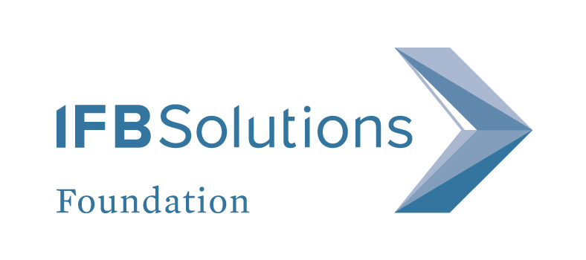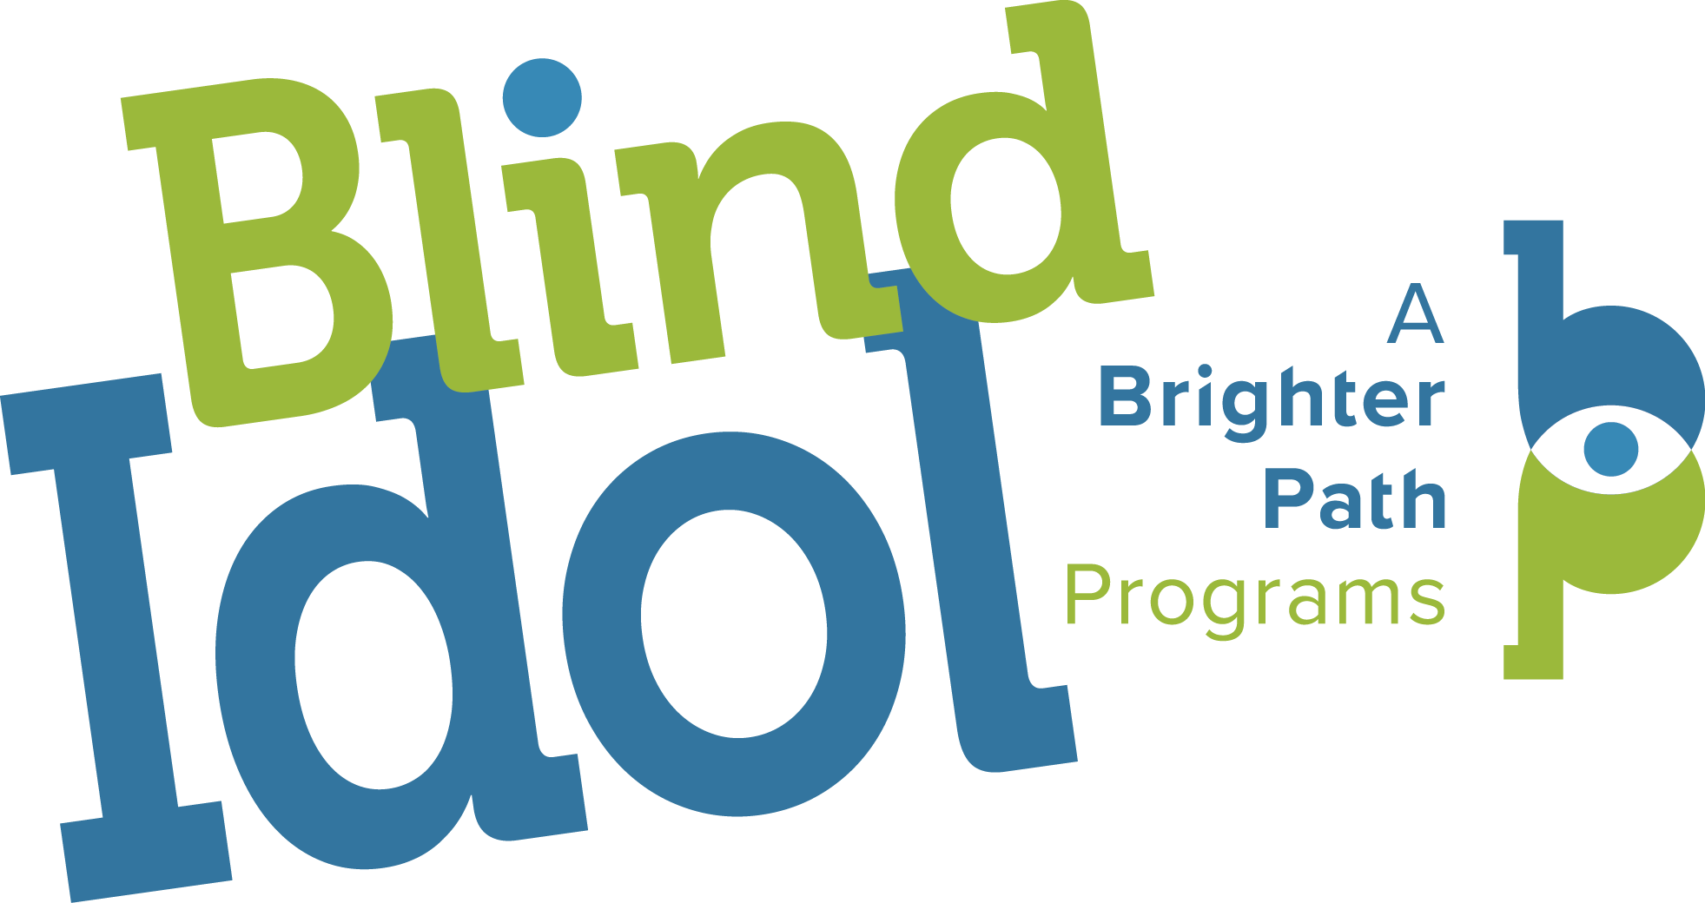

IFB SOLUTIONS announces kick-off for
National “BLIND IDOL” SINGING COMPETITION
National competition open to legally blind contestants, submissions due March 13, 2017.

IFB Solutions, in partnership with Raleigh Lions Clinic for the Blind (RLCB), is looking for this country’s best singers who also happen to be legally blind to participate in the third annual A Brighter Path Blind Idol singing competition. Interested singers can visit www.blindidol.com for competition details. Submissions open on February 13, 2017 and end on March 13, 2017.

The 2017 Blind Idol singing competition is open to any legally blind adult who is 18 years or older and a resident of the United States. Entrants are required to provide proof of legal blindness as defined by the Social Security Administration. The Blind Idol winner will receive a Grand Prize package of $1,000 cash, eight hours of recording time at a recording facility in Winston-Salem, N.C., and a professional headshot. The total prize package is valued at $3,000.

To enter, contestants must submit a video or mp3 audio file of an individual singing performance no longer than two minutes in length, either online or by mail, no later than March 13, 2017. A panel of judges will then select 20 semi-finalists to perform in a live audition hosted by RLCB in Raleigh, N.C. on June 3, 2017. Five finalists will move on to the live finale competition on August 12, 2017 at the Southeastern Center for Contemporary Art in Winston-Salem, N.C. Contestants will be responsible for their own transportation and lodging.

The 2017 Blind Idol singing competition is sponsored by IFB Solutions Foundation, the supporting foundation of IFB Solutions. Anastasia Powell, program associate for IFB’s A Brighter Path, and Chris Flynt, director of A Brighter Path programs, are returning as the event’s co-organizers. Powell and Flynt have not let their lack of sight deter them from pursuing their love of music, and they encourage everyone who shares that love to enter. “Music has the ability to move all of us – young and old, sighted and not sighted,” said Powell. “Blind Idol is a great opportunity to showcase our talents on a national stage and enjoy these tremendous performances.”

For more information regarding Blind Idol completion guidelines, contact Anastasia Powell at 336-245-5698 or apowell@ifbsolutions.org.

About IFB Solutions (ifbsolutions.org)

IFB Solutions (IFB) is a nonprofit corporation founded in 1936 that provides employment, training and services for people who are blind or visually impaired. As the largest employer of people who are blind or visually impaired in the United States, IFB operates manufacturing facilities in Winston-Salem, N.C., Asheville, N.C., and Little Rock, Ark., in addition to more than 50 office supply stores and optical centers across the country. IFB also provides outreach through A Brighter Path Foundation, which operates Community Low Vision Centers across North Carolina and Tracy’s Little Red Schoolhouse based in Winston-Salem.

