SAVE THE DATE!
MAKING A DIFFERENCE IN LIVING THE LIVES WE WANT!

THE NATIONAL FEDERATION OF THE BLIND
OF COLORADO

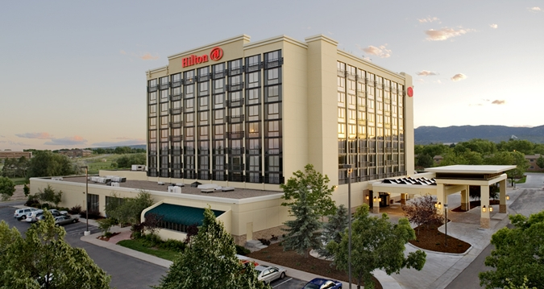

63rd ANNUAL STATE CONVENTION
October 26 through October 29

The 63rd Annual State Convention will kick off Thursday afternoon, October 26 in Fort Collins, Colorado starting with a robust and dynamic employment seminar cosponsored by the Colorado Department of Labor and Employment followed by a networking reception. Thursday evening will feature a screening of Do You Dream in Color, an award winning documentary chronicling the difficulties blind youth face in school. Colorado’s own Carina Orosco is one of the students featured and will be on hand to lead us in a discussion afterwards.

Friday morning will start off with registration and our sponsors and exhibiters show case. We will also hold the meeting of the Resolutions Committee where we will discuss the Federation’s policy goals for this and coming years. A General Convention Session and luncheon will begin at 11:00 am. Afterward, we will transition into a variety of stimulating workshops including Art, Tactile Graphics, Technology, Seniors, Blind Parents and Parents of Blind Children Division Meetings. On Friday evening, we will offer social activities ranging from adventure stations like a mechanical bull and climbing wall, board games, and good old socializing.

Saturday morning will open with registration and a sponsors and exhibiters showcase. This will be followed by the second General Session of the Convention when we will hear from our National Representative, Cathy Jackson, Member, NFB Board of Directors and President, NFB Kentucky; a state Presidential Report, a Colorado Center for the Blind update, My Blindness, Myself (blind individuals telling their story about their blindness and living the lives they want) and many other inspirational and informative items. Saturday afternoon will highlight various division meetings such as the Colorado Association of Blind Students, Colorado Association of Guide Dog Users, Sports & Rec and Blind Merchants as well as a Seminar for the Colorado Association for Education and Rehabilitation of the Blind and Visually Impaired. We will reach the high point of our Convention Saturday night with our Annual Banquet with a keynote address from our National Representative, Cathy Jackson, presentation of awards and scholarships, the drawing for our Amazing Colorado Raffle offering $4,000 in cash prizes, our Annual Fundraising Auction, socializing, and much, much more.

The last day of Convention, Sunday, begins with a Chapter/Division Breakfast where we will hear reports from all of our entities and share useful information on how to build the Federation. The last General Session will take up other inspirational presentations and the business of the NFB of Colorado. The Convention will adjourn no later than 11:47 am.

Join the largest gathering of blind men, women and youth in Colorado to make a difference in the lives of the blind across the state! Please note that the Convention is still being planned and not all sessions are finalized. Stay tuned for a full Convention Agenda slated to be released in early October.

Sponsors and exhibiters will be demonstrating their products and services on Friday and Saturday. Look for information about our sponsors and exhibitors times and locations in the agenda.

THE NFBCO CONVENTION HOTEL: Our 2017 convention will be held at the Fort Collins Hilton, nestled in the foothills of the Rocky Mountains at 425 West Prospect Road, Fort Collins, Colorado 80526.

HOTEL ROOM RATES: The NFBCO room rate is $99 a night for singles and doubles; $109 a night for triples and $119 a night for quads. Reservations MUST be made by Monday, September 25. You must get your reservations in by the deadline, as we will not be granted any extensions. We urge you to make your reservation as soon as possible!!! There is a CSU Rams, home football game going on that same weekend, and when our block expires, there will be absolutely no further rooms available to us.

To reserve your room by phone call: 970-482-2626 and mention that you are with the National Federation of the Blind of Colorado.

Click here to reserve your room online.

Pre-registration fees: BEFORE October 13
$20 registration
$25 Friday luncheon
$25 Saturday luncheon
$40 Saturday banquet
Total: $110.00

The Sunday morning breakfast is complimentary if you pre-register by October 13. If you choose to register on site, the breakfast may no longer be available, and if it is, the cost to you at that time will be $20.

CLICK HERE FOR CONVENTION REGISTRATION ONLINE NOW

Registration fees AFTER October 13
$25 registration
$30 Friday luncheon
$30 Saturday luncheon
$45 Saturday banquet
$20 Sunday Breakfast (if available)
Total: 150.00 (Save up to $40.00 and pre-register!)

Stay tuned to your email and check our website at www.nfbco.org for more information about convention registration. OR contact Lisa Bonderson at lkb@labarrelaw.com.

FOR MORE CONVENTION INFORMATION CONTACT:
Scott C. LaBarre, President
Phone: (303) 504-5979
slabarre@labarrelaw.com

