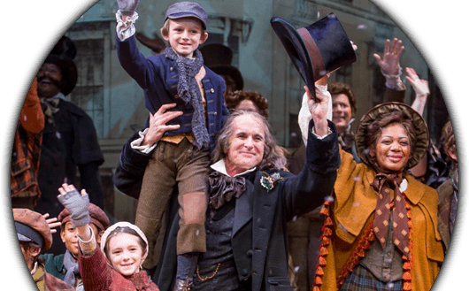
A CHRISTMAS CAROL
By Charles Dickens
Adapted by Richard Hellesen
Music by David de Berry
Directed by Melissa Rain Anderson

DATE: Sunday, December 10, 2017
TIME: 1:30 P.M.
PLACE: Stage Theatre
TICKET PRICE: $35

Run Time: Approximately 2 hours, plus a 15 min intermission
Age Recommendation: 6+; ages 4+ are welcome in our theatres. Includes period language and ghost scenes that may frighten younger guests.
Advisory: Stage fog and strobe lights are used in this production
Essential to the holiday season in Denver, A Christmas Carol promises to “warm your heart and renew your holiday spirit” according to the Examiner. Based on Charles Dickens’ classic novel, this joyous and opulent musical adaptation traces money-hoarding skinflint Ebenezer Scrooge’s triumphant overnight journey to redemption. A Christmas Carol illuminates the meaning of the holiday season in a way that has resonated for generations.
Sam Gregory returns in the role of Ebenezer Scrooge with Director Melissa Rain Anderson at the helm of this beloved holiday tradition.

- Available
- Available
- Available
- Available
- Available
- Available
- Available
- Available
- Available
- Available

