band!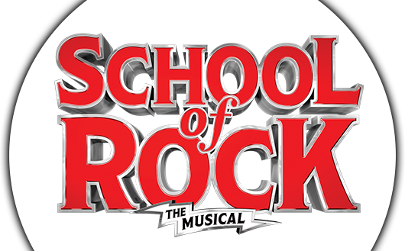
DATE: Saturday, June 10, 2018
TIME: 2:00 p.m.
PLACE: BUELL THEATRE
TICKET PRICE: $30
Run Time: Run Time: 2 hours and 15 mins with one intermission.
Age Recommendation: 8+
Advisory: To Come
School of Rock is a The New York Times Critics’ Pick and “An inspiring jolt of energy, joy and mad skillz!” (Entertainment Weekly). Based on the hit film, this hilarious new musical follows Dewey Finn, a wannabe rock star posing as a substitute teacher who turns a class of straight-A students into a guitar-shredding, bass-slapping, mind-blowing rock band. This high-octane smash features 14 new songs from Andrew Lloyd Webber, all the original songs from the movie and musical theater’s first-ever kids rock band playing their instruments live on stage. Vanity Fair raves, “Fists of all ages shall be pumping!”

- Brittany Savage
- Available
- Available
- Available
- Available
- Available
- Available
- Available
- Available
- Available
- Available
- Available
- Available
- Available
- Available
- Available
- Available – Limited View
- Available – Limited View
- Available – Limited View
- Available – Limited View

