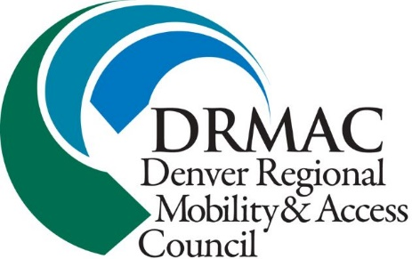

Transit Advocate Job Description
DRMAC is looking for one or more transit advocates to represent us at a variety of area meetings and outreach events on issues related to transportation, disability issues, senior advocacy, and more. This is a volunteer position, but the benefits include:
Business cards and a name tag
Office space w/laptop, phone extension, printer, etc
Ongoing updates on a wide variety of activities in the greater Denver area
Association with the rest of the DRMAC staff
Title and credibility associated with an established organization
Occasional perks such as holiday parties, business luncheons, and happy hours!

The work, which can be a little as 6 hours per week, can include:
Attendance at a variety of disability and transit related meetings, and a report back
Attendance at one of the Local Coordinating Councils, and a report back
Attendance and report at a weekly 1 hour staff meeting
Monthly brief on activities to be shared with the Board of Directors
Representing DRMAC in the community with name tag and business cards

If interested, contact Kate Williams at kwilliams@drmac-co.org or 303-861-3711, ext 100. Please consider this as a commitment on your part, and on the part of all of the staff of DRMAC. Not all candidates will be accepted.
A personal interview will be requested, but can be arranged at your convenience.
August 2018

