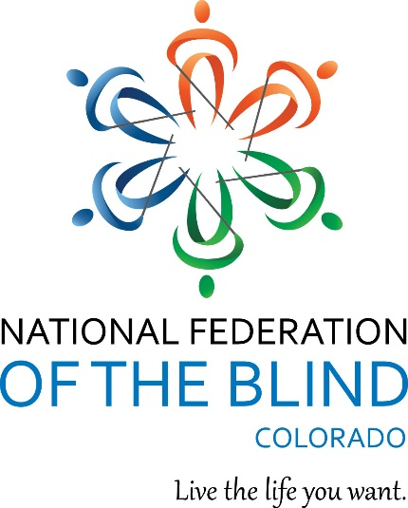
(Up there on top is the NFB of Colorado Logo followed by “Live the life you want.”)
Blind Coloradoan Blog January 25, 2019
Writer, aggregator Kevan Worley. Co-editor Dan Burke.
Happy New Year! Here is what you need to know.

Hear ye, hear ye! Oh yay, oh yay! Draw nigh! Carpe Diem! The Seventy-second session of the Colorado General Assembly has begun. On February 11, blind citizens and allies will gather for the NFBCO Day at the Capitol. NFBCO extends to you a warm and welcoming invitation to join the day. We will assemble by 8 a.m. on Monday February 11 in Senate Caucus Room 352, S.C.R 352, for our issue briefing. Senator Pete Lee and State Representative Mark Schneider plan to offer brief remarks. Those who have previously joined us for the Day at the Capitol know that after the briefing we will fan out to locate members of the general assembly in their offices or elsewhere in the capitol. We will have educational materials about the National Federation of the Blind for General Assembly members and their legislative staff members. This year, we will provide legislators perspective and information about our continuing effort to gain complete total and convenient access to the ballot. (See Dan Burke’s excellent article, I Voted Twice, in the January issue of the Braille Monitor.) We will also advocate for the General Assembly’s continuing support for NFB Newsline. In addition, we will be following up our work of 3 years ago to ensure that specialized services through the Blindness and Low Vision Services Unit under the Division of Vocational Rehabilitation continues unimpeded. Even those who are not active members of NFBCO will enjoy the Day at the Capitol experience. Learn about the positions taken by the oldest and largest organization of the blind in Colorado. Learn about the process of law making at the state level. Enjoy the camaraderie. You will meet some wonderful people. The need for change is great. Our record of legislative accomplishment has been remarkable. In the last session, Representative Jessie Danielson sponsored and managed our parent’s rights bill, H.B. 18-1104, The Family Preservation Safeguards for Parents With Disabilities Act. She did so with determination and diplomacy. When concerns were raised by county officials as to the sweeping nature of reform, Representative Danielson brought leaders and stakeholders together. NFBCO President Scott LaBarre is an expert on civil rights law. He says he thinks this new law, signed by the Governor this past June, may be the strongest parents’ rights bill in the nation. When we share the authentic needs, hopes, and dreams of the blind of Colorado with members of our General Assembly they are willing to take up our cause. This is what we will do on February 11. (Note: This past November, Jessie Danielson was elected to the Colorado Senate. Congratulations to her!)
Field Trip. Teachers and parents bring your blind students to our Day at the Capitol! It’s a marvelous way to experience how laws are made. You and your students will benefit by joining blind role models. It is great fun! Hey teachers and kids, lunch on me.

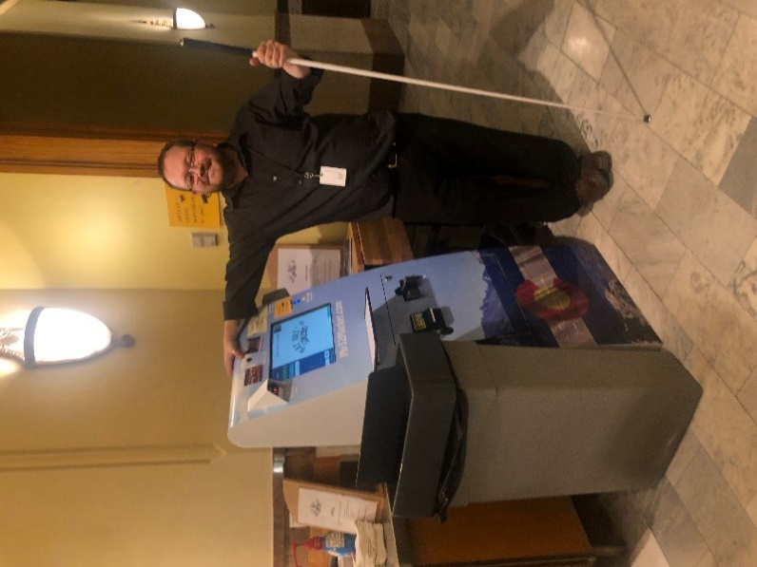
Photo of blind entrepreneur, Nate Hecker, standing by the kiosk he operates at State Capitol Lower Level.

Colorado is a vote-by-mail state. As noted above, members of NFBCO and our allies will visit with members of the General Assembly on Monday, February 11. Curtis Chong, long-time Federation leader, has provided perspective on equal access to the ballot to the Blind Coloradoan. Here it is. Registered voters receive in the mail a printed ballot which they mark and send in during an election. Blind Coloradans who are unable to see the printed ballot have no way to mark this printed ballot without sighted assistance, thus compromising their ability to cast a truly secret ballot. Although it is possible for voters who are blind to use equipment at the polls to mark the ballot in complete secrecy, some voters who are blind either do not have transportation available to get them to the polls or the equipment provided for nonvisual access to the printed ballot oftentimes does not work.

Fortunately, there is a solution to this dilemma. Technology exists which enables blind voters to request an online version of the printed ballot and secretly and independently mark the ballot using the access technology with which they are most familiar. This technology has been successfully deployed in Maryland and New Mexico, and in the case of the latter, at little or no cost to the state.

The State of Colorado should adopt a similar system—a system that is based on proven technology and which has worked extremely well for blind voters.

Membership in the National Federation of the Blind brings tangible benefits. Aira announces NFB exclusive plan. For details and to experience go to aira.io/nfb or call 800-835-1934. Introduce yourself! The NFB Aira Intro Plan is the most inexpensive Aira has ever offered. $20 for 30 minutes per month. It’s a very nice rate to begin enjoying the service. The most popular plan is the NFB $99 offer. Receive 140 minutes, numerous guest features, connect with agents anytime anywhere, referral plan to earn savings and minutes. Austria glasses are included. Inexpensive options to upgrade to the newest Horizon glasses available. Learn more by listening to NFB President Mark Riccobono’s release January 4, #worldbrailleday.

To paraphrase Herodotus, “Neither snow nor rain nor heat nor gloom of night nor Government shut down stays these civil rights activists from their appointed rounds with members of Congress.” National Federation of the Blind will visit the 116th Congress January 28th, 29th, and 30th. If you are not able to attend send us your positive energy. We will need your help when we return. Get all the facts! You become the expert. Read and share with your chapter or division.

Hey Alexa. Monday January 15, NFB Newsline subscribers received orientation to the Alexa NFB Newsline Skill. Colorado joined subscribers from Georgia and Indiana. The interactive presentation was taught by the main man himself, Scott White. Scott is Director, NFB Newsline. He has led the development of this service for 12 years. Scott’s innovative management has led to more ways to access the service. His commitment to increase content has built NFB Newsline into the power news and entertainment provider for people who are reading disabled. Future NFB Newsline training calls are contemplated. To do a deep dive into the Skill spend some time at NFB.org.

Maureen Nietfeld joins Project Literacy. At the 2018 NFBCO state convention, we kicked off a new initiative to grow and promote braille literacy, NFB Newsline, NFBCO scholarship program, and our 2nd annual 6 Dot Dash 5k. Maureen Nietfeld, one of the busiest, most respected NFBCO leaders has agreed to join this new effort. Maureen left her position at the Colorado Center for the Blind after 8 years as the Home Management Coordinator. At CCB she taught, mentored, and inspired staff and students alike. Maureen and David Nietfeld are now the proud parents of Logan. The little man is 5 months old. Mamma Maureen plans to return to school and go back to work assisting with the Project Literacy enterprise. She joins NFBCO Secretary Jessica Beecham and all of us who do this work with joy.

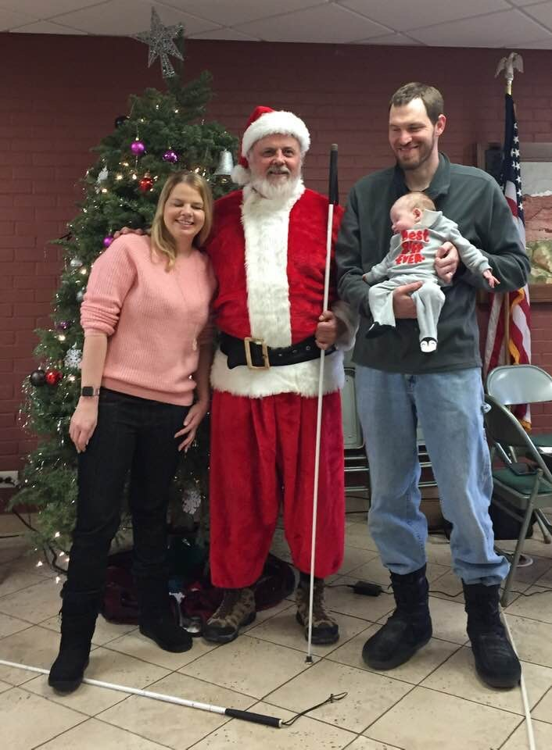

Our Christmas Babe in arms. Pictured here David holds sleeping Logan, Maureen with Santa Dan Burke at the Colorado Center for the Blind.

In its January 19 meeting, the NFB of Denver Chapter elected the following:
Dan Burke, President;
Vicki Sayler, 1st Vice President;
Dishon Spears, 2nd Vice President;
Treasurer, Brittany Savage;
Secretary, Kyra Sweeney;
Board Members John Batron, Brett Boyer and Showe Trella.

Note to our fitness enthusiasts. The January USABA Newsletter is out. Click here to check it out!

A discussion of air travel among the bling will inevitably lead to stories of the horrible and hilarious. Doctoral student, Bhoomika Bhagchandani, offers us an opportunity to share our experiences. Bhoomika is a doctoral student at Hugh Downs School of Human Communication at Arizona State University. She is conducting a research study to examine the air travel experiences of individuals who are blind and visually impaired. She can be contacted at bbhagcha@asu.edu or 602-317-2337.

Award * Encourage * Achieve
Building opportunities for the blind in education and beyond.

So, you are blind. You are visually impaired. You are a parent or teacher of a legally blind student. Never fear, the NFBCO is here! On Saturday March 2nd at noon, NFBCO will share tips and tricks to seek and complete scholarship applications specific to blind students. Do not face the daunting task of searching for financial assistance to further your education alone. Details about this all-important training will be announced soon. For now, just spread the word and plan to join the experts. This special seminar at the Colorado Center for the Blind will be one not to be missed.

This year the National Federation of the Blind of Colorado will be awarding up to $15,000 in scholarship funds for deserving students. If you are a legally blind student who is a resident of Colorado, please apply immediately!
- If you are a teacher, counselor, family member or friend of a legally blind student who is a resident of Colorado, please encourage them to apply now! Students who have previously won an NFBCO scholarship are encouraged to apply again.
- All scholarships are awarded based on academic excellence, service to the community, and financial need.
- Applications are due by Monday, April 15, 2019
- Winners will attend the 2019 National Federation of the Blind of Colorado’s annual state convention held October 31st through November 3rd at the Fort Collins Hilton. Winners will be awarded their scholarships at the banquet on Saturday evening, November 2nd, 2019. Proud moms, dads, teachers, siblings, grandparents, and friends are invited to join the celebration. In addition, scholarship winners will be required to attend the 2019 NFB National Convention which is scheduled to take place July 7-12 at Mandalay Bay Resort and Casino in Las Vegas, Nevada. This expense-paid National Federation of the Blind convention education experience is in addition to the scholarship grant.
- For info reach Scholarship Chairperson Jessica Beecham, jessica@nfbco.org. Also visit National Federation of the Blind of Colorado.

But wait, there is more!
Deserving, starving students always need more money. The National Federation of the Blind has the most robust scholarship program in the nation. Thanks to our generous partners, there are thirty merit-based scholarships currently available, ranging from $3,000 to $12,000. Deadline for applications is March 31, 2019. Visit National Federation of the Blind for more scholarship information and application.

But wait, there is even more!
The SEE THE FUTURE Fund is pleased to award scholarships to qualified visually impaired and blind students who are Colorado residents. This scholarship fund is made possible through generous donations by ophthalmologists, optometrists, opticians, staff, corporations, educators, foundations and many others with an interest in the lives of the visually impaired and blind. All scholarships are awarded based on academic achievement, school and community service, and individual need. Scholarships totaling up to $42,000 may be awarded. Probable distribution will be one (1) $12,000 four-year scholarship, one (1) $10,000 four-year scholarship, one (1) $8,000 four-year scholarship, and three (3) $4,000 two year scholarships. Application deadline, March 1st, 2019. For more information and application, See The Future.

Christian Record Services for the Blind Scholarships.
“When I was a child of about 7 years old, I was living with grandparents in small-town Illinois. I felt isolated with no access to reading material or blind peers. One day, a gentleman came to our door from the Christian Record Services for the Blind. He was interested in my welfare and that of my family’s. He provided information and inspiration. And, he gave me a record. He connected us with the Library of Congress Talking Book Program and the Foundation began sending me these audio magazines on record. Inspirational articles were read. Interviews with real blind people were presented. I will always have a place in my heart for the Christian Record Services for the Blind.”
As one of the leading producers of free full-vision publications for children and teens with visual impairments, Christian Record Services for the Blind awards several partial scholarships annually for up to $2,000 to legally blind young people who are striving to obtain a college degree in the United States. Deadline, April 1st, 2019. Get the info at Christian Record Services for the Blind.

The December 14th issue carried a note about the upcoming Anchor Center Visions of Love event. But, you can never have too much love! Especially around Valentine’s Day. Friday, February 8th, the Anchor Center for Blind Children is hosting Visions of Love 2019. This charming event pairing wine and chocolate celebrates the artistry of all things decadent. Enjoy this opportunity to pamper your palate and share the magic of Anchor Center’s building and mission during the season of love. Hosted by the Denver Delta Gamma Alumnae Chapter, tickets are $50 for General Admission, $75 for VIP. Get all the dets at Anchor Center for Blind Children. See you there!

Winner, winner, winner! At the 2018 convention of the National Federation of the Blind, an award of $5,000 went to Peggy Chong who, for more than two decades, has documented empowering stories about blind people on her website, theblindhistorylady.com. Peggy was honored along with 5 other recipients of the distinguished Bolotin Award. Many of us enjoyed Peggy’s stories at the 2018 NFBCO State Convention. Peggy and her husband Curtis have been leaders of the Federation since the early 1970s. This past Fall, they moved to Colorado. Peggy is already taking a leadership role in our affiliate. The Dr. Jacob Bolotin Awards honor individuals and organizations that are a positive force in the lives of blind people and whose work advances the ultimate goal of helping transform our dreams into reality. Dr. Jacob W. Bolotin (1888-1924) was the world’s first physician who was blind from birth. He achieved that goal despite the tremendous challenges faced by blind people in his time. Not only did he realize his own dream, but he also went on to support and inspire many others.
Application information. Application deadline, April 15, 2019. Contact James Gashel, Chairman, Email: bolotinaward@nfb.org, Mobile: 808-234-9259, Google Voice: 970-306-9779.

Applications are now open for the third annual Holman Prize for Blind Ambition. The Holman Prize is funded by the LightHouse for the Blind and Visually Impaired of San Francisco. This prize awards up to $25,000 each to three blind individuals who wish to push their own limits and carry out a “dream” project of their own creation. The Holman Prize is named for 19th century explorer James Holman (“the blind traveler”), who was the first blind person to circumnavigate the globe, and the most prolific traveler of any person before the era of modern transportation. The application process consists of 3 phases. Phase 1, the YouTube Pitch. Phase 2, the written proposal. Phase 3, the interviews and judging. 2019 prizewinners are announced in July. Check out the frequently asked questions at www.holman.ligthhouse-sf.org/faq.

Share Braille books. Do you have a Braille book you'd like to share with others? Are you interested in receiving a Braille book in the mail? Register, log in, share, and browse. Join hundreds of Braille readers, teachers, parents, and students in increasing the use of Braille books through ShareBraille.org. www.ShareBraille.org lets you share Braille books all year long. You can continually send and receive Braille books, keeping them in circulation for years to come.

NEW BOOKS FROM NATIONAL BRAILLE PRESS. National Braille Press, nbp.org, 800-548-7323. A number of board books for babies and preschoolers are available from National Braille Press. They can be purchased singly or, at a discount, in sets of three. Titles include Animal Kisses; Hop on Pop; Bears and a Birthday; What's Wrong Little Pookie?; That's Not My Monkey; That's Not My Pony; and That's Not My Elephant.

Writing Your Way. Also available at nbp.org, Composing and editing on an iPhone or iPad, by Judy Dixon. Available in Braille and electronic formats. Most of us who have used an iPhone or iPad have done some writing on it, but how many are ready to write a term paper or full-length article with this technology? In this comprehensive reference guide, Judy Dixon explores strategies and techniques that can make writing and editing on your device a breeze.

TECHNOLOGY. Computers for the Blind, computersfortheblind.net, Computers for the Blind provides refurbished computers with assistive technology installed at affordable prices. Recently Computers for the Blind has partnered with VFO, whose brands include Freedom Scientific and Ai Squared. Laptop and desktop computers with monitors are available with Windows 10, and they ship with JAWS and ZoomText installed.

“There is no business like show business” especially when we join our friends for truly spectacular performances direct from Broadway at the Denver Center for Performing Arts. Lorinda Riddle, our own Ethel Merman, sends the following announcement. The Mile High Chapter of the NFB of Colorado have two plays lined up as fundraisers for the spring and summer season. Ticket prices this year, even at our discounted rate, have increased so our price to you is also higher. For those who have attended in the past you know that our seat locations are quite good and worth the cost.

The first play for the Mile High Chapter will be "The Play That Goes Wrong" on Sunday, March 17 at 2 pm. Tickets are $40 each. On Sunday, June 1 at 2 pm we will see "Wicked." Those tickets will be $50 each.

The Blind Parents are also planning to attend two shows to raise funds. CATS on Saturday, April 27 at 2 p.m. "Charlie and the Chocolate Factory" on Sunday, July 27 at 2 pm. Contact Brittany Savage at tanielizabeth21@yahoo.com if interested in these shows.

The Seniors will be attending Fiddler on the Roof on Saturday, June 15 at 2 pm and possibly Hello Dolly on Sunday, April 7 at 2 pm. Contact Anahit LaBarre at alabarre@cocenter.org if interested.

“Mr. Wonka: "Don’t forget what happened to the man who suddenly got everything he wanted."
Charlie Bucket: "What happened?"
Mr. Wonka: "He lived happily ever after.”
― Roald Dahl, Charlie and the Chocolate Factory

Did Not See Your Item in This Issue? Be a contributor! Send announcements, ideas, articles, and observations to either myself or Dan Burke. Enjoy this blog on NFB Newsline or read it at blog spot. When it comes to 2019, we say, “Live the Life You Want.”

