(Up there on top is the NFB of Colorado Logo followed by “Live the life you want.”)
Blind Coloradoan Blog February 27, 2019
Writer, aggregator Kevan Worley. Contributing editor Dan Burke.
Here is what you need to know.

First, this is the 7th Blind Coloradoan since we founded Project Literacy. We are still figuring out the best format. Our social media folks will be helping to put the new format together. We want to make it easy for folks to get to the information they really want while not having to endure my prose. But we also want to make it inviting to read longer pieces. We will be driven by your feedback.

For the First Time Ever in the 30-Year History of the Colorado Center for the Blind, A Member of Congress Comes to Learn. Our thanks to @RepJasonCrow for spending an hour visiting and for taking the grand tour. Freshman Congressman Crow serves Colorado’s 6th District, which includes the Colorado Center for the Blind. Dan Burke Public Relations Specialist, Colorado Center for the Blind was there. Dan says, “Thanks for coming, meeting, and listening, Congressman! It meant a lot to everyone!” Of great interest to our veterans who are blind, Jason is an outspoken advocate for veterans’ rights. He helped lead the charge to replace the overcrowded, 60-year-old VA hospital in Denver and bring it to Aurora. Jason Crow, a man worth knowing. Top of his class at ROTC, former Army Ranger, Bronze Star recipient, Captain, attorney, Congressman. Thank you for your service to the nation.
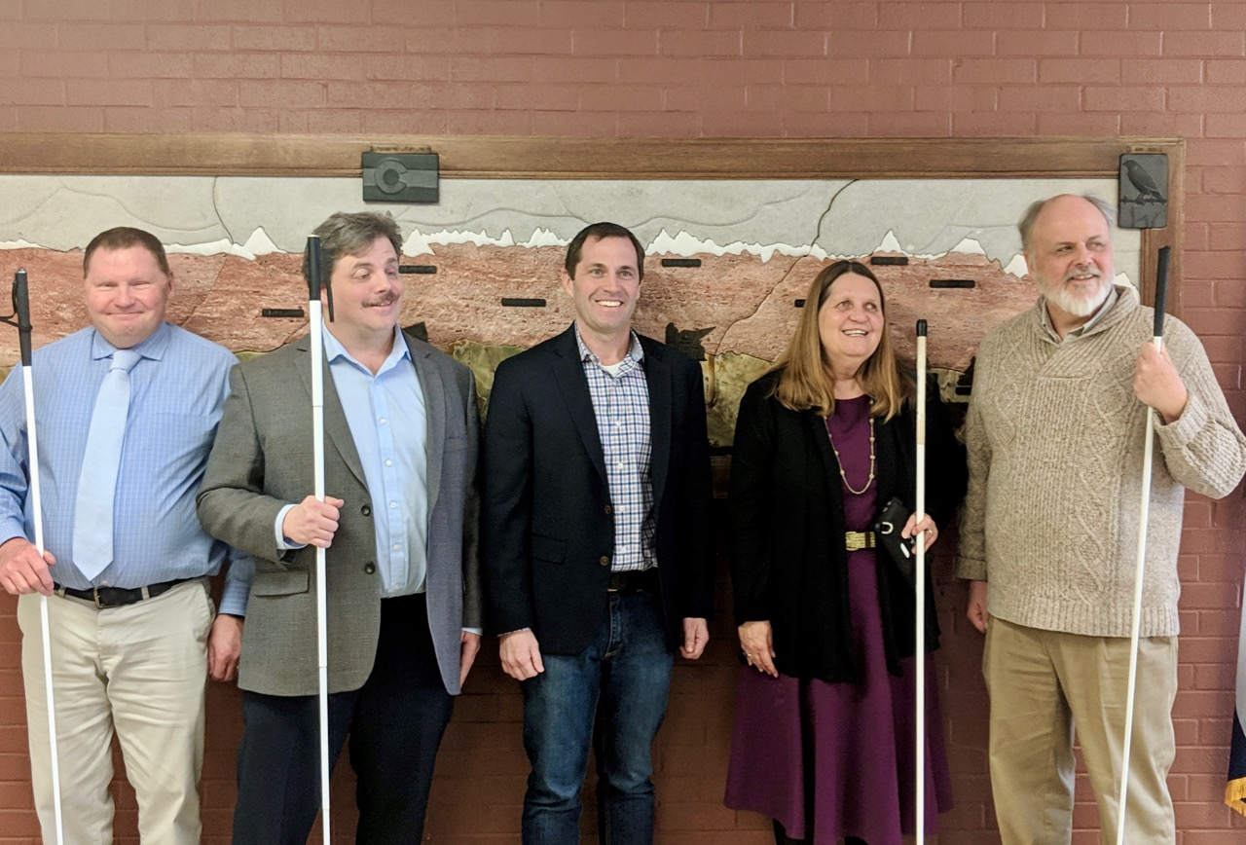
Standing in front of the tactile Colorado Mountain mural are Brent Batron, Scott LaBarre, Congressman Jason Crow, Julie Deden, Dan Burke.
Coming Soon! Coming soon, you and your friends and family will be able to register for the 2019 NFBCO 6 Dot Dash on June 29 at the Colorado Center for the Blind. We need your help! If you have connections with agencies, employers, or people you think may have an interest in learning about all of the sponsorship opportunities for 6 Dot Dash and related weekend activities please make the introduction. Please make the introduction today! Contact Kevan Worley 303-929-2369, or kevan@nfbco.org.
Live in Power. Rest in Peace. The disability rights movement lost a true thought leader, woman of heart, and activist on February 24, 2019. Carrie Ann Lucas was a talented photographer and cook. A citation of Carrie Ann’s activities, accomplishments, and awards is astonishing. Of heart to the National Federation of the Blind of Colorado is her strong, intelligent, imaginative advocacy during our fight to pass H.B. 18-1104, Family Preservation for Parents with Disability Act.
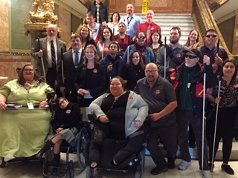
A group of disabled parents bill supporters the day of the vote. Carrie Ann is bottom left corner.
According to the obituary on the Colorado Cross-Disability Coalition website, “Carrie Ann died after an arbitrary denial from an insurance company caused a plethora of health problems, exacerbating her disabilities and eventually leading to her premature death. She was 47 years old.” You can read the entire obituary, www.ccdconline.org/2019/02/24/disability-community-loses-one-of-our-rock-stars.
Dan Burke and Scott LaBarre worked closely with Carrie Ann during the negotiation to pass Family Preservation for Parents with Disability Act. Dan said, “what a terrible, terrible loss.” “She was tireless, man. She was fearless. And, she knew that bill backwards and forwards.” “She knew every comma in that bill.” Carrie Ann Lucas, we mourn your passing, we celebrate your life. Your work will impact the lives of people with disabilities, their families, and society for generations to come. Thank you. At this writing we do not have information about memorials. Please subscribe to Colorado Talk, local channel of NFB Newsline, or check out Colorado Cross-Disability Coalition. On a personal note, the reports on the CCDC website indicate that Carrie Ann’s death was largely due to a failure of our health care system. The fact that a life with such soul and humanity could be lost due to lack of money is truly disturbing. I think what Carrie Ann would say is “this shows how much further those of us who care about human and civil rights have to go.”
From the Mountains to the Plains. NFBCO Mountains and Plains At Large chapter conference call meeting, 3rd Thursdays of the month at 7 p.m., call in 641-715-0866, code 405276#. President ReNae Anderson and the team look forward to hearing your voice.
Hey Partner! Wild West chapter saddles up first Saturday of the month. High noon. Carmody Recreation Center, 2200 S. Kipling Street, Lakewood.
“If everything isn’t black and white, I say why the hell not?” -John Wayne
Here’s What Happened at The NFBCO Triumphant 2019 Day at the Capitol. When we last left our state capitol in 2018, State Representative Jessie Danielson was in the midst of marshalling support for and bringing together stakeholders in order to ensure passage of H.B. 18-1104 - Family Preservation for Parents with Disability Act. Colorado now has the strongest blind parent protection law. And here we are again asking Senator Jessie Danielson to sponsor a bill that would make it possible for blind Coloradoans to vote from home without a sighted person to read or mark their ballot for them. During the Day at the Capitol, Monday February 11, attended by dozens of blind Coloradoans and allies we got the word. Senator Jessie Danielson, S.D. 20, planned to introduce a bill for an act concerning ballot access for voters with disabilities.

It is fair to say that Jessie Danielson has dedicated a great deal of her career to ensure that everyone has a right to vote secretly and independently, but that right has not always been guaranteed for the blind and visually impaired.

“We absolutely insist on our right to vote privately and independently,” said Scott LaBarre, President of the National Federation of the Blind of Colorado, on the Day at the Capitol. “But we also have the right to vote at the time and place of our choosing, just as our sighted friends and neighbors do now, for the same reasons they do.”

Colorado blind citizens fanned out to visit the offices of the General Assembly with fact sheets in hand. Our legislative memoranda featured three issues.

First, a solution to the barrier that currently prevents people who are blind from voting by mail.

Secondly, we were at the capitol to tell our government that the Blindness and Low Vision Services unit developed by the Colorado Department of Labor and Employment (CDLE) in 2016 had largely been successful. However, we detailed for them the need to protect the unit within the Division of Vocational Rehabilitation (DVR) in statute or at the very least regulation. Furthermore, our legislators needed to know that despite successes in eliminating waitlists for services, increasing number of job placements at higher wages, and bringing expertise to clients from professional staff uniquely qualified to serve the blind; Rural Colorado was not receiving those specialized services. Funding would be necessary. (Note: before the day was out, we heard from CDLE management that they shared our concerns and they pledged their commitment to work with us and the General Assembly.)

We also urged law makers to continue supporting NFB Newsline through the Disabled Telephone Users Fund (DTUF). For 12 years, the Legislature has funded this unique and dynamic news and entertainment delivery service to the blind of Colorado.

Visiting with our legislators and their aides was educational, challenging, and fun. Button-holing members of the General Assembly wasn’t always easy. The idiosyncratic nature of the room numbering system was, well, interesting. It made for a uniquely challenging training experience for Colorado Center for the Blind students. We met legislative aides in the basement cafeteria. We called them off the floor during session. The National Federation of the Blind of Colorado was bringing our message of love, hope, and determination to the golden dome!
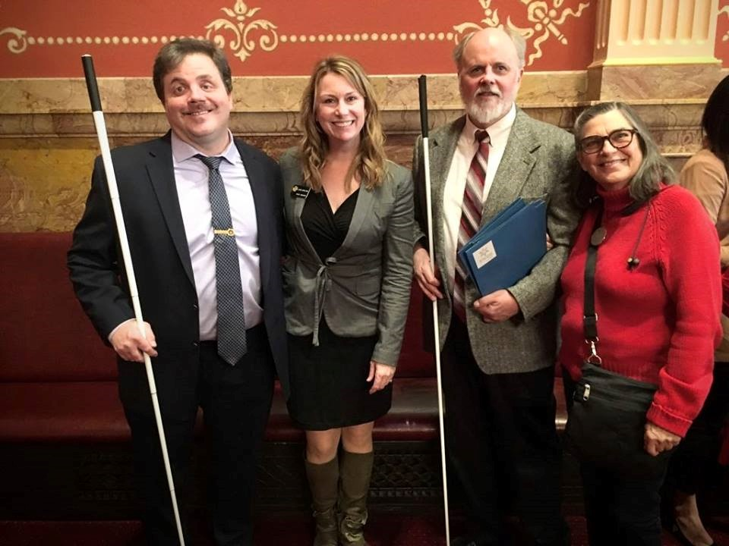
Pictured left to right is Scott LaBarre, Senator Jessie Danielson, Dan Burke, Ann Cunningham.

The big news of the day being able to vote by mail would likely soon be possible for blind Coloradoans!

In This Issue, We Congratulate Ann Cunningham. She has been teaching and inspiring blind artists for 20 years. My favorite piece is the mural depicting a beautiful Colorado Mountain-scape. Stop in and touch it, see it, and enjoy it in the dining room at CCB. She inspires people who are blind to live the lives they want through art. The more you learn the more you will love! Check out acunningham.com. You may also take joy from her Sensational Books.

NFBCO Grand Valley Chapter Makes a Difference on the Western Slope. Join them the first Friday of each month at the Center for Independence, 740 Gunnison Ave., Grand Junction. Join the group at 10 a.m. Thanks for hosting, CFI!

Students and Parents There Really is Money for College. Get your higher education in the art and science of winning those all-important scholarships. NFBCO will conduct an informative and lively work session from noon until 4:00 Saturday March 2nd. Be there or be poor. Contact jessica@nfbco.org.
National Federation of the Blind of Colorado Awards Congressional Experience Scholarships. Deyannira Villa Cazares, 16, of Denver, and Ian Lee, 18, of Aurora, joined other Coloradoans who participated in the National Federation of the Blind's Washington Seminar, January 28-31. Villa Cazares and Lee were chosen in a statewide essay contest.

Two Colorado High School students traveled with more than a dozen blind Coloradoans to Washington DC to advocate for legislation to improve the lives of the blind throughout the country. The group joined more than 500 blind Americans at the 2019 Washington Seminar held each year by the National Federation of the Blind (NFB).

Deyannira Villa Cazares, a 16-year-old sophomore at DSST: Conservatory Green High School, and Ian Lee, an 18-year-old senior at Aurora West College Prep, were the winners of an essay contest sponsored by the Colorado Center for the Blind in cooperation with the National Federation of the Blind of Colorado for blind high school students to attend the annual event. Deyannira of Denver and Ian of Aurora earned an all-expenses paid trip to the seminar, where they met with Colorado's congressional delegation and learned from leaders in the National Federation of the Blind.

"One of the biggest reasons visiting Washington would enrich my life is that I want to be able to advocate for people like me, blind or visually impaired, to have the same rights or opportunities as sighted people," Deyannira wrote in her essay.

"I need to know what laws impact my life and what I can do to help influence changes in the future," Ian wrote.

According to Julie Deden, Executive Director, Colorado Center for the Blind, “Beyond the legislative issues, these two bright, engaged students will be traveling the halls of our nation’s capital with blind adult role models. Our nation’s capital is big and complicated. They will learn that blind can go anywhere and engage members of congress.”

While in Washington, the students joined others in educating representatives and senators about three legislative priorities:

- The Access Technology Affordability Act (ATAA), which would provide a refundable tax credit for qualifying purchases of critically needed access technology. With this bill, Congress would stimulate individual procurement of this technology and promote affordability of these tools.

- The Greater Accessibility and Independence through Nonvisual Access Technology (GAIN) Act. The legislation would have Congress set minimum accessibility requirements for advanced digital interfaces which create barriers that prevent blind individuals from independently operating essential devices that enhance quality of life.

- The Disability Employment Act (DEA) is intended to spur innovation that will increase and enhance modern employment opportunities for people with disabilities.

(Note: Much of the above information about Washington Seminar and our two essay winners was taken directly from a press release distributed throughout the state by our contributing editor Dan Burke.)
The Builders. True stories from the history of the Rocky Mountain blind by Peggy Chong. The History Lady, Peggy Chong, has agreed to share her research with us in the Blind Coloradoan. I am very excited to share these columns with you all with greatest appreciation for Peggy’s work. We will learn of the victories, the vices, the legislation, the lives, the exclusion, the poverty, the adversity, and the achievements of those who lived lives with blindness over more than a century. We stand on their shoulders. Of course, we had our rogues, rats, traitors, and rascals. What would the history of Colorado be without them? We had our thinkers, our leaders and rank-in-file members, families and allies working to make it possible for more blind people to live the lives they wanted. As she digs through the dusty bins of history, I hope she finds a story about a blind gunslinger. We know there were blind miners, cowboys, and pioneers. Here is our first installment from The History Lady. -KW
As this is our legislative season and we have just come from the Day at the Capitol, I thought a look back just over 100 years at the activities of the blind in the legislative arena would be nice.
From the Keota News, October 4, 1918
“An Important measure of constructive initiative law coming up at the forthcoming election is the inaugurated be the United Workers for the Blind of Colorado entitled “An Act for The Relief Of The Adult Blind”; And we want everybody to vote for it. The bill must be alright, as it is officially endorsed by both the leading political parties, and the Colorado State Editorial Association, the Denver Press Club, Colorado State Federation of Labor, Denver Labor and Trades Assembly, Colorado State Grange, Farmers Educational and Co-operative Union, Colorado State Federation of Women’s Clubs, Women’s Club of Denver, W. E. T. U., Jane Jefferson Club, Nine United Italian Societies, Sons of Colorado, Ministerial Alliance of Denver, Colorado Farmers Congress, Farmers Institute of Greeley, Loveland and other places; Navy League Colorado Pioneer Printer, Denver Rotary Club, Mothers Congress, Colorado Suffragists Association, Parent and Teacher’s Association, Society of Ornamental Horticulturists, Royal Highlanders, National Order of Cow Boy Rangers, Colorado Tourists Bureau, Colorado Milk Producers’ Association, Jewish Relief Society, besides the approval of several religious and fraternal societies and labor Unions.”
That was a long sentence and must have been a lot of work for the blind members of the United Workers for the Blind. Just think if we had to get the support of all of these groups today for our legislation.
As We Go to Press, A.K.A BREAKING NEWS! We are told by the Chairman of the Board of Trustees, Colorado School for the Deaf and Blind, Brent Batron that the appointment of a new superintendent had been offered to Dr. Nancy Benham. We strongly urge the reading of an article in the Colorado Springs Gazette dated February 15 detailing the process, the offer, and different perspectives voiced by the deaf and hard of hearing community about the process.
For more information about the appointment, read the official release from CSDB.
Governor Polis Names Cabinet Appointees. Of special interest to our community is the appointment of Joe Barela to direct Colorado Department of Labor and Employment (CDLE). Joe brings more than 25 years of workforce management leadership to the DOL including working with Arapahoe and Douglas counties, the State of Colorado, and most recently with Skillful - an initiative of the Markle Foundation. We look forward to getting to know the new director of the state agency charged to keep Colorado working. The Division of Vocational Rehabilitation (DVR) is under the management of CDLE. We look forward to getting to know Joe Barela.
Congratulations to Anchor Center for Blind Children on a Highly Successful Visions of Love Gala. On Friday, February 8th, Jessica Beecham and Kevin Kovacs joined over 200 members of the community at the Anchor Center for Blind Children. The 9th Annual Visions of Love Wine Tasting was attended by supporters of the Anchor Center including parents of blind children, volunteers, staff, donors, eye care professionals, Delta Gamma alumni, and members of the community wanting to know more about Colorado’s only brick and mortar early intervention program. Guests were treated to a tour of the facility while tantalizing the taste buds with wines white to red. There was a delicious selection of chocolates and hors d’oeuvres. VIP guests started the tour with an exclusive bubbly and beer tasting and ended with signature sensory cocktails that tantalized. Beecham said, “it was exciting to see all of the thought that went into the architecture of the building as well as the care and love that gushes from each of the staff members.” She went on to say, “The Colorado Center for the Blind and National Federation of the Blind of Colorado are great resources for blind people but often come into contact with families when the kiddos are a bit older. It was excellent to build connections to families as well as professionals who provide early intervention services.”
In This Issue We Have the Duty to Give You Information About the Death of Two Wonderful Human Beings. Our Aurora chapter mourns the loss of James Knight. The Denver Post says, in part, James Brian Knight of Aurora, CO passed away peacefully on January 26, 2019 following a long illness. James served honorably in the Armed Forces as an Army Paratrooper and most recently served as an officer in the Colorado Department of Corrections. James was also a Certified Coach with the 1Touch Project, which provides self-defense training for the blind.
Donations may be made to the National Federation for the Blind, the National Association of Blind Veterans, or the 1Touch Project. NFBCO honors the life of a hero. His life honored ours. Thank you for your service.
Have you Enjoyed This Video? You really Should. It truly captures the essence of our community. In a time where life can often seem tumultuous this 10-minute piece shows that sometimes things really can be poignant, poetic, and possible. Love inspires.
And the Show Must Go On! Members and friends know of the retirement of Lorinda Riddle. We also know of her dedicated service. She handled the management of a number of NFBCO activities. One of her duties was to manage some of the affiliate’s theater fundraisers. Here is a note from Anahit LaBarre about upcoming theater events to benefit CCB Seniors Programs. She says, “So, here we are, with an upcoming performance of Hello Dolly on April 7th, at 2 P.M. It will be an audio described performance. BUT, HOLD THE PRESSES! This Hello Dolly fundraiser is SOLD OUT! But, never fear! Our next show will be Fiddler on the Roof, June 15. For information email Anahit LaBarre.

Thanks to Those Exhibitors Who Made an Early Commitment to Our NFBCO 6 Dot Dash 5k for 2019! Five Wellbeing Studio & Spa

Hello Muddah, Hello Fadduh. I Hear the BELL of Summer Confidence Camp Ringing. This summer, The Colorado Center for the Blind will combine their experiences and results-based summer programing with the curriculum of the National Federation of the Blind BELL Academy. Since our Littleton Center was established more than 30 years ago, NFBCO has empowered many families through a variety of summer-fun programs. Over the past decade, the NFB Jernigan Institute has been rolling out Braille Enrichment in Literacy and Learning, BELL, Academies. These BELL Academies are managed by affiliates all over the country, including Colorado. Let’s make sure families know about this unique day camp opportunity. Kiddos love getting their fingers on playdoh, Braille, and peanut butter and jelly. There is always a host of activities from pizza making to swimming all with the goal of fun, confidence, and education. Stay tuned for more information about confidence camp BELL in Littleton June 10-21, Westminster June 24-28, and Grand Junction July 15-19. The NFB BELL Academy helps blind and low-vision children, ages four through twelve, develop the literacy skills that will empower them to achieve their academic goals and live the lives they want. This year, with the assistance of our Wells Fargo partners, we provide opportunities for students to imagine, create, and touch their future and dreams; by not only raising expectations through Braille instruction, but by nurturing their development of tactile arts and graphics. To apply visit nfb.org/bell-academy. We are also looking for volunteers. If you or someone you know enjoys working with blind kiddos and are able to pass our background check please be in touch with Martin Becerra, mbecerra@cocenter.org, Colorado Center for the Blind 303-778-1130. Here I am at Camp Granada!
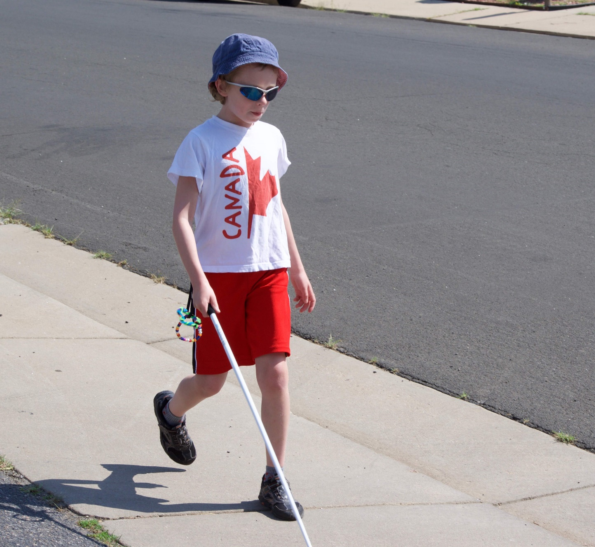
Young BELL student Asher stepping out to check out the world, cane in hand.
A Victory for Braille Literacy! Dan Burke writes: Colorado Center for the Blind hosted the Braille Challenge January 24th, referred to as the “Braille Blizzard Challenge” by CSDB staff who drove north in the storm. It was slow going for participants, teachers, and parents who came from as far away as Dillon and Fairplay. Even took as long as 90 minutes to get to Littleton from Aurora as wind and snow swirled across the Metro area that morning!

There were 14 participants in the Braille Challenge hosted at the Center, and there were 25 in Colorado Springs Thursday January 17th at the Colorado School for the Deaf and the Blind (CSDB). No doubt, BRAILLE RULES!

Four Colorado Students Recently Completed the Braille Readers are Leaders Contest. Sadie Ainsworth, Parker, CO received the Kelly Doty Award. These awards are given to students who have coped with extra challenges in order to become proficient Braille readers.

Come On, Just Try It! On your mark, get set, GO! Saturday May 11, Colorado Center for the Blind will be hosting a Try It Seminar. You will be able to try numerous physical and adaptive sport activities. Details coming soon.

Second Saturday in March is March 9. That will be the next meeting of the Colorado Springs chapter NFBCO. President Jeanette Fortin, VP Brian Smith, and the gang invite you! to join them! at the Garden Ranch Y. It is 9:30-10 for the great get-together and 10-11:30 for the meeting. Location 2380 Montebello Drive West. And dig this, the first Colorado Springs Meet-and-Greet the Blind of the City will occur at Springs Orleans, 123 E. Pikes Peak. Drop in any time between 5:00-7:00 on Tuesday March 19. People who are blind and are allies and friends gather to break bread, do some visitin’, lift a toast on your own tab. Bring a guest and guest gets first beverage on the house. No purchase necessary, void where prohibited by law.
“May your troubles be less, and your blessings be more. And nothing but happiness come through your door.” Saint Patrick’s Day is Nigh. Befittingly on a Sunday, March 17th. We toast the lads from Saint Patrick’s Brewing Company and Blind Faith Brewing. Thanks for brewing up good times in support of our 6 Dot Dash 5k 2018.

“Luck is believing you're lucky.” -Tennessee Williams
“To succeed in life, you need three things: a wishbone, a backbone and a funny bone.” -Reba McEntire

“I try to be grateful for the abundance of the blessings that I have, for the journey that I'm on and to relish each day as a gift.” -James McGreevey

“Lucky is how I feel to be doing what I do with so many of you.” -Kevan Worley
Did Not See Your Item in This Issue? Be a contributor! Send announcements, ideas, articles, and observations to either myself or Dan Burke. Enjoy this blog on NFB Newsline or read it at blog spot. When it comes to 2019, we say, “Live the Life You Want.”

