Up there on top is the NFB of Colorado Logo followed by “Live the life you want.”

Blind Coloradoan Blog April 8, 2019
Writer, aggregator Kevan Worley. Contributing editor Dan Burke.
Here is what you need to know.

Showing the Love. NFBCO deeply appreciates 6 Dot Dash 5k Gold Sponsors. Thank you, Comcast, Southern Foodservice Management, Inc., Philadelphia Insurance, Sysco Foods, and Zimmer Cox Commercial Builders. These gold star companies are committed to community, a generous corporate spirit, and support for the work we do to educate and empower the youth of Colorado. Thank you.
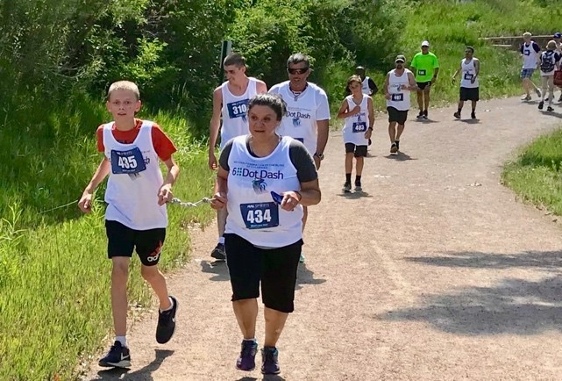
And, This Just In! Registration is now open for the Saturday June 29 NFBCO 6 Dot Dash 5k. This community-wide celebration, walk/run festival will be the event of the season. #comerunwithus
www.6dotdashco.com

Colorado State Senator Jessie Danielson Takes the Lead! National Federation of the Blind of Colorado applauds introduction of legislation to allow the state's blind to independently cast mail ballots. The bill would enable blind Coloradans to join the rest of the state in voting privately. State Senator Jessie Danielson (D-Wheat Ridge) introduced SB19-202-Voting Rights for Voters with Disabilities Tuesday, March 19. The legislation would make it possible for blind Coloradans to vote from home without a sighted person to read or mark their ballot for them.

“I have dedicated a great deal of my career ensuring that everyone has a right to vote secretly and independently, but that right has not always been guaranteed for the blind and visually impaired. We’re going to change that,” said Senator Danielson of District 20.
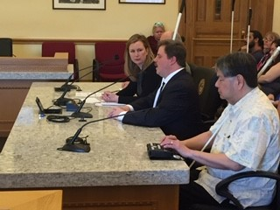
Pictured left to right, Senator Jessie Danielson, NFBCO President Scott LaBarre, Curtis Chong.

“We insist on our right to vote privately and independently,” said Scott LaBarre, President of the National Federation of the Blind of Colorado (NFBCO). “And we also have the right to vote at the time and place of our choosing, just as our sighted friends and neighbors do now, and largely for the same reasons they do.”

The Voting Rights for Voters with Disabilities Act, SB19-202, would allow qualified blind voters equal access to the mail ballot, something required by the Americans with Disabilities Act (ADA), but not provided for under Colorado statutes. It would permit blind voters to use the talking or magnification software (known as assistive technology) that they use daily in their work or home lives to cast their votes with confidence. It affords the same secrecy and convenience now available to everyone else.

For voters who are both deaf and blind, the law would permit them to use electronic Braille displays to read and mark votes – the only truly private and independent means for them to do so. Currently, there is no way for a deaf blind person to mark a ballot without sighted assistance, either in a polling place or on an absentee ballot.

“When Colorado went to a mail ballot in 2013, there really weren’t any accessible, equal options for the mail ballot,” said Curtis Chong, a retired blind Assistive Technology manager who helped pass a similar law in New Mexico last year before moving to Aurora. “Now that’s changed, and we can get the technology essentially for free.”
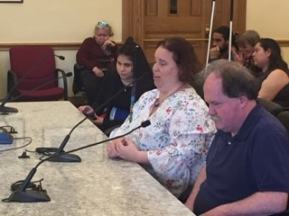
Pictured left to right, Deya Villa-Cazares, Jenny Callahan, and Chip Johnson.

On Monday afternoon, April 1st, SB19-202 was heard by the Senate Committee on State, Veterans, and Military Affairs. After testimony was given by leaders of NFBCO, county clerks, and other interested organizations, the committee passed the bill unanimously. Next step, the floor of the Colorado Senate.

Hunting for Those Beeping Easter Eggs! I remember Easter egg hunts, family Easter gatherings, at school or church. All the little kids would gather round and then scurry out to find as many eggs as they could find. There was the expectation that I would stand on the sidelines and cheer. The few times I did participate were frustrating. I could not see those multi-colored eggs scattered over the field. I was excluded, often embarrassed, and I was never eligible for prizes. Our Grand Valley chapter is changing those egg-spectations for this generation of our blind children.
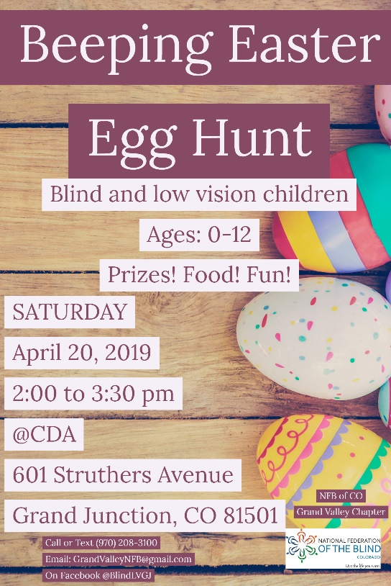

Congratulations to the Grand Valley chapter for their egg-straordinary work!

Come Ring with Us. This summer is closer than you think. We must find every blind and visually impaired child in the state of Colorado. We encourage educators, parents, and kiddos to ring the bell of freedom, independence, and literacy. BELL, Braille Enrichment for Literacy and Learning, is an amazing day camp for blind children. The emphasis is on fun, learning, and independence. The first confidence camp BELL program will take place June 10-21 at the Colorado Center for the Blind, 2233 W Shepperd Ave. Littleton, CO. The second camp, June 24-28 at the Rocky Mountain MS Center, 8845 Wagner St., Westminster, CO. And, the third camp, July 15-19 at the Center for Independence, 740 Gunnison Ave, Grand Junction, CO. For more information contact Michelle Chacon 303-507-6291 or Martin Becerra 303-778-1130 extension 223. Register your child at https://nfb.org/programs-services/nfb-bell-academy/colorado.

Sponsorships are still available. Enrichment $500, Literacy $250, and Learning $100. Please contact Kevan@nfbco.org for complete sponsorship information.

What to do, what to do. I am often asked by parents with blind children about interesting ways they can be sure to include the blind child in vacation activities. The Rocky Mountain Dinosaur Resource Center (RMDRC) is in Woodland Park, Colorado. It is a welcoming space that is entertaining and fun for the family. They have tours which include a lot of exhibits that are touchable. The curators are knowledgeable and love what they do. They love to encourage blind kids to get their hands all over fossils and replicas.
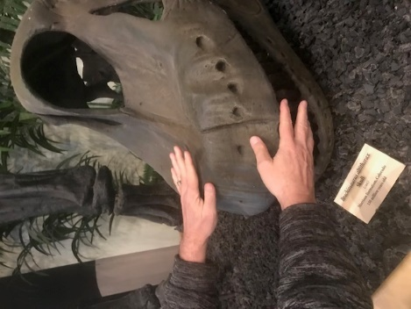

RMDRC is a world class museum. They feature an awe-inspiring display of dinosaurs, prehistoric marine reptiles, pterosaurs, and fish of North America’s late Cretaceous period. The fossil skeletons on display are supplemented with vibrant graphics and life-restoration sculptures to help you visualize these fascinating animals in life and the environments in which they lived. Visitors can read the stories of the discovery of each specimen and see a working fossil laboratory where important recently discovered paleontological specimens are being freed from their rock matrix and undergoing restoration. In addition, they have a children’s area where they can brush off fossils in a dig box, there are books to read, a magnetic board for them to make their own imaginative dinosaur, a rubbing station where they can take home their colorful drawings of dinosaurs, and a fun and informative movie for the whole family to watch together. For more information check out www.rmdrc.com or call 719-686-1820.
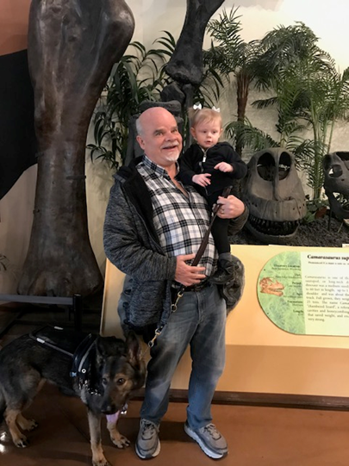
Pictured, Kevan Worley, Granddaughter Finley, and guide dog Onyx.

Tag! You’re It! From the Blind History Lady, by Peggy Chong. Before there were White Cane fundraisers, we had “Tag Days” to raise funds for many causes. The blind were no exception. Members of an organization and their supporters would stand or sit at street corners and ask for the support from passer’s by. This was not considered begging. I don’t know why. But it should be noted that “Tag Days” were an accepted way that many organizations doing good works raised funds. This included organizations such as “Denver Dramatic League”, a home for girls, the “Negro Women’s Club Home”, and “Sacred Heart Orphanage”. Tag days were a time for fundraising, not necessarily a type of fundraising. One Tag Day said the prize went to the prettiest girl in the club with the most votes. One seemed to be raffling a piano, some sold green bows (Sacred Heart). There were references to stopping people and giving them a “tag” after they gave money. The tag had a message from the organization.
From the Keota News dated June 30, 1916, we learn that the funds collected for Tag Day for the Adult Blind in Denver that year were $3,002.55. Not bad! (Note, 1916 “Tag Day” collections would be worth $73,236.86 in 2019.) To follow The Blind History Lady, go to www.theblindhistorylady.com.
Special Note. Peggy Chong serves our Western region on the National Library Service for the blind and physically handicapped special Collections Development Advisory Group, CDAG. If you have questions about the work of that group please contact Peggy by email, chongpeggy10@gmail.com, or phone at 303-745-0473.

Blind Athletes Joined Team Anthem and Other Partners for the Fight for Air Stair Climb.
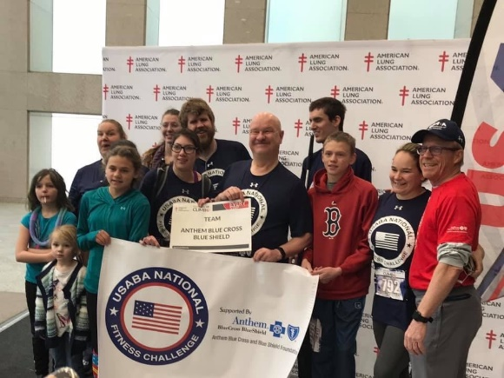
Athletes climbed 59 stories which totaled 1,098 stairs. Cody Bair, one of the athletes said “It was really empowering to be able to participate in an event like this. There was no need for guides or other accommodations. We just climbed along with everyone else.” Next year, he and Jessica Beecham, director of WE Fit Wellness and National Fitness Challenge athlete plan to train and compete in the stair ultra which consists of doing this 59 story climb as many times as possible in 1 hour. Athlete Steve Patton advises “Just take it at a steady pace and you will make it to the top no problem!” The Fight for Air Stair Climb raises awareness and funds for lung disease prevention.
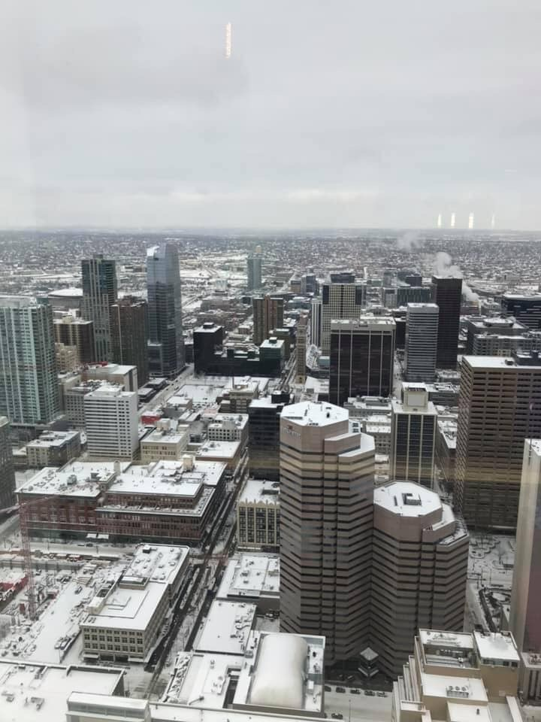
View from the top of the 59-story climb.
Try It. You Might Like It. In recent years, one of the more successful workshops hosted by the Colorado Center for the Blind has been the NFBCO Sports and Rec Division’s Try It seminars. Colorado is known as a “get out there and do it” state. The rate of obesity among Colorado citizens continues to be the lowest in the nation. Colorado is home to the United States Olympic Training Center. Our Sports and Rec Division encourages the blind of Colorado to “get out there and do it.” You can Try It first on Saturday May 11 from 1 until 4. Try Beep ball, yoga, martial arts, and much more. This seminar is perfect for you. Ages from 2 to 92 are welcome to Try It! Sometimes, blind folks are not as active because we have not been encouraged or shown how to participate in exercise and recreation. This is your opportunity to Try It! Note, Colorado is also home to the United States Association of Blind Athletes, USABA.
Ventures and Victories! Here’s What’s Up with Some of Our Local Chapters. Now This is Great! ReNae Anderson tells us that the Mountains and Plains Chapter has cutting boards, patches, lapel pins, and challenge coins for sale. I challenge you to contact her. Do you have your coin? No? You owe me a drink. Better get your coin today.
The cutting boards are $25. You can choose red oak, white oak, or a combination of oak and walnut. Each cutting board is carved in the bottom left corner with a mountain and a stylized lake, representing the mountains and plains. If anyone is interested in purchasing, contact ReNae Anderson at 970-393-0170.
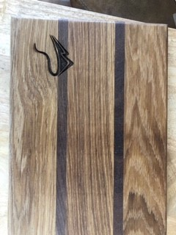
Colorado Center for the Blind Proudly Hosts the Denver Metro Chapter. They all get together the 3rd Saturday of the month at 10 a.m. In March, the Denver Metro Chapter had big fun doing group activities after the business meeting. Folks could enjoy two of three activities: Kitchen Gadget Talk, Gym Activities, and Tech Q&A. There is always something going on with NFB at CCB!
Colorado Association of Blind Students Invites You to a high-powered workshop Saturday May 4 from noon until 4. Meet students from around the state. Learn the tips and tricks that will make you even more successful on campus and beyond. It will be at the Colorado Center for the Blind, 2233 West Shepperd Ave. For complete information contact Maureen Nietfeld 215-353-7218.
Saddle Up the First Saturday Every Month at High Noon. Y’all gallop over to the Wild West Chapter meetin’ at the Carmody Recreation Center, 2200 South Kipling Street, Lakewood. Chapter has a new sheriff in town over there. Paul Sandoval was elected President. They also had elections for the 2019 Board of Directors. Paul’s posse consists of Vice President Nate Hecker, Treasurer Bradley Basta, Secretary Emily Tallent, and Board Member Scott Marcotte. Giddy up!
Blind Tech Training, Expanding Possibilities Using Technology. The Blind Coloradoan is happy to publicize blindness related products and services. Here is a note from the afore mentioned Paul Sandoval. We are a small assistive technology training company that serves the state of Colorado. We specialize in training individuals in Windows, MacOS and IOS based software solutions for the blind. We contract with both the Colorado Department of Vocational Rehabilitation and the Colorado iCanConnect program. We also offer training to private-pay clients. Training is one-on-one and highly customizable to the individual user’s needs. If interested, call us at 720-620-8007 or email at blindtechtraining@gmail.com.
And Speaking of Blind Tech Training. Paul and team will provide information about iCanConnect and other access tech solutions at the next Colorado Springs Chapter meeting. Join the chapter Saturday April 13 for Coffee, Conversation, and Connection at 9:30 followed by business meeting at 10, and more tech talk at 11:30. It all happens at the Garden Ranch YMCA, 2380 Montebello Drive West, Colorado Springs. I think the chapter is fixin’ to have a potluck at the May meeting. Yum!
iCanConnect. iCanConnect provides people with both significant vision and hearing loss with free equipment and training. Sending an email or chatting on the phone can be challenging for people with both significant vision and hearing loss. iCanConnect provides free equipment including smartphones, tablets, computers, screen readers, braille displays, and more to people who meet federal disability and income guidelines. For more information, you can connect to JoAnne Hirsch, Colorado Commission for the Deaf, Hard of Hearing, and DeafBlind, v 303-866-2097, vp 720-949-7457.
Calling the People of the Steel City. Hey Pueblo! You have a chapter of the National Federation of the Blind of Colorado. People who are blind, low vision, professionals in the field of blindness, and families and friends can attend chapter meetings on the second Saturday of each month, 85 Stanford Ave at the Wesley United Methodist Church. The networking and general business meeting will be waiting for you at noon. Join them on April 13!
Talk Back To AIN. We received this note from our good friends at Audio Information Network of Colorado. AIN just set up a “Talk Back” phone line for programming feedback. Although we focus on local news and information for our 24/7 broadcasts, content needs may be changing for some blind listeners. Younger people are asking for gaming and career topics. Older adults want more on how to navigate Medicare or Social Security benefits. Spanish speakers have asked for programming about immigration issues. Do you have a special topic that doesn’t get covered by your usual news and information feed? Give us a call at 303-786-7777, Extension 4 and “talk back”.
This Next Item Got Me Pretty Excited! I have three broken Braillers in my office. I mean, these Perkins babies are beat up! But, never fear CTBL is here! Colorado Talking Book Library now has a group of volunteers trained to service and repair manual Perkins Braillers. To schedule service for your Perkins Brailler, call Terri Marcotte at (303)727-9277 ext. 17 or email at Marcotte_t@cde.state.co.us.
1 4 5 6, 1, 1 3 4 5, 1 3, 1 3 4 5 6. Thank you.
Successful City Meetup. Brian Smith is a blind entrepreneur. He is Vice President of our CO Springs chapter. On March 19 he hosted the very first CO Springs Blind of the City Meetup (we have got to change that name.). The next one will be back at Springs Orleans Tuesday April 23rd. Stop in any old time between 5 and 7.
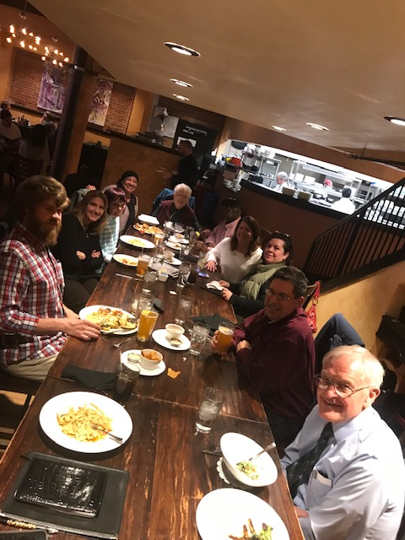
The Blind Dog. Sometimes my guide dog is referred to, by a member of the general public, as my blind dog. That has always cracked me up. Of course, I know that they are trying to say but for the purposes of guiding I would prefer a dog who can see. Melissa Green, President, Colorado Association of Guide Dog Users, COAGDU, tells us that service animals are eligible for a free! Yes, FREE! Eye exam during the month of May. Register your guide dog before April 30. Learn more about this great program!

“You can say any fool thing to a dog and the dog will give you this look that says “By God you’re right! I never would have thought of that.” -Dave Berry, author and columnist.
Dear reader, if you know of a company or an organization that you think would like to be a part of our 6 Dot Dash 5k please put us in touch with them. Sponsorships are still available. Volunteers are more than welcome. There are still a few spaces for exhibitors, and, please encourage everyone to register today for the June 29 event in Littleton!

Submit items to be considered for May Blind Coloradoan Blog by April 26th.
Forward, Always Forward!
Did Not See Your Item in This Issue? Be a contributor! Send announcements, ideas, articles, and observations to either myself or Dan Burke. Enjoy this blog on NFB Newsline or read it at blog spot. “Live the Life You Want.”

