Up there on top is the NFB of Colorado Logo followed by “Live the life you want.”

Blind Coloradoan Blog May 2019
Writer, aggregator Kevan Worley. Contributing editor Dan Burke.
Here is what you need to know.

This May Issue is Dedicated to the Mothers of the Movement. The modern holiday of Mother's Day was first celebrated in 1908, when Anna Jarvis held a memorial for her mother at St Andrew's Methodist Church in Grafton, West Virginia. St Andrew's Methodist Church now holds the International Mother's Day Shrine. Her campaign to make Mother's Day a recognized holiday in the United States began in 1905, the year her mother, Ann Reeves Jarvis, died. Ann Jarvis had been a peace activist who cared for wounded soldiers on both sides of the American Civil War and created Mother's Day Work Clubs to address public health issues. Anna Jarvis wanted to honor her mother by continuing the work she started and to set aside a day to honor all mothers because she believed a mother is "the person who has done more for you than anyone in the world", from Wikipedia. There have been so many strong women who have made our movement what it is. We could not list them all but the one who raised up many of us in Colorado is Diane McGeorge. Happy Mother’s Day Diane. This issue is dedicated to you.

This issue is in appreciation of our friends at Southern Foodservice Management, Inc. and Philadelphia Insurance Companies. Southern returns as a Gold Sponsor of our second NFBCO 6 Dot Dash 5k. Philadelphia Insurance is a Gold Sponsor for their first time. Philadelphia Insurance is the chosen insurance carrier for our Colorado Center for the Blind. If it is good enough for CCB it is great enough for me! ThinkPHLY.com. Southern Foodservice Management, Inc. has provided support and consulting services for a number of blind food service operators, including here in Colorado. No one in the foodservice industry cares more about making your day than the people at Southern. “We love food, and we love people. We even have a special philosophy that directs everything we do. We're Southern at heart, so when you eat with us, you'll experience first-hand what southern hospitality is all about.” We also appreciate our other great sponsors. You will read more about each of them in upcoming issues of this blog. Please express your appreciation to each of our NFBCO 6 Dot Dash 5k sponsors whenever you do business with them.

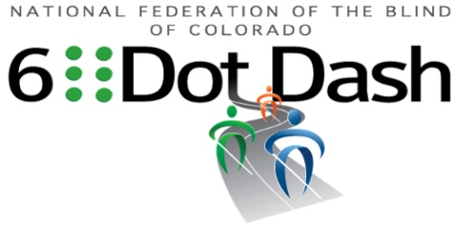

#ComeRunWithUs
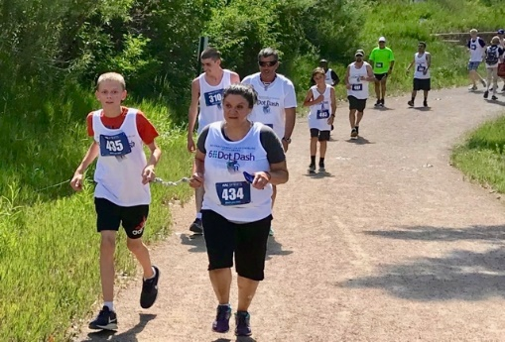
Saturday, June 29th 9:00AM-1:00PM
Colorado Center for the Blind
2233 W. Shepperd Ave, Littleton, CO 80120

Join the National Federation of the Blind of Colorado and the Colorado Center for the Blind for a 5k run/walk and Blind Beer Tasting to raise awareness and funds for Braille Literacy. For more information visit us online at www.6dotdashco.com

THIS EVENT OFFERS FUN FOR THE WHOLE FAMILY!
T-shirts Finishers Medal Chip Time Huge Expo
Kids Fun Run Harley’s Hot Dogs Bounce House
Face Painting Kona Ice
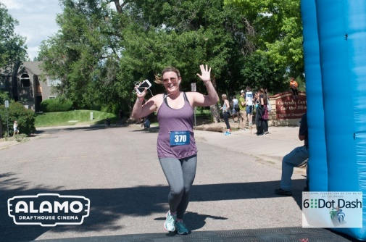
Like Us on Facebook
@6DotDashCO
SIGN UP TODAY!

Colorado Blind Voters Prevail in Quest for Equality. Readers of this blog will know that Dan Burke is not only our intrepid contributing editor; Dan also serves as chairman of our NFBCO Governmental Affairs effort. Here is a note of celebration from Dan.

Our voting rights for Voters with Disabilities bill, SB19-202, passed out of the Colorado House on Thursday. Because it was amended after leaving the Senate, it had to return there. April 27, the Senate voted to concur with the House amendments and passed it. That means the bill now goes to the Governor for his signature, making SB19-202 the law!
We did it!

Thanks, Dan! Thanks, team! Thanks to Senator Danielson and to the members of the Colorado General Assembly! It is likely that by the time you read this, the Governor will have already signed the bill. We know that he plans to sign it. And we know that it will occur well before Thanksgiving. Note, the governor must sign or veto legislation within 10 days after transmittal, or it becomes law without his/her signature. For bills transmitted after session adjournment, the governor must act within 30 days after the end of the session, or the legislation becomes law without being signed.

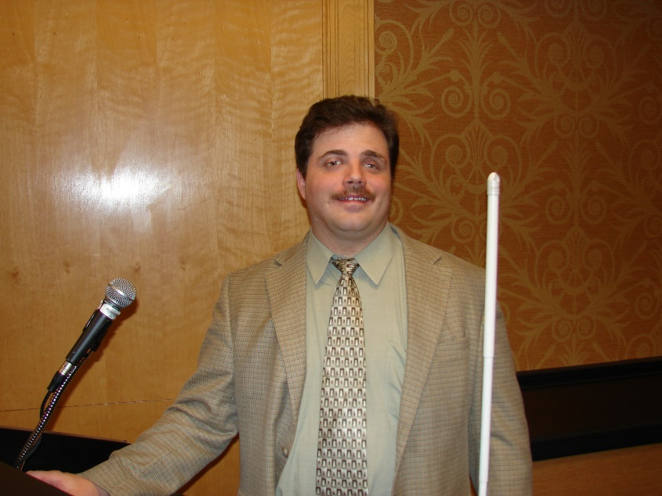

Happy Thanksgiving from the President of the National Federation of the Blind of Colorado, Scott C. LaBarre. It is great to have an item from Scott for this issue. As always, Scott is witty, perceptive, grateful, and compassionate. Here is what the big turkey says:
HAPPY THANKSGIVING

First, I want to wish everyone a Happy Spring!! However, as I write this (Tuesday morning, April 30), it is actually snowing outside. Ah, Spring time in Colorado.

Speaking of Spring, many of us have recently celebrated the holidays of Easter and Passover. Nevertheless, my mind is being drawn to Thanksgiving. No, I am not craving turkey and all the wonderful holiday fixings but rather experiencing an immense sense of gratitude for my involvement in the National Federation of the Blind. This past weekend, I had the honor of representing Colorado on our national scholarship committee, and that experience reminded me of how my journey in our Federation began.

In 1986, I won an NFB scholarship coming out of high school. As I reflected on this while reviewing hundreds of 2019 scholarship applications, I marveled at how significantly we have impacted the lives of blind people all over the world since then. I had the opportunity to participate on the Federation’s Scholarship Committee early on in my involvement, and I am quite astounded by how much the landscape has changed for all of us.

Over 30 years ago, the vast majority of individuals applying for one of our scholarships mostly had never heard of us and thus were not members. Now, the exact opposite is true. The vast majority of those applying for scholarships are active members of the Federation, and seemingly all applicants recognize the Federation’s work to bring about substantial, societal change to improve our opportunities.

It is also fair to say that thirty years ago, the breadth of careers and interests being pursued by scholarship applicants was much narrower. Now, it appears that our philosophy of living the life you want has taken root, and blind men and women are not letting their blindness limit pursuit of their dreams. Our applicants are seeking careers in every imaginable vocation from astrophysics to zoology. For example, whereas the idea of a blind person acquiring a medical degree was incredibly rare thirty years ago, now we find many in our applicant pool striving after a career in medicine.

Beyond just academics and careers, the interests and hobbies of our applicants are also significantly more diverse. I smiled while reading the file of one applicant who is now active in a blacksmith club and was the first blind person to join. He remarked on the fact that he was one of the few who had not burned himself while practicing this ancient art.

As I boarded the plane back to Denver, I was incredibly thankful for our ability to raise the expectations of the blind community making it possible for us to live without artificial limitations being placed upon us. We have not yet met the outer boundaries of what we can achieve. Because of our work, we share a future which is full of unlimited potential.

I am also incredibly thankful for our, NFB of Colorado. There are scores of reasons why this is so, but our work over the last month on our voting rights legislation, S.B. 19-202, is a wonderful case in point. We have the organizational maturity and sophistication to recruit and sustain key legislative allies like Senator Jessie Danielson who has become a true champion of our causes. As you know, the Representative Danielson carried and passed our parental rights bill last year and, as a first year Senator, has shepherded S.B. 19-202 through the General Assembly with unanimous support.

She was able to accomplish these feats because of her political talent but also because of the wonderful members of the NFB of Colorado who have traveled to the Capitol to support our bills and/or who have made the phone calls and sent the emails persuading our legislators. We have so many talented and dedicated members who make it far easier to bring our message forward. Take, for example, Jenny Callahan who testified before the Senate State, Veterans, and Military Affairs Committee on April 1st. She gave impassioned testimony about how, as a sighted person, she had always taken her right to vote for granted, and when she lost her vision, she felt that her human dignity had been stripped from her because she was forced to work with others to fill out her ballot, depriving her of the independence and privacy that everyone else enjoys as a matter of right. Because of Jenny’s moving testimony and all of our work, S.B. 19-202 will soon become law, and all of us will be able to realize the same options of every Colorado voter, the option of either going to our polling places where accessible machines are present because of the previous work of the Federation or the ability to vote from the privacy and comfort of our homes.

There are countless examples like our work on S.B. 19-202 of how the Federation has advanced and implemented our right to live in the world, and I am thankful for all of them!! However, we all know that we aren’t done with our journey to full freedom, but as we continue to build the Federation, I know we will get there!! As we celebrate Thanksgiving, well, the Spring version thereof, I want to thank each and every one of you for helping us transform our dreams into reality!! Oh, and enjoy the snow.

Scott adds, “Happy Mother’s Day to the mothers of the movement. A big thank you to my strong and loving mom, Donna, and to the beautiful and talented mother of our children Alexander and Emily, Anahit. And to the mom who raised many of us in the National Federation of the Blind of Colorado, Diane McGeorge.”

Ever Wonder Why Your Picture is Not in The Blind Coloradoan? Probably not. But I have. Please, slide on some decent threads. Take a pic. Send it to me. We need your visage to brighten up our blog.

Techy, Nerdy, Profitable? Probably all of the above if you read the Blind Institute of Technology newsletter. These guys get stuff done! Here is info about an upcoming BIT Seminar.
BIT'S ACCESS SYMPOSIUM
JUNE 12, DENVER, CO

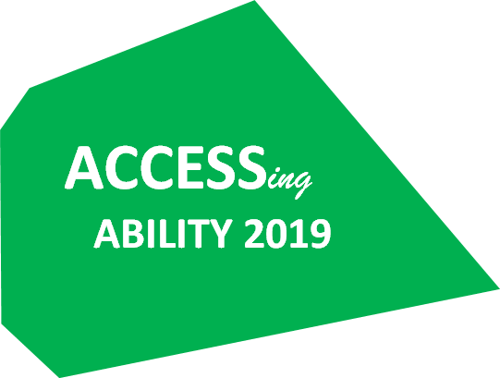

We are thrilled to be hosting our second annual symposium, featuring a new name but an old theme – using technology to ACCESS the abilities of all users.

BIT is all about getting… stuff… done, and the ACCESS Symposium is our way of bringing this spirit to a wider audience. ACCESS is completely focused on the ‘how’ of accessible technology. Whether you’re struggling with implementing accessibility into your development cycle, wondering how to deal with third-party vendors, or interested in cold hard code, ACCESS has something for you!

You can find more event details here, and please feel free to reach out to us directly at events@blindit.org.

The May newsletter from BIT also highlighted the promotion of Ron Sorozan to Vice President of Technology for LCI. BIT was instrumental in that opportunity. Here is part of what Ron had to say, “…I strongly encourage anyone seeking their next career position to contact BIT as they will go out of their way to assist in finding and closing your next opportunity. I equally, though, recommend that any organization seeking highly motivated and talented people to also reach out to BIT as their mission to educate around improving accessibility in the workplace and to place those who are disabled into meaningful positions will be rewarding for all involved."
Will You Please Help. Help us make certain that no blind or visually impaired child is left out. We don’t know where all the blind kiddos and their families are across our great state. Help us find them. The NFBCO Confidence Camp and BELL Academies combine to bring Summer fun and instruction in a day-camp like setting. This is what children’s Summer memories are made of. Program dates and locations are Littleton June 10-21, Westminster June 24-28, and Grand Junction July 15-19. For information, please reach out to Michelle Chacon 303-507-6291. You can register your child at www.nfb.org/bell-academy. The last time I volunteered at a BELL program there was everything from Play-Doh and Legos to swimming and pizza making. I am sure there will be song singing and general merriment.

This Is a Big Deal! Graduating from the Independence Training Program at the Colorado Center for the Blind is a big deal. Recently, Dan Burke posted the following on the CCB Facebook page. The responses from this particular post have been many and amazing.

It was a big day, an emotional day for Omar Santana, one that would make his Sicilian mother proud as he served Italian sausage alfredo to 60 people last Wednesday.
"I didn't really believe I could do all the (cane) travel," he said before his graduation. "I didn't believe I could learn Braille."
He says these things with a tone of awe and pride that he has, indeed, mastered these and other blindness skills.
Admittedly, Omar just wasn't quite ready for training when he first came last year. He struggled with the idea of being a blind person. When last summer rolled around, he decided to spend it with his 11-year-old daughter out of state. "I wasn't coming back," he says now, "but Julie wouldn't leave me alone - Julie and Vicki and fellow students kept after me. I wouldn't be here without them."
Omar will be traveling to Europe in a couple of months, resuming his career as a popular DJ for Electronic Dance Music. Before his vision deteriorated significantly, he DJed regularly in Europe and all over the U.S.
And how does Omar feel about traveling to Amsterdam now?
"No problem," he said without hesitation. "I've got my cane."
Yes, Omar can go around the world again with his white cane, his training at the Colorado Center for the Blind, and the confidence and pride he has as a blind person.
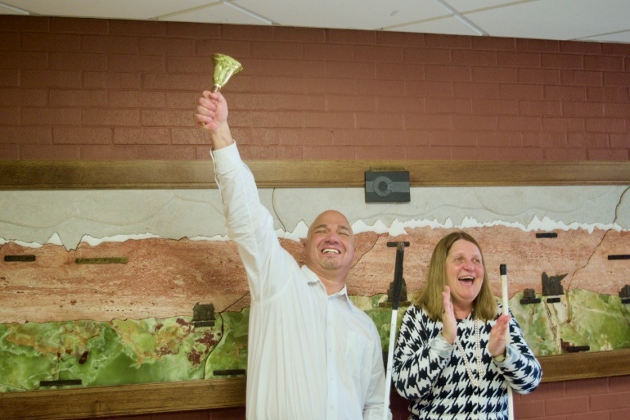
Graduate Omar Santana and Executive Director CCB Julie Deden

When it Comes to Fake Service Animals, I Get Very Dogmatic. Since receiving my guide dog Onyx, the Wonder Shepherd from Fidelco Guide Dog Foundation, some 30 months ago I have been following with great interest and given a great deal of thought to the issues surrounding dogs of all kinds in public places. Guide dogs, service dogs, emotional support animals, and pets. Sometimes you can’t tell the difference. The Colorado Springs Center for Independence reports on their advocacy and the media coverage it created. I saw the item on News 5 when it first ran. My wife Bridget told me that our good friend City Councilwoman Yolanda Avila would be in an upcoming story about fake service animals. Here is a note about the matter we received from the Independence Center.

Last month, Advocacy held an Assistance Animal Open House. Eric Ross from KOAA attended and interviewed Becca Michael and Pat Going. Eric took this story and ran with it, investigating how people who misrepresent their pets (and doctors who write “prescriptions” for emotional support animals without an actual exam) make it more difficult for the people with disabilities who rely on service animals. He also interviewed Councilwoman Yolanda Avila, who has a service dog named Puma.

Watch the captioned video and read the associated article here.

We Salute the Business Enterprise Program for Colorado. Creating jobs with high earnings potential through self-employment. Unlike many similar programs operated under terms of the Randolph-Sheppard Act Colorado’s continues to grow. For information about training and business opportunities contact Dan Whalen, Manager, 303-866-3425. Or our Trainer and Chief, Ellie Karre, 303-866-3429. We thank BEP for being a Silver Sponsor at the NFBCO 6 Dot Dash 5k. #comerunwithus.

Potlucks, Advocacy, and a Meet Up at the Saloon. Springs Chapter President Jeanette Fortin says that they will hold a potluck at the next scheduled monthly meeting. This chapter knows how to eat well! For the info contact Jeanette, nettiecosp@icloud.com. I will be there 9:30 a.m. Saturday May 11 at the Garden Ranch YMCA. I think I am baking a cake if I know you are coming.

Good times had by all at our second city blind meet up downtown at Springs Orleans. Great to have folks from Independence Center, City Councilwoman Yolanda Avila, and new Springs family Jessie Lorenz and her daughter, along with blind entrepreneur Brian Smith and NFB chapter president Jeanette Fortin at the meet up. We are finding this to be a great way to engage our community in an informal setting. The next one will be perfect for you. Join the crowd, Tuesday May 21 at Springs Orleans anytime between 5 and 7. Note, when you sit at the bar happy hour appetizers are two for one!

Greeley Group Does NFB Newsline® Training. Using the instructive material easily available at https://nfb.org/programs-services/nfb-newsline, the Greeley chapter plans to get folks signed up, oriented, and trained to maximize all the benefits of NFB Newsline®. Great idea Greeley! And, to other chapters from Mountains and Plains to Mile High all the news about NFB Newsline® is laid out for us on the website. Great chapter activity. And, hey! Sign up today!

Here is an Item That Your Aggregator and Contributing Editor Know Little About. Ok, nothing about. But Jessica Beecham and Maureen Nietfeld do. Here is what Jessica Beecham reports. Colorado Center for the Blind board member Maureen Nietfeld facilitated a class with blind teens Yesbi, Deya, and Alma, how to apply makeup. As a blind person, the process of uptime on makeup can feel a bit daunting but Maureen came prepared with tips and tricks that made it a snap!

The girls started with eye makeup, moved to Foundation and blush, and finished off with the lips! The girls learned about when certain color combinations work best and how to find out what colors work best for them. From all of the giggles and smiles it was clear that everyone had a blast and came away feeling more confident!
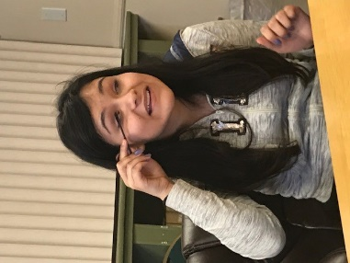
Alma
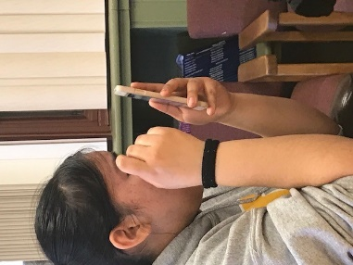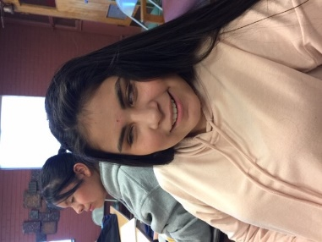
Yesbi, Deya

Extra, Extra! Read All About It! The Colorado Springs Gazette is back. For a time, NFB Newsline® was having difficulty getting the feed from the Gazette newspaper. Our Baltimore team worked closely with the IT mavens at the Gazette. It’s back! And the likelihood is that NFB Newsline will soon be able to carry the weekly Gazette community papers as well. Special thanks to Derek Marlowe at the Gazette.

Colorado School for the Deaf and Blind is Celebrating Its 145th Year. They have certainly had some wonderful dorm mothers over the years. The 2019 graduation takes place on Friday, May 31th. For more info, call the school, 719-578-2100.

Look Ma! No Hands! The Blind Coloradoan wants to hear from you. If you grew up blind, what activities drove your mom crazy? My mom was great with camping, running, jumping, riding bikes, playing hide and seek, football, etc. I was lucky. Some blind kids don’t get that kind of support and independence. I will say that trying to shoot bottle rockets out of an air rifle wasn’t one of her favorites. Can you say, “you’ll shoot your eye out!”

We Have Another Mother. The Blind Parents of Colorado are lucky to have President Nate Trela and his wife Showe Trela. Nate writes, “Here she is ... Suana Nicole Trela. She checked in at 7 pounds, 10 oz, and 19.5 inches. Sounds like she's a cute blend of Showe and me. Can't believe she is here!”
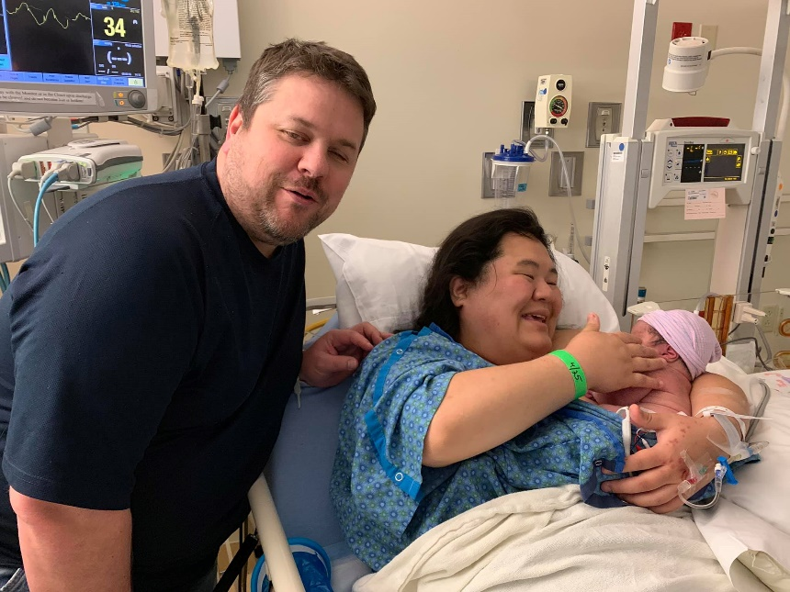

Blind Moms and Dads. This is for You. The Blind Parents Connection Podcast is a Blind Parent Education Initiative supported by the Gibney Family Foundation and brought to you by National Federation of the Blind. We are excited to bring you eleven episodes, so stay tuned for more. Subscribe and listen by searching for "Nation's Blind Podcast" in your podcast client. Listen to Episode 1 of the Blind Parents Connection: Resources.

Did you read this important Notice in Our Last Blog? If so, try reading it again. If Not, try reading it now.
Try It. You Might Like It. In recent years, one of the more successful workshops hosted by the Colorado Center for the Blind has been the NFBCO Sports and Rec Division’s Try It seminars. Colorado is known as a “get out there and do it” state. The rate of obesity among Colorado citizens continues to be the lowest in the nation. Colorado is home to the United States Olympic Training Center. Our Sports and Rec Division encourages the blind of Colorado to “get out there and do it.” You can Try It first on Saturday May 11 from 1 until 4. Try Beep ball, yoga, martial arts, and much more. This seminar is perfect for you. Ages from 2 to 92 are welcome to Try It! Sometimes, blind folks are not as active because we have not been encouraged or shown how to participate in exercise and recreation. This is your opportunity to Try It! Note, Colorado is also home to the United States Association of Blind Athletes, USABA.

Egg-straordinary! May is for Mother’s Day. April was Easter. Here is what Rob Harris, Treasurer of our Grand Valley chapter, says about the Beeping Easter Egg Hunt. “I am reminded to share that the beeping egg hunt was held at Colorado Discover Ability and it was awesome! In attendance were 4 blind and low vision kiddos from ages 1 to 13 searching for the eggs to trade them in for treats of all sorts, mostly candy. Our members baked items, stuffed eggs, setup the location, advertised and put this together in 3 weeks! We hope for another event next year.”

MAKING CONNECTIONS THAT WORK FOR YOU. 3rd Annual Career and College Seminar Wednesday, May 8, 2019. Learn from inspiring speakers. Practice your interviewing skills. Consider your future career. Find out what it takes to be successful in college. Network with other seminar participants! 9:00 to 3:00 p.m. Colorado Center for the Blind 2233 West Shepperd Avenue, Littleton. Lunch is provided but you must register by May 6th. Keynote Speakers are Petr Kucheryavyy and Cody Bair.

Petr works as the Senior Manager for Accessibility with Spectrum Communications. An engaging speaker, Petr was born in the Ukraine and gradually lost his vision even as his family emigrated to the U.S.

Blind since birth, Cody grew up on the eastern plains of Colorado and now lives in Denver. Cody is a Certified Public Accountant and is employed as a Business Tax Services Senior Associate for KPMG LLP. His dedicated pursuit of attaining his dream in a highly-demanding profession will inspire.

Rehab counselors, blind students, and job seekers have all indicated how much they have gained from the two previous events. Register for Making Connections Now!

The Builders. True stories from the history of the Rocky Mountain blind by Peggy Chong, The History Lady. Note, typically, this column features people who are blind from Colorado. However, this is a special May Mother’s Day issue. We are carrying a longer piece from the History Lady to celebrate motherhood.
Happy Spring to my Blind History Lady fans;

May is a month full of so many things to celebrate. This May I want to acknowledge Mother’s Day. This mother is one I have been researching for more than six years. She did not leave a big paper trail. What she did leave is a family who loves her still and are willing to share her story. She was a blind mother who gave all for her family and gave us a song she wrote and published to remember her by.

(From the cover of the sheet music)
Springtime
Words and Music by
Helen Dobbins Brown
Published by
Helen Dobbins Brown
Marshfield, MO
Copywrite 1937
Price 25 cents

Tis Springtime, sweet Springtime there’s joy ev’ry where;
The birds with their war-blings are teeming the air.
The flowers are blooming, in vale and on hill.
While hearts with dreams of rapture thrill.

O Springtime, tis springtime, with in ev’ry heart;
When love is awakened by Cupid’s true dart;
And yielding to kisses and armes that entwine,
Is rapt in ecstasy divine.

When Springtime is faded and summer is gone,
And Autumn has followed, the winter passed on;
Then lonely we linger, and wait but in vain,
For springtime flow’rs and songs again.

This was written by Helen Dobbins-Brown when her youngest was 17 and she was 57.
Helen Elizabeth Dobbins, born in 1880, attended the Iowa College for the Blind and then Oberlin College. She married a sighted man who fell in love with her voice before he even seen her. Sounds like a fairy tale and Helen may have even agreed that in many ways her life was a fairy tale. But, as all good fairy tales, there need to be struggles to overcome before the happy ending. Helen had struggles in spades.

Helen married Eugene Brown, the man who had to find the woman that the beautiful voice belonged to. In nine years, the couple had eight children, Helen being over thirty when her first child was born. For a time, they homesteaded land in South Dakota, living in a sod house. A short stay in Montana and then they moved on. There were no complaints from Helen.

Although the South Dakota prairie had few close neighbors, she kept in touch with family and friends. Her blind school chums had a circulating braille letter. One would start the letter in braille, mail it to the next blind friend on the list who read the letter, wrote one of their own, sent both letters to the next friend on the list. The round robin would come back to the original friend, who read all the rest, took his original letter out, inserted a new one and sent the whole bunch on the way to the next.

Soon the Browns moved near Marshfield Missouri to farm land where they had to once again, build a home, barns and wooden walkways to minimize the mud and farm animal droppings from their shoes. This all took time. Helen cared for her many children, cooked, washed clothes, cared for the chickens, gathered eggs, tended a garden, put up produce for the winter, milked and kept up the house.
A farm wife back then was said not to be employed. REALLY!

Just as their house was almost finished, Eugene passed away in 1926, leaving Helen with eight children to raise. They continued on as they knew Gene would have wanted. Not once did she think of giving up her land or sending any of her children off to live with relatives or become live in help for neighboring farmers as many families with both sighted parents were forced to do as the depression grew in the country. Helen had paid off the land and homestead. They grew their own food and could live modestly and happy.

The depression affected Helen along with her neighbors. Helen re-invented her land to support the family. She built cabins along the road bordering their farm for travelers heading west for a better life. The road now was called route 66. She built a gas station. Inside the station she sold ice cream. During the migration west, Helen and the kids made a comfortable living.

The farm got electricity before the depression, another expense. But it was necessary to operate the radio and hear the news. When the new talking book player came to Missouri, Helen was glad to get hers and enjoy the many books now on record that were not in braille.

The Brown home was filled with music. They had a piano that Helen loved to play and sing along with. The children enjoyed when Mom played. They often sang along with her the old favorites, hymns and popular music. She sang in the choir of her Methodist church.

All of her children finished high school. Several joined the military in the mid 1930’s before the second world war. At least one son made the military his career. Some became nurses, all lived very successful lives, thanks to their mom. Each child loved Mom and appreciated all that she had done for them. When it was time to leave the nest, each knew that Mom wanted them to spread their wings just as the birds in the spring. Helen did not expect any of her children to sacrifice themselves to stay with their “blind” mom.

After the children left the home, Helen remained on the farm for almost two decades by herself. She still grew her garden and canned for the winter. One of her daughters came out once a week on the Greyhound to bring groceries from town. As she grew older, her closest daughter asked Helen to come live with her and her daughter in Springfield. Finally, Helen did move into Springfield with her daughter. She found an organization of other blind persons where she attended monthly meetings. Through the meetings she met good friends who also enjoyed music and would get together to play and sing.

This brief sketch of Helen highlights just the love of family that she had to her parents, her husband, and children. I hope you also get the impression that Helen’s love was an example and lesson that was learned and passed on generation to generation. Although she has been gone more than fifty years, her descendants remember her warmly today.

You can read more of my Books at https://www.smashwords.com.

Still time to join us at NFB National Convention at the Mandalay Bay, Las Vegas, July 7-12.

Dear reader, if you know of a company or an organization that you think would like to be a part of our 6 Dot Dash 5k please put us in touch with them. Sponsorships are still available. Volunteers are more than welcome. There are still a few spaces for exhibitors, and, please encourage everyone to register today for the June 29 event in Littleton!

Hey, Blind CO Fans! We will continue to publish this blog on a regular basis. Typically, each month. But we will also be adding additional content more frequently. Also, our regular monthly Blind Coloradoan issues will begin to contain less text and more links to our blog posts. This will allow you, dear reader, to more easily read the NFBCO news and views you want. So, check out this blog space more frequently. Remember, all of this content can be found on NFB Newsline®.

Submit items to be considered for June Blind Coloradoan Blog by May 25.
Did Not See Your Item in This Issue? Be a contributor! Send announcements, ideas, articles, and observations to either myself or Dan Burke. Enjoy this blog on NFB Newsline or read it at blog spot.
Forward, Always Forward!
“Live the Life You Want.”

