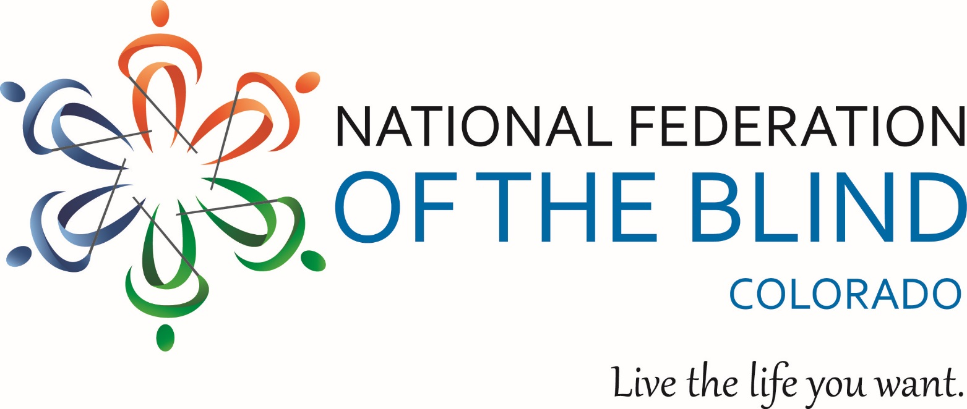

Are you looking for new and better ways to use your iPhone?

Are you a new or longtime user looking for some basic tips and tricks?

If you are a blind or low vision iPhone user who says “Yes,” to these questions,
The National Federation of the Blind Boulder Valley Chapter has
the perfect FREE class for you.

September 7, from Noon to 2:00 pm
Boulder Public Library Main Branch
1001 Arapaho Avenue in the Boulder Creek Room

The first hour will be devoted to new users with one-on-one assistance from more experienced participants.

The second hour will focus on best practices, apps, and preferred accessories.

Have questions or need directions to the class?
Please contact Maryann Migliorelli at 720-284-2318
or email maryannmigs@gmail.com.

