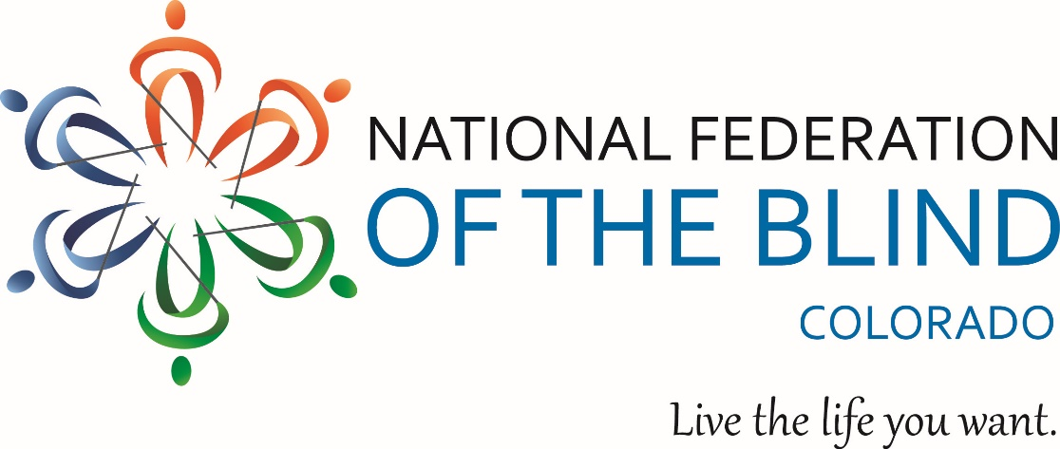

MAKING A DIFFERENCE IN LIVING THE LIVES WE WANT!

THE NATIONAL FEDERATION OF THE BLIND
OF COLORADO
65th ANNUAL STATE CONVENTION
October 31 through November 3
will kick off Thursday evening, October 31 in Fort Collins, Colorado and wrap up Sunday, November 3 by noon.

CONVENTION REGISTRATION BEFORE Friday, October 18:
Registration: $20
Friday & Saturday Lunch: $25 each
Saturday Banquet: $40
CONVENTION REGISTRATION AFTER Friday, October 18:
Registration: $25
Friday & Saturday Lunch: $30 each
Saturday Banquet: $45
Register Now!
Our 2019 convention will be held at the Fort Collins Hilton, nestled in the foothills of the Rocky Mountains at 425 West Prospect Road, Fort Collins, Colorado 80526.
A block of rooms has been reserved for October 30, 2019 - November 3, 2019. The special room rate will be available until September 25th or until the group block is sold-out, whichever comes first. Room rate is $109 per night for singles and double, $119 for triples and $129 for quad per night.
Convention kicks off Thursday evening with our Boot Scoot and Boogie Western Halloween Ball. Pay $5 at the door or show your NFBCO membership coin. Dress in your finest western duds or dress as a favorite character from the old west. Resolutions, General Session, and workshops begin Friday morning. Family fun night and more surprises Friday evening. Saturday features an array of informative activities. Saturday evening Banquet will feature a keynote address from the delightful and motivating Norma Crosby. We guarantee you will love her. A leader in our movement for more than a generation, Norma serves as President of the Texas affiliate. Norma is also member of our National Board of Directors. Of course, there will be childcare. Details on childcare, schedules, and costs coming soon.
See you at the Hilton Fort Collins in October!

