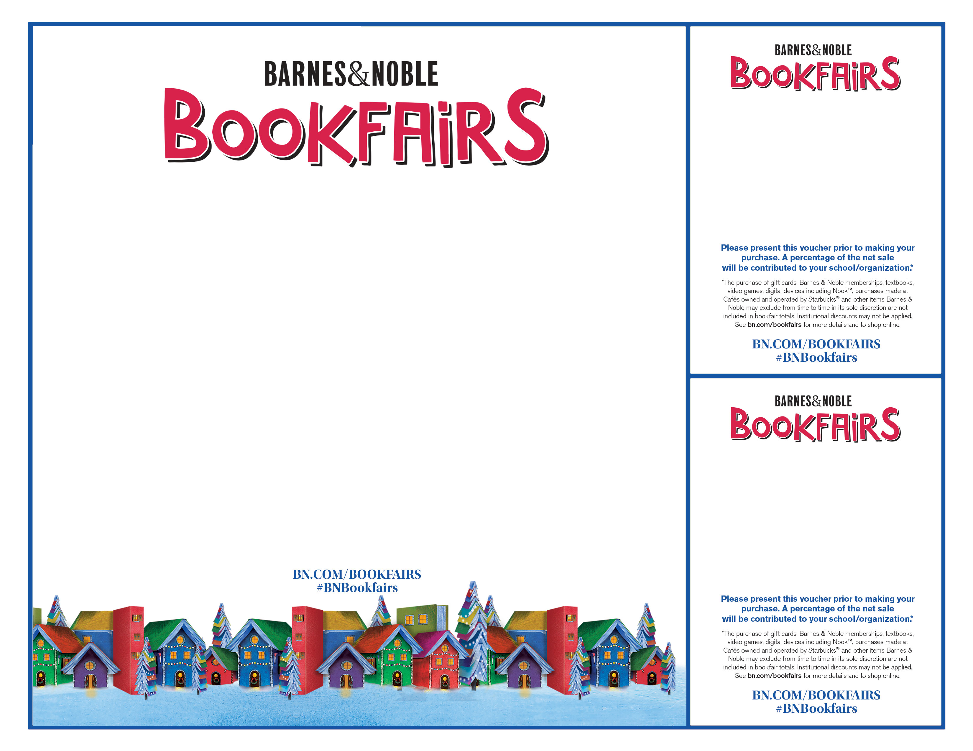\

**National Federation of the Blind of Colorado**

**Grand Valley Chapter  
Tuesday, December 10, 2019, ALL DAY**

**Barnes and Noble in GJ  
2451 Patterson Rd, GJ, CO 81505**

**OUR MISSION**

**“The mission of the National Federation of the Blind is to achieve widespread emotional acceptance and intellectual understanding that the real problem of blindness is not the loss of eyesight but the misconceptions and lack of information which exist. We do this by bringing blind people together to share successes, to support each other in times of failure, and to create imaginative solutions.”**

**The NFB of Colorado, a state affiliate of the national organization, shares this mission and works as a whole and in concert with its state-wide chapters to accomplish it.**

**Voucher is good in person at any BN**

• Learn about Braille literacy and other tactile hands on learning.

• Decode the message in Braille

supporting

**NFBCO Grand Valley Chapter**

**Tues. December 10, 2019**

**Barnes & Noble**

**2451 Patterson Rd. GJ, CO**

**Bookfair ID 12576013**

supporting

**NFBCO Grand Valley Chapter**

**Tues. December 10, 2019**

**Barnes & Noble**

**2451 Patterson Rd. GJ, CO**

**Bookfair ID 12576013**