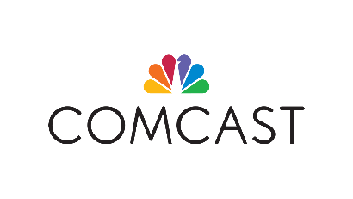
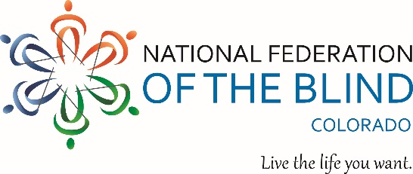

Comcast Uses Storytelling Platforms to Raise Awareness About the Work of National Federation of the Blind Colorado Center During “Meet the Blind” Month
For Immediate Release

Littleton, Colorado (October 5, 2020): In honor of “Meet the Blind” month, which begins October 1, Comcast is launching a public service announcement campaign to help tell the story of the National Federation of the Blind Colorado Center (NFBCO). The Center, based in Littleton, has been providing training, expertise, and inspiration to the blind of all ages and their families since 1987. For the last two years, the organization held the NFBCO Comcast 6 Dot Dash 5k to raise funds and awareness to support Braille literacy and blindness skills training, scholarships for deserving blind students, summer camps for blind children, and more. Comcast has proudly sponsored the event and many Comcast employees have run with the blind in the race.

This year, the NFBCO Comcast 6 Dot Dash 5k will take place virtually. Over a five-week period, participants can run, walk, or roll anywhere and everywhere and track their process from coast to coast online.

According to Scott LaBarre, President of the National Federation of the Blind of Colorado, “Comcast has contributed financial support and people power to the work we do. This year, they have added their special brand of media and messaging. We know that Blindness is not the characteristic that defines us or our future. All too often, low expectations keep blind people from achieving equal participation in society. The Comcast team recognizes that and is helping to tell our real story.”

“As a company uniquely positioned to educate, entertain, and empower, Comcast is committed to bringing together diverse communities and inspiring our customers, audiences, and employees to make a positive impact,” said Mary Spillane, Director of Community Impact for the Mountain West Region. “As we all work together to navigate these new and uncertain times, we remain focused on the importance of inclusivity and creating a better experience for everyone.”

To learn more and to register for the NFBCO Comcast 6 Dot Dash visit, http://6dotdashco.com.

# # #

About the National Federation of the Blind of Colorado
The National Federation of the Blind of Colorado is the oldest and largest organization of blind Coloradans. The National Federation of the Blind knows that blindness is not the characteristic that defines you or your future. Every day we raise the expectations of blind people because low expectations create obstacles between blind people and our dreams. You can live the life you want; blindness is not what holds you back.

About Comcast Corporation:
Comcast Corporation (Nasdaq: CMCSA) is a global media and technology company with three primary businesses: Comcast Cable, NBCUniversal, and Sky. Comcast Cable is one of the United States’ largest high-speed internet, video, and phone providers to residential customers under the Xfinity brand, and also provides these services to businesses. It also provides wireless and security and automation services to residential customers under the Xfinity brand. NBCUniversal is global and operates news, entertainment and sports cable networks, the NBC and Telemundo broadcast networks, television production operations, television station groups, Universal Pictures, and Universal Parks and Resorts. Sky is one of Europe's leading media and entertainment companies, connecting customers to a broad range of video content through its pay television services. It also provides communications services, including residential high-speed internet, phone, and wireless services. Sky operates the Sky News broadcast network and sports and entertainment networks, produces original content, and has exclusive content rights. Visit www.comcastcorporation.com for more information.

CONTACT
Kevan Worley
Manager, National Federation of the Blind of Colorado Project Literacy
Kevan@nfbco.org
303-929-2369

Alison Busse
Manager, External Communications, Comcast Mountain West Region
Alison_Busse@Comcast.Com
720-448-3912

