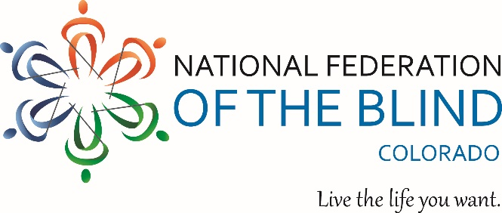

National Federation of the Blind of Colorado Organization of Parents of Blind Children Celebrates Learning Box Program Early Success!
Seeks More Families to Participate.
Our first Learning Box activity was a huge success! Nine students from the ages of 2-14 participated in two interactive lessons. Each student received a magnetic white board with geometrical shapes in a variety of sizes, colors, and textures. The lesson included an educational component where students identified shapes and their attributes, discussed concepts of geometry, worked with patterns, matching, sorting, and more.

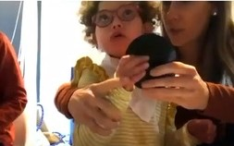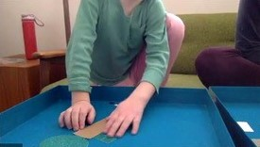
Your first learning box activity lesson is on us! Subscription Prices and Options:
$25 month to month subscription
$125 for a 6-month subscription
$250 for a 12-month subscription
Note: Scholarships are available. We don’t want any family left out!

We will continue to have learning boxes on the fourth Sunday of each month for students. Here is a tentative list of upcoming Learning Box activities:
February: Math (Cooking, measuring, marking home appliances)
March: Science (Fun experiments)
April: Literacy (Create your own story)
May: Science (exploring plant life)

To join in the fun for our February learning box activity contact us at: coloradoparentsofblindchildren@gmail.com

Any donations are greatly appreciated.
We are indebted to the American Action Fund for Blind Children and Adults and the Colorado Center for the Blind for their vast knowledge, inspiration, and support for our emerging dynamic education initiatives.

Sincerely,
Amira Lucas-President, Colorado Organization Parents of Blind Children, a proud division of NFBCO.
Michelle Chacon-Teacher of blind students; and chairperson, NFBCO Children’s Education Initiative.
Martin Becerra-Miranda-Director of Youth Services, Colorado Center for the Blind

