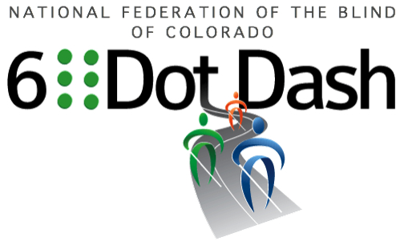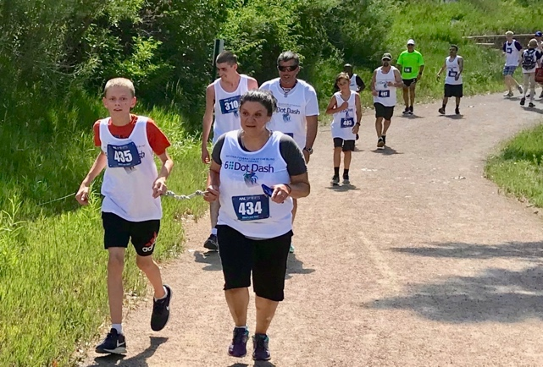

#ComeRunWithUs September 18, 2021 at 8:30 AM
Colorado Center for the Blind
2233 W. Shepperd Ave, Littleton, CO 80120
Join the National Federation of the Blind of Colorado and the Colorado Center for the Blind for 5K run/walk event to raise awareness and funds for Braille Literacy. For more information visit us online at www.6dotdashco.com

THIS EVENT OFFERS FUN FOR THE WHOLE FAMILY!
T-shirts Finishers Medal Fun Race Expo 5K Inflatable Slide
Food Truck Shaved Ice Drawings and Giveaways Puppy Booth
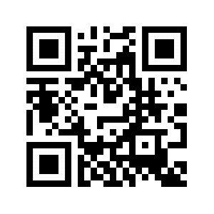
Join Our Facebook Group – Colorado 6 Dot Dash
Sign Up Today www.6dotdashco.com/registration
FREE REGISTRATION FOR ALL PARTICIPANTS WHO FUNDRAISE $100

