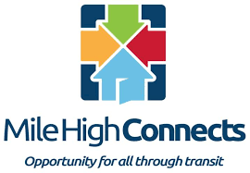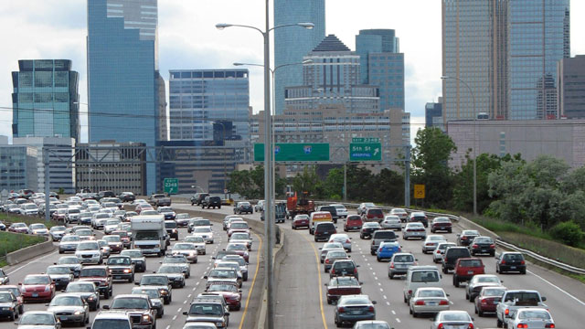

**When:**

Tuesday, July 27th

6:30-8:30 pm

**You’re invited to a community conversation**

**FOOD AND DRINK WILL BE PROVIDED!**

**Electric Vehicle Development,**

**Your Community, & You**

Want to join the conversation by Zoom?

Scan this QR code at the start of the event! 🡪

**Location:**

Girls Incorporated of Metro Denver,

1499 Julian St.

Denver, 80204

*This event is hosted by 🡪*

* **State legislators**
* **Denver transportation experts**
* **Electric vehicle specialists**

**Come to this event to share your thoughts with:**

We need to know what this change means to you. What are your hopes, concerns, and questions?

As we become a greener Denver, electric vehicles will have more impact on our lives.