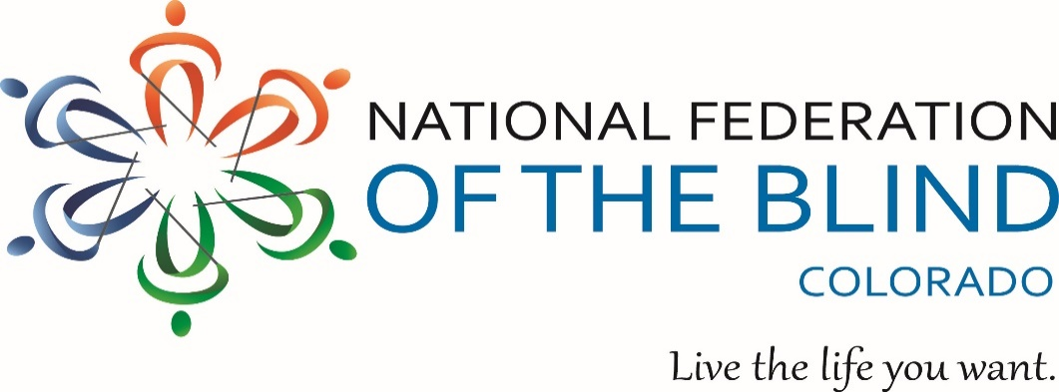

Blind Coloradoan Blog August 1, 2021

Writer, Aggregator: Kevan Worley.   
Contributors: Dan Burke & Erin Daley

Here is what you need to know-

Two of the National Federation of The Blind of Colorado annual signature events are happening this fall.

First, our NFBCO 6 Dot Dash is on Saturday, September 18. Our NFBCO State Convention will occur in person with some virtual elements on October 28, 29 & 30. Make plans now to participate. Ready! Set! Go!

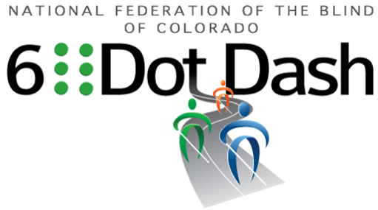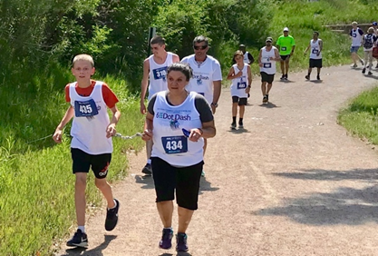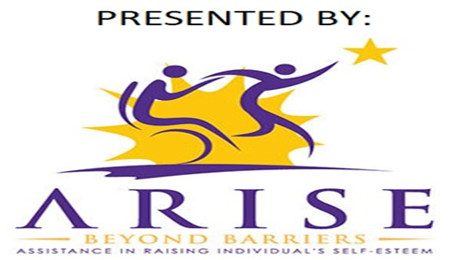

#ComeRunWithUs September 18, 2021, at 8:30 AM

Colorado Center for the Blind

2233 W. Shepperd Ave, Littleton, CO 80120

Join the National Federation of the Blind of Colorado and the Colorado Center for the Blind for a 5K run/walk event to raise awareness and funds for Braille Literacy. For more information visit us online at www.6dotdashco.com

THIS EVENT OFFERS FUN FOR THE WHOLE FAMILY!

T-shirts Finishers Medal Fun Race Expo 5K Inflatable Slide

Food Truck Shaved Ice Drawings and Giveaways Puppy Booth

Join Our Facebook Group – Colorado 6 Dot Dash

Sign Up Today <http://www.6dotdashco.com/registration>

FREE REGISTRATION FOR ALL PARTICIPANTS WHO FUNDRAISE $100

# **Presidential Reflections**

## By Scott C. LaBarre

As I write this on Thursday, July 29, 2021, a mere 93 days separate us from the beginning of our 67th Annual State Convention. Every state convention is, of course, special in its own way, but for me, the coming annual gathering of our Colorado federation family will be quite notable.

As those who were attending our 2021 Virtual National Convention know, I announced to the nation that I would not be seeking another term as President of the NFB of Colorado and that I was supporting the candidacy of our current First Vice President, Jessica Beecham. This should not have come as much of a shock to the Colorado Affiliate because we have been discussing our transition plans for a few years now. However, as soon as I got done announcing the NFB of Colorado during the Roll Call of States, my phone started blowing up with text messages registering shock and some inquiring whether my health was ok. Later, I received a number of phone calls where several individuals asked me why I was stepping aside so early and so young. All of these inquiries brought a smile to my face, and I did my best to convince the concerned that everything was healthy with me and with our affiliate.

We are transitioning the Presidency precisely because we are strong and healthy. Sure, the truth is that I am only fifty-three years young, and I certainly could contemplate trying to stay in the office for another twenty years or so, but I firmly believe that would be the wrong thing to do.

When I hand over the gavel, I will have completed sixteen years as your President. It has been my greatest honor and privilege to serve all of you in this role. Our affiliate continues to grow, and we continue to accomplish great achievements that few other affiliates can match. The reason why we are so remarkable is all of you. We have enormous talent in our affiliate and a tremendous level of commitment. This has been so from the beginning due to the strong and loving leadership of Ray and Diane McGeorge and all the succeeding leaders who they brought along, including yours truly.

By electing Jessica, we will continue the tradition of engaging younger talent and allow new leaders to drive our affiliate to even greater heights. In Jessica, we have someone who is bright, talented, innovative, passionate, and the right leader for the 21st century. She will undoubtedly lead this affiliate in a different way and bring to the table new ideas and initiatives. Like Diane before me, I may, at times, question whether the young, brash new leader has lost her mind and wonder whether she is driving us off a cliff. One thing that I will never question, though, is her unyielding commitment to building the Federation to a stronger and better place because the blind of our state, of our nation deserve nothing less. Our successes thus far have been substantial, but our work is far from over. Until we reach a day when our blindness is not regarded as a substantial loss or tragedy but rather simply a different way of experiencing the human condition, our mission is not complete.

As for me, I’m certainly not going anywhere and plan to be just as involved as I have ever been. I also plan on committing significant time supporting our Colorado Center for the Blind through my leadership on that Board. As you also know, I aim to continue expanding my leadership in the American Bar Association, and who knows, maybe I will look into serving our community and nation as a judge of some sort. As I said before, I’m still young and have decades of good years ahead, years that I do not plan on wasting.

For whatever reasons only known to the Greater Universe, October has been a highly impactful month in my life. On October 18, 1978, I became blind, something that obviously and radically altered the course of my life. It is in October, October 4, 2002, to be exact, when our first child, Alexander, was born. It was in October of 2005 when I became your President, and it will be in October of 2021 when we transition our Presidency to the next generation.

# **National Convention Personal Recollection**

## From the Aggregator:

*Over the next few blogs, we will be posting some National Convention memories if you would like to share, you can post or send memories to us. Here’s one from member, radio personality, and job seeker David Dunphy.*

I very much enjoyed my convention experience, even though it sadly was not in person again. I was especially struck by the awesome musical talent featured at the One Voice, Stronger Together concert held by the Performing Arts Division. Their audio description panel was awesome. In addition, as someone who is an active job seeker, I was very happy with my networking opportunities at the career fair, especially with the contact I made at Wells Fargo. Lastly, I'm eager to see what happens with the new NFB Direct Access to help job seekers determine what skills they have to find the most appropriate jobs in what is already a challenging venture.

# **Important Announcement for Blind Parents and Parents of Blind Children.**

Calling all parents. Calling all kiddos. Calling all families. The Colorado Association of Blind Parents is sponsoring a big doins’ this Sunday, August 1 from 2 until 4 PM. And when we say big, we mean, well, big! One of the best ways to exchange tips and tricks about parenting from the perspective of a blind person is by getting together and socializing with other families. This is also true if you happen to be a parent of a blind child. So, bring the family. The kids will be able to check out a firetruck and other cool stuff. There will be snow cones, refreshments, and fun. If you have questions please contact Maureen Nietfeld at [maureenbassmaster@gmail.com](mailto:maureenbassmaster@gmail.com). Maureen is the President of our Colorado Association of Blind Parents. Have Fun!

# **Resolute in our Convictions**

## From the Aggregator:

Most readers of this blog know that at National and State Conventions, we consider the policies that will guide our work in the months and years to come. Each of these important policy declarations come from the grassroots. We encourage you to read the resolutions recently passed by The National Federation of the Blind membership assembled virtually at our 2021 National Convention. Over the years at the State and National level, we have been able to pass laws, influence policy and create partnerships with industries and nonprofits doing work with the blind because of the resolutions brought by members and passed at National and State Conventions. We encourage you to think about the challenges and possibilities to be found in the work we have to do next. If you have a policy idea that you would like to bring to the State Convention to be held in late October at the Denver South Marriot, Lone Tree, please bring them to the attention of the State Board. It's not too early to start drafting. Here is the link to the 2021 National Conventions resolutions:

[https://nfb.org/resources/speeches-and-reports/resolutions/2021-resolutions#](https://nfb.org/resources/speeches-and-reports/resolutions/2021-resolutions)

# **Join the Club by Erin Daley**

## From the Aggregator:

*“I refuse to join any club that would have me as a member” The great comedian Groucho Marx.*

*In recent months, like many of you. I have received invites to a new social networking app called Clubhouse. Our great friend and contributing editor Erin Daley submitted the following article.*

Every few months it seems that a new “it” app hits the scene. Usually, for the blind, a new app just means a new fight for accessibility and equal access. This is compounded by the highly visual nature of these applications, some big ones being Instagram and Snapchat.

It was very interesting to me, then, when I kept seeing posts and comments about this new app called “Clubhouse.” I was told it was an audio-only chat app and, I will admit, I completely forgot about it. I was in chat rooms on AOL - I was over that. However, because the app was still in beta testing, there were waitlists to join and you needed an invitation. Since I like being part of an elite group, I accepted an invitation and joined. I’ve been on Clubhouse just about every day since, and that includes during my trip to Turkey.

When you join Clubhouse, you select your interests, select a profile picture, and fill out your bio. Then you enter your hallway - populated by rooms the app thinks that you will like based on your interests or rooms where people you follow are in. That’s how the app works best - follow people who you like or connect with, and see and join the rooms they are in. Follow more people and find more rooms!

Clubhouse is now open to the public - no invitation necessary - and I have to say, it has changed my life and I cannot recommend it enough. Clubhouse, like any other social platform, can be used for fun or for business and networking.

For fun, I go into travel rooms and have joined a group of people who have become like family to me. I have met some of them and about 40 of us will be meeting up in Chicago soon! There are game shows and competitions and rooms on everything - from an FBI negotiator sharing stories and tips to a club that is based on packing dishwashers - seriously! From a more professional aspect, Clubhouse is an excellent place to network. Rooms on how to monetize Instagram and YouTube are everywhere for content creators and there are rooms where Hollywood producers listen to pitches, others where writers brainstorm, and even more where other businesses and companies hold sponsored rooms.

But is it accessible? As with everything, it’s complicated. Because the app was in beta for so long, they did have ample opportunity to tweak and improve. The founders worked with various disability groups to improve accessibility and, as a concept, it’s a more even playing field as a primarily audio app. As with everything, there are some quirks to get used to, and the app has its own lingo. New features, such as in-app messaging, are rolled out and often require even more updates to fix. However, this app has opened many doors and connecting people locally and around the world at a time in our society when human contact has become hard to come by.