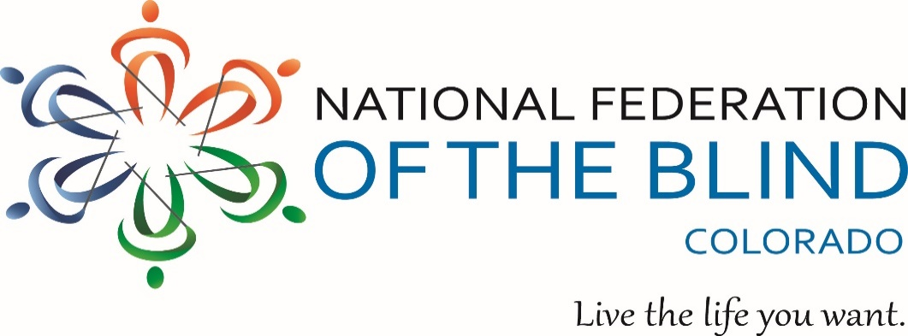
Blind Coloradoan Blog
September 1, 2021
Writer, Aggregator: Kevan Worley.
Contributors: Dan Burke & Erin Daley
Here is what you need to know-

From the President’s Virtual Desk
I want to thank Kevan and his team for another outstanding Blind Coloradan which I’ve had the opportunity to preview before writing this piece!! I just wanted to add this quick note to this issue for the purpose of expressing a few thoughts about State Convention. We have shared the Convention registration and hotel reservations logistics elsewhere in this Blind Coloradan, and I urge you to register and make your hotel reservations as soon as you can.
As the Delta Variant of the COVID-19 Pandemic rages across our country and the world, many have asked me if our Convention will be going entirely virtual. As of this writing which I am scribing on September 1st, we have not altered our plan to conduct a hybrid convention. Events will start on October 28th at the Denver Marriott South, and we will be putting out as much of the Convention content as practical onto the Zoom platform including major meetings like Resolutions, all general sessions, and the Banquet as well as other selected breakout sessions. We request that even virtual participants register for the Convention so that you can be eligible for door prizes and, if you are a current dues paying member, the ability to vote. The registration fees will also help us defray the considerable internet expense we will be incurring at the hotel. Unfortunately, they don’t give access to the Internet away for free.
The detailed agenda for the Convention will come out in early October, but I want to share a few highlights. As we have indicated elsewhere, we are delighted to announce that President Riccobono will be serving as our National Representative. On Thursday October 28th, we plan on conducting some seminars in the afternoon focusing on personal empowerment from education to employment to personal safety and more. Thursday evening will feature our Opening Ceremonies followed by a fun filled, festive, and competitive Trivia Night with socializing galore. Friday will offer the Resolutions Committee; opening of the Exhibit Hall including an Hour of Power where our exhibitors will tell you about their goods and services; the beginning of our General Sessions including a special Scholarship Luncheon; the conducting of several substantive, breakout sessions; and the holding of several exciting social events in the evening including all kinds of adaptive games pitting Federationists against each other in friendly competition and the offering of interactive arts and crafts. Saturday comes with more General Sessions, breakout meetings, and our Annual Banquet. Sunday closes the Convention with our Federation Family breakfast including chapter reports and highlights and it is also when we will conduct our Business Session where we will consider and adopt our resolutions, consider important reports like our financials, and elect our officers and members of our Board.
As I discussed in the last Blind Coloradan, this Convention will be special in that we are affecting a major transition of leadership. After October 31st, I will no longer be your President, and I fully expect that we will elect Jessica Beecham our next President. We will spend some time at the Convention marking this important transition and celebrating it as well. All in all, I believe we will have a tremendous State Convention, and I hope you will join us either at the Marriott or in the Zoomisphere. Don’t miss it!!

Colorado Center for the Blind Update
This summer CCB resumed its outdoor challenge recreation activities, the first since skiing was cancelled at the beginning of March 2020. We took two groups whitewater rafting on Clear Creek near Idaho Springs to get things started with a splash. (No, nobody fell out of their raft!) And last week, we started rock climbing again with a new group, the Denver Climbing Co.
During morning announcements on Tuesday, August 31, student Amanda Juetten called for recognition and announced that she had someone on the phone.
“I’m safe and sound,” we heard a voice say from her iPhone’s speaker. Cheers broke out, along with cries of “Thank you for your service.” The voice was Amanda’s son Lorenzo, a U.S. Marine Corporal just back in Kuwait after participating in the mission to protect the Kabul Airport during the evacuation. He was one of more than 5,000 Marines deployed in that mission. We all had been worrying along with Amanda since Lorenzo’s deployment and felt relief and gratitude for his service and the safe return of Lorenzo and for his fellow Marines, and all send our love, thoughts, and prayers to the grieving families of the 13 Marines who gave their lives on that difficult mission.
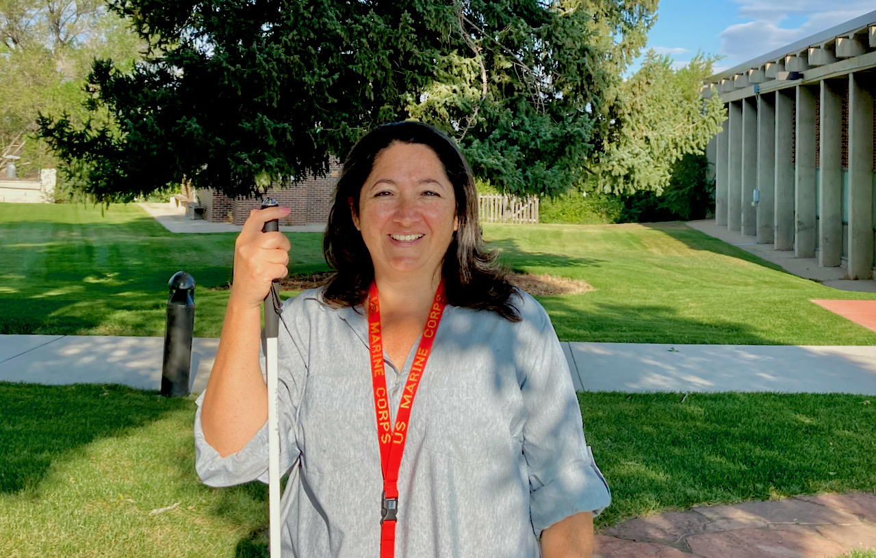

Ready! Set! Go!
Register now for the 4th Annual NFBCO 6 Dot Dash! Saturday morning September 18, at Colorado Center For The Blind, Littleton Colorado. Register for in person event or join the action virtually. Please support our literacy programs. Walk or run with us in person or through your own neighborhood, the treadmill or jog in place. Doesn’t matter how you do it. Just do it! There will be finishing medals, t-shirts, and a feeling of accomplishment. Bring your family for a day of fun and games. We will feature a beer tasting in partnership with our friends at Brewability. Tours of The Colorado Center for the Blind will be provided. As in the past. There will be a number of exhibits, items for sale, and a puppy raisers kissing booth sponsored by Guiding Eyes Puppy Raisers.
This is our annual signature fundraiser and we all know of the important work these organizations do for all of our blind students and their families. Those who raise $100 in donations may participate in the race at no cost. What a deal!
We want to thank all of our sponsors. This year we thank our title sponsor Arise Beyond Barriers. If you have questions you may email assistance@nfbco.org. You may also reach out to Jessica Beecham jbbeecham@gmail.com. Register now you will be glad you did. http://6dotdashco.com/

Breaking News!
We are more than excited to announce that the President of The National Federation Of The Blind Marc Riccobono will be attending our upcoming state convention. You read it here first! It’s a Blind Coloradan exclusive.
67th ANNUAL STATE CONVENTION
October 28 through October 31
The 67th Annual State Convention kicks off Thursday October 28 with a variety of seminars and initial socializing. The programming will continue all weekend long with exhibitors, informative and inspiring presentations during general sessions, additional breakout seminars including meetings of our several special interest divisions, interactive and exciting social events, and much more! Join the largest gathering of blind people in Colorado to make a difference in the lives of the blind across the state!
We will hold a hybrid convention starting Thursday, October 28. The main sessions for exhibitors will be on Friday, October 29 with other opportunities sprinkled throughout the weekend. Virtual participants must register and pay the $20 registration fee to be eligible for door prizes.
Please note that the Convention is still being planned and not all sessions are finalized. Stay tuned for a full Convention Agenda slated to be released in early October.
THE NFBCO CONVENTION HOTEL: Our 2021 convention will be held at the Marriott Denver South at Park Meadows located at 10345 Park Meadows Dr., Lone Tree, CO 80124. Just off the Lincoln light rail stop (E Line), the Denver Marriott South at Park Meadows offers convenience, the beauty of Denver, exciting entertainment options of the Park Meadows Mall, and the comfort that has become synonymous with the Marriott Brand. When you add in over 300 of your favorite blind friends you have one FANTASTIC NFBCO convention!
HOTEL ROOM RATES: The NFBCO room rate is $104 a night. There is no limit on room occupancy. Reservations MUST be made by Friday, October 8.
To reserve your room, call the hotel at 303-925-0004. You will need to press 1 for reservations which will take you to the Marriott 1-800 number call center. You must mention that you are with the National Federation of the Blind of Colorado. If they cannot find our block under our full name, try asking for NFB. If this still doesn’t work please contact Lisa Bonderson at 303-504-5979. You may also use the following link to make a reservation:
click here to make a reservation
Convention registration has gone live, and you can register using the following link.
Registration for NFBCO Convention | NFBCO
Pre-registration fees: BEFORE October 15
$20 registration
$0.00 Thursday reception
$25 Friday luncheon
$25 Saturday luncheon
$40 Saturday banquet
$0.00 Sunday breakfast
Total: $110.00
Registration fees: AFTER October 15
$25 registration
$0.00 Thursday reception
$30 Friday luncheon
$30 Saturday luncheon
$45 Saturday banquet
$0.00 Sunday breakfast
Total: $130.00. You save $20 by pre-registering.
Stay tuned to your email and check our web site at www.nfbco.org for more information about convention registration. OR Contact Lisa Bonderson at lkb@labarrelaw.com.
FOR MORE CONVENTION INFORMATION CONTACT:
Scott C. LaBarre, President
Phone: (303) 504-5979
slabarre@labarrelaw.com

Memorializing 9-11

From the Aggregator
We dedicate this issue of our Blind Coloradoan Blog to the memory of those thousands who lost their lives, endured great injury, or worked tirelessly to bring relief and healing during and in the aftermath of the horrific 9-11 attack on our nation. Blind or non-blind, all of our lives were changed on that day. It's been 20 years and we remember. We remember and honor the sacrifice of so many.
Colorado Center For The Blind board member Mike Hingson was one of the thousands fighting through the smoke and thunder of the explosions. Perhaps you have read Mike's account of that day. He and his guide dog escaped with hundreds streaming down from the highest floors of The World Trade Center. His book Thunder Dog is Mike's account of his harrowing escape. The book is available on Amazon or on Bard. It also makes a good gift. The book offers a perspective on this American tragedy, guide dogs, and a positive philosophy of blindness.
Another story, I had not known about was of a second blind man and his guide dog who also escaped from the World Trade Center on that terrible day. It was brought to my attention by the blind history lady Peggy Chong. We will post that account later in this blog. As we gather for chapter meetings, our annual 6dotdash event, and all of our ongoing NFBCO activities, I know we will keep all of our American heroes in our thoughts and prayers. With all of the social and political strife our country is now struggling with, there is an organization for blind people and our families to come together as a big family regardless of all other characteristics. In The National Federation Of The Blind, we say together with love, hope, and determination. We transform dreams into reality. The American dream is still alive. The dream of blind Americans to live the lives we want with true equality, security and opportunity remains our guiding principle. Love to you all.

Personal Empowerment Starts from Within

By Julia Zanon
From the aggregator: Many of you have offered glowing comments about this series of articles by NFBCO Mile High Chapter member Julia Zanon. Many of you also know Brenda Mosby as one of our activist and through her work as an employment specialist at our Colorado Center For The Blind. We think you will enjoy this profile.
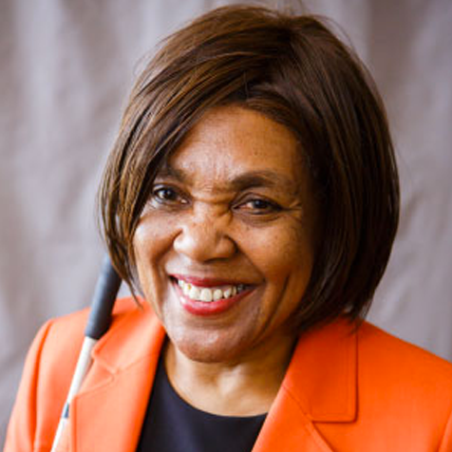
As we explore employment experiences and the many ways people have found their careers, it is crucial to note that being able to work and have a job contains its own intrinsic value. Whether one is the family caregiver, providing volunteer services or employed and earning a wage, people need to feel valued, productive and respected and having an occupation is key.
Having the knowledge, confidence, means, or ability to do things or make decisions for oneself is one of the many definitions for empowerment. Having a job can bring a sense of empowerment. Overcoming difficulties, barriers and negative attitudes also creates empowerment.
A career supporting others and watching them find their inner power is what excites Brenda Mosby. Brenda has been self-employed as the owner of Mosby Employment Services, LLC for over 20 years. She has created a powerful program called Personal Empowerment through Emotional Intelligence which takes individuals through a process to change negative thoughts and beliefs that hinder them into positive beliefs that help them grow into a positive and happier person.
Brenda, who became blind at the age of 40, was able to overcome her own barriers and negative beliefs and learned the blindness independence skills needed to be successful. She received assistance from the Colorado Division of Vocational Rehabilitation to acquire her skills and academic training. Combining her own experiences with education and a master's degree in counseling, Brenda discovered that self-employment was the best fit for her. Brenda also realized how paramount it is that she first looked inward to clarify her own talents and goals before coaching others toward success.
When asked how her current job compares with what she wanted to do in high school, Brenda responded, " It isn’t even close. I was sighted and knew nothing about the community of people with disabilities. Actually, I did not have an employment goal coming out of high school."
Brenda lives in Denver and is excited about getting married this year. What is her dream for her future? She imagines herself living in a small village in Spain off of the Mediterranean Sea.
And, finally, what does Brenda say about what makes NFBCO so great? "The NFB is a role model for the blind and other groups who are marginalized."

Member of NFB Performing Arts Division brings her viola magic to the stage on Sunday November 14, 2021, 7-9pm, University Park United Methodist Church
From the aggregator:
We were delighted to see this announcement on our Colorado Talk email list serv. We have heard of the beautiful music played by National Federation Of The Blind 2021 scholarship winner, Christina Ebersohl. We hope you will join us for a special night of music. Tickets are available now. Here’s what Christina says about the concert.
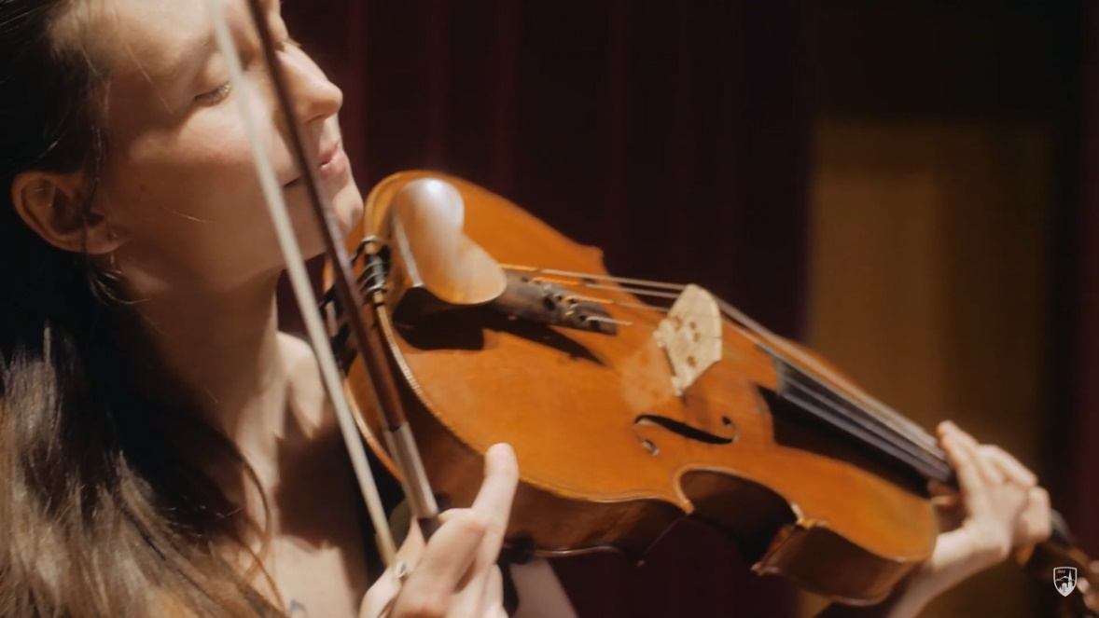
Join violist Christina Ebersohl for a Fall charity concert extravaganza with pianist Beth Nielsen!
In addition to an evening of stunning music, join in to win raffle baskets, bid on silent auction items, and treat yourself to a complimentary reception.
Here is a sneak peek at what the raffle tickets may win you:
THE DENVER EATS BASKET: full of local eateries and coffee shop goodies and gift cards
THE DU YOU BASKET: full of DU swag, concert tickets, and signed CD's from some of the stellar musician faculty
THE COFFEE CURRICULUM BASKET: full of fresh beans from local roasters, coffee mugs, and flavored treats to add to your morning joe
THE PASS-GO-GRANDMA BASKET: fun games for the family, snacks, and all things needed to make family game night a blast
...and much MORE!
All proceeds will go to the National Federation of the Blind Performing Arts Division.
This concert will be in-person and live-streamed, with options to donate or bid for both audiences!
Tickets are now live! Find out more information at https://www.christinaebersohl.com/events/2021/11/14/viola-visions
https://youtu.be/Z3_y72pKKFY

A new chapter begins by Silvia Vigil

From the Aggregator
Sylvia Vigil has become a frequent contributor to this blog. Many of us have enjoyed her recipes as well as her articles that detailed her journey. One of the priorities of importance to the National Federation Of the Blind and our Colorado Center For The Blind is employment. We spend a good deal of time on the challenges faced by people who are blind who are seeking a job. No one exemplifies hard work, courage, and creativity in pursuit of employment like CCB Graduate Silvia Vigil. Sylvia exemplifies the hard work, courage and creativity necessary to secure employment. She grew up in Walsenburg, Colorado. We could have titled this article Small town girl makes it big in the big city. Here is what Sylvia says.
A New Chapter Begins:
Written By: Sylvia Vigil
I was a little blind girl in a little town. I went to school of course. Even attended Blind School at CSDB for a few years. Then a few years ago I made the decision to attend the Colorado Center For The Blind in 2019. I started my training on June 24 2019. After months of training I was about to graduate. I had three weeks to go. But my graduation was postponed for quite a few months due to COVID! Not to mention I had just learned how to travel here, and there by myself, and we got hit with the stay at home order due to COVID. I needed something to keep me busy so I joined Mary Kay, and became an independent Beauty Consultant and started my journey with Mary Kay.
I met Patty at an arts and crafts fair at the center. I had bought some things from her for Christmas gifts. She asked me if I would love to do a facial. So she came to my apartment, and gave me a good facial. And of course we talked about things.
I decided to join Mary Kay. I like working my business, but it has its ups, and downs. But I still stick with it. I am trying to get active again. It is not easy. But I’m going to try my best!
In February 2021 I joined Tupperware to see if I could do better in that. I haven’t done much there, because they switched to a new system, and everyone has to learn how it works. So far I’ve been studying how-to videos. But I believe once I get going I will be fine.
During the pandemic I stayed home, did chores around the apartment, and ran my business. After waiting for 5 months to go back to the center to finish my training I finally graduated from the center.
During the time I had with a very slow business, and the new system I was applying for different jobs here, and there. One job in particular was a job at Texas Roadhouse. I had applied for a hostess job in Sheridan. I hadn’t heard from them for a while! Then a month later, like out of the blue I get an email from Texas Roadhouse. It was an invitation to a hiring event in Northfield. I wasn’t too sure about attending because it was far away. But somehow Davina convinced me to go. So I scheduled my interview, and printed 3 copies of my resume to take with me.
The day of my interview I took with me my resume, and some questions for asking at the interview. I was interviewed by 3 different people. I showed them my resume, and they had me do some scenarios. And I also got to ask my questions. They really liked my resume, and the answers I gave for the scenarios. Not to mention the fact I asked questions of my own.
So after all of that interviewing the head manager didn’t think the hostess position would be a good fit for me, but he did offer me a job. I told him well it may not be the job I wanted, or applied for, but it’s a job so I’ll take it.
I went to orientation, and learned about the company rules and policies. Not to mention the benefits. And I was given two work shirts, and my work schedule. I started working Monday June 7, 2021. So as of June of this year I became a Roadie.
So I guess you can say I have 3 work titles. They are as follows.. Mary Kay Consultant, Tupperware Lady, and Roadie. And just recently I became a student at Penn Foster online college studying Event Planning. I can’t wait to see what will happen next!

Colorado Springs Chapter highlights Presidential release
As you know, In recent times President Riccobono has been offering his monthly presidential release live. Typically on the first of each month at 6pm mountain time. Following the live release a recorded version is available at NFB.org. The Springs Chapter meeting now features a Presidential release contest. At the beginning of the meeting, members can win prizes by answering questions from information heard on the release. Great idea Springs Chapter!

From the aggregator: as mentioned above this issue memorializes those we lost on 911. We also celebrate our blind American heroes. Here is what we received from Peggy Chong, The Blind History Lady.

The Denver Post
Sunday, October 7, 2001
Sounds, smells conveyed terror
Blind survivor fled WTC tower
By Winnie Hu
The New York Times
NEW YORK – While much of the world will never forget the images of destruction, Omar E. Rivera will never forget its violent, terrifying sounds. Even in quiet moments, Rivera, who is blind, still hears the explosive boom of a hijacked plane smashing into 1 World Trade Center.
He still hears the crying, the screaming, and the desperate praying of men and women inching down flights of stairs through chunks of debris and pools of water.
And he still hears the crackling of walls and floors buckling and then falling apart.
He heard everything that day, but saw nothing.
Guided down stairs Rivera, 43, and his yellow Labrador retriever, Salty, escaped unharmed with many of his co-workers from the 71st-floor office of the Port Authority of New York and New Jersey. A senior systems designer, he was sitting at his desk when the first of two hijacked planes hit the World Trade Center on Sept. 11.
“It was very big, very strong, very violent,” Rivera said.
He struggled to find more words to describe the impact, and then simply formed a fist with his left hand and smacked the palm of his right hand. “It was like something exploded,” he said, then added, “It is difficult to describe sounds with words.”
Afterward, River said, he heard the rustling of scattered papers, the crunching of broken glass and the thud of his computer sliding off his desk. He also heard the panicked screams of co-workers.
He quickly said his own prayers, and then called Salty to guide him through the commotion. “He was very nervous,” Rivera said. “But he didn’t run away.”
With one hand on Salty’s harness and the other on a friend’s arm, Rivera descended into an unknown world filled with acrid smoke and the sickening smell of jet fuel. He said Salty refused to leave his side, even when another co-worker tried to take the dog’s leash. Together, they kept pushing forward.
Rivera, who lost his sight to glaucoma 14 years ago, said he was able to focus on getting out because he did not have to see the destruction everywhere.
“Not being able to see also allowed me to concentrate on asking God to please allow me to go back and hug my family,” he said.
An hour and 15 minutes later, Rivera and Salty came out on the ground floor. Salty was exhausted, Rivera said, but they both kept walking. Then they started running. He could hear the crackling sounds, louder now, echoing through the building. A short time later, he heard it collapse.
Rivera said he has not returned to the World Trade Center since then. He has tried to resume his work at home, but it is difficult, for many reasons. His computer, which was equipped with voice-recognition software and had files dating back 13 years, was lost, and many projects have been interrupted.
For many nights, Rivera woke up hour after hour. Sleep comes easier now, he said, but sudden noises still make him jump. Gone are the routines that once made his life manageable and comfortable.
“I feel like I’m also at ground zero,” he said. “And I need to start building again.”
He paused a moment, then sang a line from a Colombian song above the din of passengers scurrying to catch their trains. He said it was about a walker who suddenly found himself without a path. “There is no path, there is no road,” he said. “You have to make your own path.”

That’s It for This Edition of the Blind Coloradoan
Forward, always Forward!

