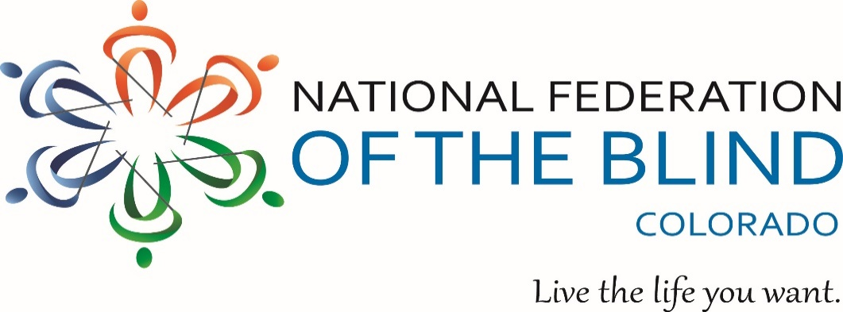
Blind Coloradoan Blog

November 24, 2021
Writer, Aggregator: Kevan Worley.
Contributors: Dan Burke & Erin Daley

Here is what you need to know-

Better late than never!
By the time you read this Thanksgiving will be upon us or you have just finished the last of the leftovers. This is probably my favorite Blind Coloradoan to assemble each year. Most of us have so much for which to be thankful. Of course, we have obstacles that we must confront as blind people, as well as the tumultuous times in which we all live. In this Thanksgiving issue, we will focus on the gratitude. In many ways, we reflect the struggles, machinations and disparities, injustice, and divisiveness all too prevalent in society. NFBCO members are a microcosm of society. We just happen to be blind. I submit that while rage, recrimination and rants roil around us, we who are blind, our families, and allies have a National Federation of the Blind for which to be extremely grateful. We are grateful for you, each and every one of our dear readers and members. As we gather with friends and families to celebrate this season, we give thanks for a strong, loving family, The National Federation of the Blind of Colorado. So, a happy giving of the thanks to you all. By the way, did you know that the names of the turkeys pardoned by President Biden are Peanut Butter and Jelly?

The 67th state convention of The National Federation of the Blind Of Colorado was held in Lonetree Colorado, October 28th - October 31st.
More than 150 joined the fun and wide-ranging deliberations and dozens more joined over zoom. (Imagine trying to explain to our organization founders a “hybrid convention?”) There is really no other way to describe this convention other than it was remarkable! We were grateful to have our national president, Mark Riccobono with us to provide a steller national report and a sturring banquet address. It was a convention of transition. Our long-time president Scott LaBarre decided to step away from the presidency, and we elected the energetic entrepreneur Jessica Beecham for a 2-year term. There will be much about the activities of the 2021 convention to report in this blog and blogs to come.

After her election to the presidency, Beecham made the following remarks:
“NFBCO is built on a foundation of tremendous leadership. Ray and Diane McGeorge and Scott LaBarre have led our affiliate to astounding heights.
Our Colorado Center for the Blind, outstanding advocacy efforts, and impactful legislative efforts have created an environment where blind leaders can flourish and thrive. As a result, we have a deep pool of leadership and talent. if you are a blind person, there is truly no better place to live and there is certainly no better affiliate in which to serve.
Thank you for your trust and confidence in my ability to lead us into the next chapter. As President Riccobono mentioned, we have not found the limit of possible when it comes to the capacity of blind people. I look forward to working with each of you as we continue to push the envelope.
From time to time we may stumble, we will most certainly have some incredible successes and I am inspired and energized to think about all the ways we will continue to make life better for blind people.
Together with love, hope, and determination, let’s go build the National Federation of the Blind of Colorado.”
During the Thursday evening opening ceremonies an audio tribute to Scott LaBarre was played. Scott served as president for 16 years and he has been a member of the federation since 1986. You will enjoy Scott’s story and the voices of the people in Scott’s life. Enjoy the 22-minute audio tribute on our youtube channel. https://www.youtube.com/watch?v=jBTHYWe7gnI
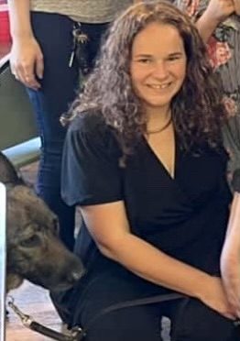

Thankful for the resolute blind
Conventions are a time for informative seminars, camaraderie, and celebration. The hard work and heavy lifting we do throughout the year is very often a result of the policies on which we deliberate and pass in the form of resolutions during our annual convention business. This year the membership passed 7 resolutions deemed important to the blind of Colorado. These resolutions will power our work in the coming year and beyond. Here are the titles of the 7 resolutions:
*Resolution Regarding an Accessible, Equitable and Inclusive Solution to Rideshare Pickup Locations at the Denver International Airport
*Resolution Regarding Commendations and Congratulations to Debbi MacLeod upon her retirement from many years of service to the Colorado talking book library
*Resolution Regarding the Inaccessibility of Remote Device Interfaces For Assistive Hearing Instruments
*Resolution Regarding Accessible Technology in Colorado State Government
*Resolution Regarding Rideshare Services in Colorado
*Resolution Regarding the Inaccessibility of Kronos
*Resolution Regarding the Danger that Leading Pedestrian Intervals Present to Blind Pedestrians
It is our understanding that some positive change has already resulted from our resolution concerning accessible technology in Colorado state government. We will be reporting on all of this work in upcoming blogs. The full text of each resolution will be found on our website nfbco.org. According to our new president, “we need all hands on deck, we are the blind of Colorado taking individual actions, collectively focused. So pick your passion. Pick your pleasure. And let's act on the policies we have set for ourselves”

Of little scavengers and rocketeers
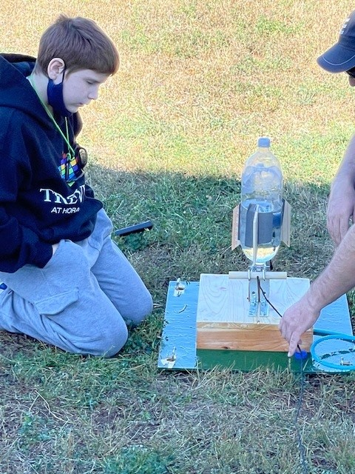
On a Saturday in October aka blind achievement equality month, 8 school aged students and others came together for a tactile art scavenger hunt inside the Colorado Center for the Blind. The kids then built water rockets from 2-liter soda bottles and shot them off outside the north door of the Center. The lesson of course was all about propulsion, and each rocket was fitted with a sounding device that made it easy to audibly track the progress of the rocket after take-off. Some went left, some right, and one went straight up! Everyone had a wonderful time and we were all surprised to see how far the rockets soared.
The program combined NFBCO’s Learning Box program with CCB’s FAST (Fun Activities and Skills Training) programs. Of special help were CCB shop teacher Paul Stewart (a CCB grad) and CCB student Cragar Gonzales. Cragar graduated November 19 and returned to Houston where he is studying Atmospheric Science.

Learning box
From the aggregator: It has been at least a year since our private school initiative folks started teaming up with our Colorado association of blind parents for our monthly learning box adventure. Blind children and families come together over zoom for learning and fun. If you know of a child who might enjoy receiving their own learning box and the opportunity to learn and share with others please contact Michelle Chacon rascal.angel2@gmail.com. Here is what Michelle says about our December learning box program:
December 12, 2021 2:00 to 3:00 p.m.:
Which way should we go on the number line? Let’s learn about positive and negative numbers. Students will be provided with a Braille/large print number line. They will have opportunities to engage in math problems that would require use of the number lines.
Please register by December 6 to give us enough time to mai out the learning boxes. You can register at: https://cocenter.org/learning-box/

Braille readers are leaders
The American Action Fund for blind children and adults has launched this year's braille readers are leaders contest. The contest is open with categories for children and adults. Sign up today and try your hands. Put your fingers to work. Details and signup here https://actionfund.org/programs/braille-readers-are-leaders

Ho! Ho! Ho!
Every December, the National Federation of the Blind helps Santa send letters in Braille to young blind children across the country. Get your favorite blind child on Santa’s list today. https://nfb.org/programs-services/early-childhood-initiatives/santa-letters/english-form

Curtis and Peggy Chong receive Raymond W McGeorge award
The highest honor a Colorado federationist can receive is the Raymond W McGeorge award. This year the award was presented to Curtis and Peggy Chong. This blind dynamic duo are leaders in our Aurora chapter. Peggy and Curtis move to Colorado from New Mexico only 3 years ago. They have served the organized blind movement wherever they lived throughout the nation in a career of service over 50 years. When the Chongs moved to town stuff gets done. Our readers know of Peggys work as the blind history lady. Readers know of Curtis for his technology expertise, his advocacy on the 16th street mall project, and his constant commitment and staunch leadership to ensure equal access to the ballot. But those descriptions fall short. The Chongs bring leadership, humor, and humanity to everything they do. It was not the technical expertise that made Ray McGeorge the leader and teacher so revered for over half-century, although he had technical expertise in many areas. It was Ray’s determined effort to do everything possible to build the federation. It was his wit, grace, and love. Therefore, honoring the Chongs was so appropriate. We lost Ray in 2010. Of course, Ray knew the Chongs. Ray would have been so proud and so are we. With much gratitude, we send our appreciation and love to Curtis and Peggy.

What I learned after using electronic ballot return during the coordinated election
By Curtis Chong
From the aggregator: I dare say, no one knows more about or has given more effort to how to bring true voting equality to disabled citizens of Colorado. Here’s what Curtis has to say about his most recent voting experience. Note, I'm pretty sure Jena Griswold, Colorado Secretary of State, and Curtis Chong are pretty much on a first-name basis.
We who are blind or print-disabled in Colorado now have access to a nonvisually-accessible system through which we can mark our ballots using the access technology with which we are most familiar and (now that SB21-188 is law) submit our marked ballots electronically without having to print or sign anything. With the advent of the November 2 coordinated election, I and several others decided to try the new ballot return system. I can tell you that I received quite a few calls and emails asking for help after the official ballots were mailed out on Friday, October 8. Based on those calls and my personal experience with the new voting system, I learned a few things which I want to share with those of you who are reading this article.
The first thing I learned was the importance of knowing how to find and upload files through the Internet. The electronic ballot return process requires the blind or print-disabled voter to upload three files: the ballot itself (in PDF format), the filled-in ballot application document (also a PDF file), and a picture of your identification document, usually the Colorado State ID. Each one of the three files needs to be uploaded separately. There is no way to select all of the files and upload them in a batch.
The second thing I learned was that the dialog which opens up when the voter activates the Print Or Download Your Ballot function is not the same dialog which opens up when the voter activates the Download Ballot Package function. The former brings up a dialog which assumes that something is to be printed, and the latter brings up a dialog which behaves as if you want to download something.
The third thing I learned is that if you have taken a picture of your Colorado State ID using your iPhone, the file which holds the picture may not be of the usual JPG variety. Instead, the iPhone creates a file type of HEIF (High Efficiency Image Format). HEIF files are currently not allowed when you try to upload your ID into the ballot upload system. The file must be converted into the JPG format. Fortunately, on Windows and/or an Apple Macintosh, there are utilities available to convert HEIF files to JPG. Also, there is a way on your iPhone to change the default format of pictures that are taken from HEIF to JPG.
1. Unlock your iPhone or iPad, launch the "Settings" app on your device, and activate the "Camera" option.
2. Activate "Formats."
3. Activate “Most Compatible.” This will set the picture-taking format to JPG instead of HEIF.
The fourth thing I learned during this election was that when you go to the ballot upload page, your screen reader’s focus is set into the first edit field, which is where you would enter your first name. If you fail to move backwards toward the top of the page, you will miss all of the information and controls which enable you to upload the three files I was talking about earlier.
Looking at all of this with a broader perspective, I am more convinced than ever that accessibility and usability are two different things. Is Colorado’s electronic ballot delivery and return system accessible to nonvisual users? Yes, it is. Is it easy and efficient for a blind person to use with a screen reader? Not for everyone. The system is more usable to people who possess a high degree of situational awareness and the confidence and ability to find specific files on their systems. For blind people who do not feel comfortable with the complexity of the Worldwide Web, I fear that Colorado’s electronic ballot delivery and return system will not deliver the results which all of us are hoping for.

NFBCO Blind Parents Division elect leadership team
Monday evening October 25th our Blind Parent's Division held their annual meeting. The Blind Parents Division was founded to provide mutual support, advocacy, fellowship, and a forum to share tips and tricks. The board members who will lead the effort over the next year are Maureen Nietfeld, president, Shon Spears, vice president, Brittany Savage, secretary, Kevin Kovacs, treasurer, board members are Pipi Adams, Jo Elizabeth Pinto, Nate Trela, David Nietfeld.

Please just drive normally. A cartoon in words by Nate Trela. Stolen from Facebook with his permission.
Had a long and painful conversation with a parent today as I dropped off Suana at daycare. She asked questions about driving near a blind person and I really appreciate that, but man she would not listen.
Parent: I see you walking your little girl all the time. I was wondering, is there anything I can do when I'm driving around you that is helpful.
Me: That's nice to ask, but really, just driving normally is the best thing. The noise of the cars when I walk actually tells me a lot about what traffic is doing, what the road looks like, and where the cars are.
P: Oh, OK. But in the parking lot, would it help if I honked?
Me: No, not really. I hear the engine of the cars, everyone moves slowly through the lot and the echo from my cane lets me know if there is a parked car in front of me.
P: OK, but would the honking help?
Me: Uh, if everyone did that it would actually be pretty distracting. Just driving normally, yielding when you should, is great.
P: Oh, OK. Should I honk when I slow down?
Me: No. I can hear your car stop moving.
P: OK.
Me: Have a good ...
P: I'm sorry, so I had another question.
Me: Sure.
P: Well, at the light you guys cross, does it help when I stop back from the crosswalk?
Me (thinking, so, you're one of them): No, actually that can throw me off. I walk through a tunnel of sound, I guess. Cars waiting on one side and passing on the other. If you stop back, it could make a blind person think the crosswalk is further back.
P: Well, I know that crosswalk is crooked.
Me: Right - I know that too because I walk through it all the time.
P: Right, so if you didn't know I wouldn't want you to bump into my car because you didn't know that.
Me (silently screaming behind my mask before I speak): OK, but I listen to where your car is. If you stop back from the crosswalk, if I didn't know the intersection, I'd think the crosswalk was straight and I could miss the curb cut. Does that make sense?
P: I guess. Does it help if I honked if I waited back?
Me: No. Just pull up like you should.
P: OK .. and I'm sorry it's taking so long. But does it help if I wait to go when the light changes?
Me: No, just driving normally is best.
P: But what if you step off and go into the middle of the intersection.
Me: If that happened, yes, please stop. But I listen for the cars close and parallel to me to go. That's when I know when to cross. If you wait, that makes me think the signal is still red and I end up with less time to cross.
P" Well what about the buzzing when the light changes.
Me: I don't go based on that. Sometimes they malfunction and these ones sound the same whichever way is supposed to be clear to cross. It's helpful when there are no cars around really early in the morning but really, driving normally and going when the light changes is the most helpful thing.
P: OK, but what if I'm turning.
Me: Just do what you would do with any pedestrian.
P: OK - so one time I kind of sat before making a right to block you from crossing. Then I went when the light changed. Does that help?
Me (hoping to God my eyes aren't showing what I'm thinking): No. Are you talking about a right on red? If I wasn't already at the intersection when the light changed and I wasn't confident I had enough time to cross, I wouldn't go in front of you. So just turn normally like you would with anybody there.
P: No, I stopped when it was green and waited until it turned red and then I went.
Me (certain the incredulity on my face has to be apparent): Uh, no, I think I remember that actually from the other day. That is really not helpful because it threw your car in the way when I should have been able to cross. Please, just drive normally.
P: OK, sorry - I just want you and your little girl to be safe.
Me: Me too. So, please just drive normally. That is the biggest way you can help.

Life lessons at the turkey trot
From the aggregator: Readers of this blog may know that I am absolutely smitten by the writings of Jo Elizabeth Pinto. I find her stories endearing and often profound. They are real stories of real people. Jo Elizabeth is a leader in our blind parent's work. I would also suggest that her books would make wonderful Christmas presents. Here’s what she submitted for our thanksgiving blog.
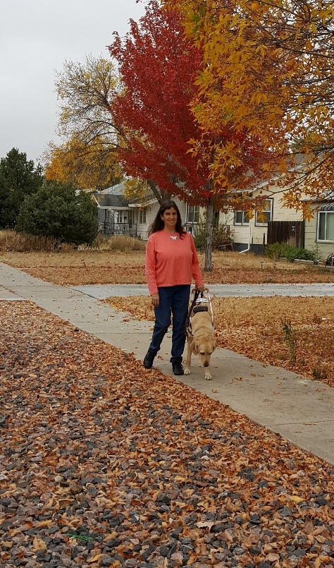
Life Lessons at the Turkey Trot
by Jo Elizabeth Pinto
My eight-year-old daughter Sarah inspired my socks off yesterday. Actually, I was wearing fur-lined snow boots, but she inspired me just the same. I went to watch her participate in her school’s annual Turkey Trot with the rest of her third-grade class.
Fortunately, the storm from the day before had subsided. It was still nippy out, and the ground was slippery with slightly melting snow, but the sun shone brightly.
“I won’t win, Mom,” Sarah had predicted glumly that morning. “I’m the slowest girl in the third grade.”
“Just have fun and try your best,” I had encouraged her as she left for school.
The race started, and my daughter was soon well behind the pack. She had left the winter jacket she usually wore at a friend’s house. The one she had on was a hand-me-down from an older cousin. It was too big for her, and the hood wouldn’t quit flopping over her eyes. She had also forgotten to put on gloves that morning. I had let her borrow mine before the race. They were too large for her hands, so she kept pushing the hood out of her face with these hopelessly floppy leather gloves that fit her like swim flippers.
I stood at the finish line as the runners came in. Soon, my daughter was left on the race course--alone. My heart sank as the seconds ticked by, lengthening into a minute, then two. A teacher went out to walk the last of the course with Sarah. I could have hugged that woman. At least my baby wouldn’t have to cross the finish line all by herself under the stares of her classmates.
Finally the dean said, “We have one more friend to cheer on.”
The entire third grade began to chant in unison, “Sarah! Sarah! Sarah! Sarah!”
I held out my arms, and my little girl rushed into them, burying her face in my purple coat to hide her humiliation.
“They’re all cheering for you!” I told her.
“Because I came in last,” she whispered.
“No!” I turned her around to face the other students. “They’re cheering for you because you kept on walking. You could have given up. You could have quit, but you didn’t. You kept right on walking. That means a lot.”
I gave my little girl one more bear hug, and sent her off with the rest of her class to finish the school day. No more fuss. She inspired the socks off me. But at the same time, I hope she learned some valuable lessons about perseverance, about tenacity, about acting with dignity when victory doesn’t come her way. Because to tell the truth, life will hand her more opportunities to practice perseverance than to take victory laps. She’ll need to remember how to keep on walking when she’s the only one left on the course, when the ground is slippery and her hood is falling in her eyes, when the way is long and lonely. As her blind mom, I know a thing or two about that. But blindness doesn’t give me a corner on that market. Tenacity and fortitude are life skills any mom should be more than ready to pass along to her daughter when the chance arises.
This story appears in my mothering memoir, “Daddy Won’t Let Mom Drive the Car: True Tales of Parenting in the Dark.” The book, full of similar lighthearted vignettes and a few more serious ones, is designed to show that while blindness might alter a few everyday logistics of parenthood, it doesn’t change what it means to be a family. It’s available in audio, Kindle, and paperback formats on Amazon or by visiting my Website at https://www.brightsideauthor.com.

Walk While Seated with your new miniTREAD®!
From the aggregator: One of the new and exciting products shown at our recent state convention was a product called, “The miniTread” Your friendly aggregator bought one to test it out for you dear reader. You’re welcome! I love it! Here is information from the company.
The miniTREAD® turns any seated activity into an opportunity to feel your best, get stronger, and live a healthier lifestyle. Its compact size (it fits under a desk) and portability deliver a calorie-torching walking workout while working, or sitting in your favorite chair while watching TV or reading. The miniTREAD® is designed for use by those of any fitness level from beginners to seasoned experts. It packs a powerfully quiet motor and unlike walking on the pavement, walking while seated is low-to-no-impact. Your hips, knees, and back can't wait for the relief! Get Fit While You Sit on the miniTREAD®!
https://onthemuv.com/

That’s It for This Edition of the Blind Coloradan
Forward, always Forward!

