Blind Coloradoan Blog
December 23, 2021
Writer, Aggregator: Kevan Worley.
Contributors: Dan Burke & Erin Daley
Here is what you need to know-
Greetings dear friends and colleagues,
I think this end-of-year blog is one of my favorites. For one thing, it took me a little while to get started. I wanted it to contain the joy of the holidays. We have all been through so much over the past year and more. In early December my wonder sheppard Onyx and I went off to the Hillside Community Center to attend the annual Kwanzaa market. There was art, jewelry, posters, t-shirts, and many other items celebrating the history and joy of this uniquely African American holiday. I heard choir singing spirituals, poetry readings, and an astonishingly beautiful drum and dance group. When I came home there were stories meant for this holiday blog in my inbox. Thanks to all of you who support our Blind Coloradan. We wish all of you season's greetings, and a joy-filled 2022. We definitely have new years resolutions on which to work. Forward together!

Message from the President
Regardless of how you are celebrating this year, I hope you are having a wonderful Holiday season full of all of your people, food, and traditions. This year was very special for me as my sister, Kevin, and I were all able to go to my Granny’s house for Thanksgiving. I was very grateful to have time with both mine and Kevin’s family.
I am equally grateful to have my Federation Family. This has been a challenging year in many ways. We have challenged each other to closely examine our organization, programs, and events. We have worked closely together to create spaces that allow everyone to participate in a way that makes them feel safe and valued. Most importantly, we have been there to support one another. We will continue to face challenges and our job will be to respond in such a way that we continue to build a stronger organization. I believe we have done so during 2021 and I look forward to a bright New Year!
Enjoy a little down time, rest, rejuvenate, and lets go build the Federation in 2022!
Happy Holidays!
Jessica Beecham
President,
National Federation of the Blind of Colorado

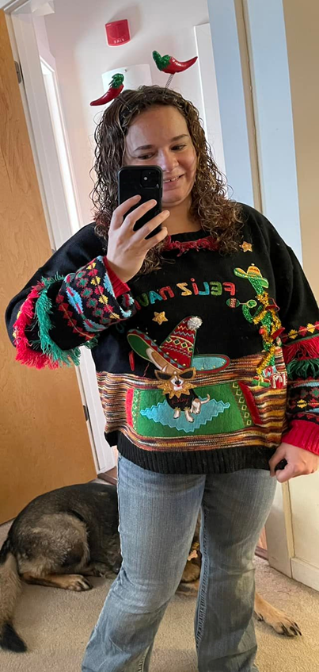

The newly elected president of NFBCO is bound and determined to win the ugly sweater contest.
Here is how she describes her holiday getup “my headband is black and sparkles with two big bouncy red chili peppers. The sweater says Feliz Navidad. There is green and red tassel and pattern print on the sleeves. There is a Taco Bell chihuahua wearing a black and gold cape that says hola, big gold sunglasses, and a huge Christmas sombrero, there is chili peppers dangling from the sweater but Emma ate a few of them, there is a tensil musician playing a maraca. It is a lot but so fun!!!!

My Christmas fidget spinner
By: Jo Elizabeth Pinto
From the aggregator:
We are once again fortunate to have a heartwarming story from author Jo Elizabeth Pinto. Readers of this blog know how she conveys with great poignancy the joys and challenges of parenting. She is a blind author and mother who is clearly living the life she wants. It is always a joy for me to post her stories. Her books would make outstanding presents any time of the year.
Two days before Christmas, we got a sudden snowstorm in Colorado. The storm was brief, but it left behind enough snow to cover the sidewalks with a few inches of white fluff. When the sun reappeared, my nine-year-old daughter took the initiative and bundled herself up in a long-sleeved shirt and a fleece-lined sweatshirt, a pair of jeans and some waterproof snow pants, three pairs of socks, high boots, a winter coat, mittens, and a neon pink knitted stocking cap with a pom-pom on top. Nearly as round as she was tall, she hustled out the door, ready to earn a few dollars shoveling sidewalks for the neighbors on our block.
"I'll give you five bucks to do our front walk between the house and the street," I offered, afraid she might not find other takers. "You need to clear the walk along the street, and the brick path that goes to where I take the dog out. Never mind the driveway—your dad’s car will pack that snow right down when he comes home."
It turned out two other neighbors let my daughter shovel for them as well.
“Your girl's a fine young entrepreneur," Dick, the kind old man from across the street, told me later. "You bet I'll support that."
When my daughter had been gone for well over an hour, I started to get concerned. I had just reached for my coat, intending to venture out and search for her, when she burst through the door on a gust of frigid air. She had a small plastic bag in her hand. I figured she had gone to Seven-11 at the end of the street, eager to spend her hard-won earnings on candy.
She threw off her wet wrappings and marched straight to her art shelf. For the rest of the afternoon, she busied herself with glue, scissors, and who knew what, all the while gleefully hinting that I was going to love the present I would find under the tree on Christmas morning.
"It cost me ten bucks, Mom!" she finally blurted out, unaware of the social taboo that generally stops people from telling others how much has been spent on their Christmas gifts.
When our little girl had half sweet-talked and half strong-armed us out of bed on the big day, her dad and I put on our bathrobes, made coffee, and settled ourselves by the Christmas tree. Surprisingly, before our excited kid opened a single gift of her own, she dropped a small tissue paper package into my lap. I peeled off a mile and a half of Scotch tape and unwrapped a fidget spinner. The thumb grip was covered with yellow sequins that had been glued firmly in place.
"There's a picture of Aqua-Man® under the sequins," my daughter said. "He was all they had at Seven-11, and you had to have a fidget spinner because you always spin mine while you think of what to write about on your computer. So I had to buy Aqua-Man® with my shoveling money and find a way to cover him up since he's a boy and you're a girl. Girls don’t do boy superheroes, you know. I tried yellow paper, but then it wouldn’t spin, so sparkles were the only way. I picked yellow because you like the sun so much. If you could see, I think you’d like the color of sunshine."
I hugged and kissed my little girl, who I decided right then must have the biggest heart in the state of Colorado.
This story appears in my mothering memoir, “Daddy Won’t Let Mom Drive the Car: True Tales of Parenting in the Dark.” To find out about this book and my other two, please visit my author Website at https://www.brightsideauthor.com.

Christmas Prophecy
by Kevan Worley
Christmas truly was the most wonderful time of year. Raised in the late ’50s and early ’60s in central Illinois, in the Church of Christ made for an idyllic childhood. We went to church at least 3 times a week. Sunday school and worship service Sunday evening and prayer meeting Wednesday evening. There was plenty of time for running about, the neighbor's yards, and around the back of the church before and after services.
Being blind since birth did not cause me many challenges until I reached about 9 or 10 years old. I could and did run and jump and summersault with the best of them. Most kids did not care that I was blind. I almost always had a speaking role of some importance in our church Christmas youth productions. I knew my 4 gospels frontward and backward. And I understood the importance of Christmas, faith, and morality to my family. Christmas was a joy! A regular Norman Rockwell event throughout the Christmas season.
Grandma Ingalsbe called me her little dickens. I don’t think she was referring to Charles. I was her favorite. She actually used to peel my apples. Grandma read Christmas stories, mostly from the bible to me every night over the Christmas season.
When I was about 9 years old some of the children at church started teasing me about blindness. Grandma had stern words for these miscreants.
After Sunday evening service I went home with Grandma and Grandpa. We rode in Grandpa’s 1956 Nash Rambler. I loved that car. He always kept that car immaculate. Even at 9 years out of the factory, it smelled brand new, but I digress. On the way to the house that Grandpa had built with his own 2 hands, Grandma told me a story from the old testament about prophecy. She also talked about how you should never judge others, “lest ye be judged”. When we got home Grandpa gave me Grandma’s pumpkin pie with real whipped cream. Grandma said “you are a fine young man Kevy Dale and I prophesy you will grow up to be a strong, kind, and funny man”. She said, “whether you earn a lot of money or are considered successful by the world I know you will be a good man”. I've always thought of Grandma's prophecy. I hope that she was right. I have not always lived up to her notions of Christianity but, I do know that she taught me the meaning of Christmas, faith, love, and understanding. For me, Christmas time is about remembering those joyous times and doing the best I can to keep faith with my Grandma's Christmas prophecy.

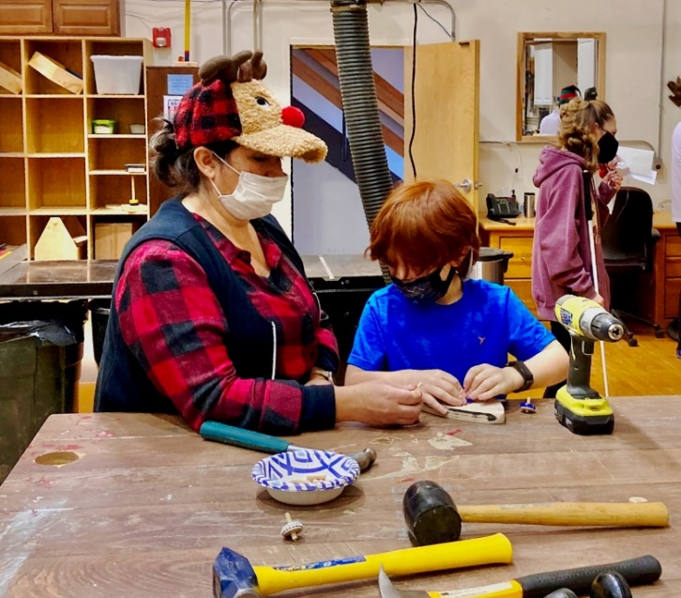
CCB students Amanda and Nate making a top at Santa’s workshop at December's fast activity.

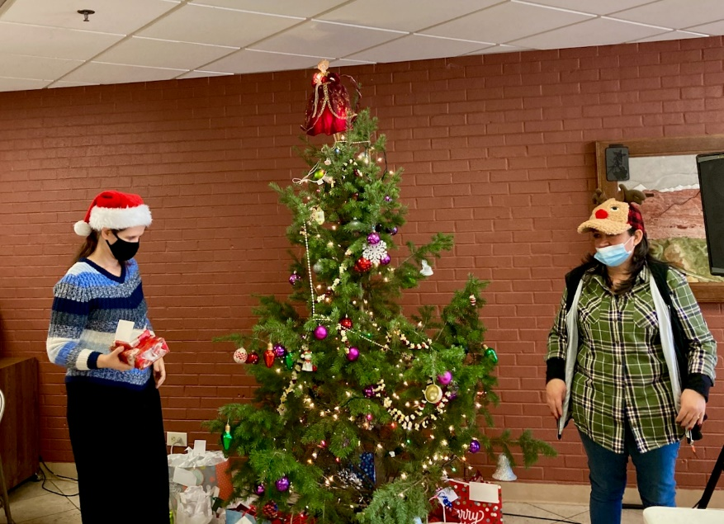
Jen and Amanda beside the tree passing out secret santa gifts at Colorado Center For The Blind.

Don’t say that you’re blind; my experiences as a blind tourist
By: Erin Daley
From the aggregator:
We were so thrilled to receive this article from one of our blind Coloradan contributors and world traveler Erin Daley. As an army brat, I traveled the world with my family. As a young blind adult, I was a true vagabond, traveling the highways, inner cities, small towns, and backroads of our nation. By myself, I hitchhiked, rode the trains, Greyhounds, and walked the nation. But, I can't really imagine traveling throughout the world completely by myself. I was astonished when my blind son Nijat traveled throughout Europe completely on his own after college. Of course, many of our non-blind friends and neighbors wouldn't want to travel the world completely alone either. I hope you will enjoy reading a piece of Erin Daley’s journey. Both figuratively and literally. Following are Erin’s thoughts.
I don’t really remember when I discovered my love for travel. I never went on too many trips as a child, mostly with the Girl Scouts to Washington, DC or some camp in the woods. I would read about different countries and places in history class, and I always wanted to go see these places that were described in thousands of books and where people had journeyed to for hundreds, even thousands of years. More than a vacation from “real life,” I think of traveling as a bridge. I cross the bridge to learn about a new culture, but these people also learn about me, as well.
Most all of us who are blind understand that we are always an ambassador of sorts to the rest of society, the vast majority of whom will never experience or understand blindness. Couple this with being in a new culture and there can be some interesting times to say the least. To date I have traveled to about 20 countries – not nearly as many as I hope to in my lifetime! Of those countries, I have traveled to three solo – England, China, and Turkey. While I have had unique experiences in every country I have visited, I would like to mention some in my solo adventures.
I rekindled my love affair with travel in 2017. I had started losing my vision more and more in college, and my last trip had been France in 2009. I had told myself for so long that I just couldn’t travel anymore and that I would need to find a less expensive and impossible hobby. I then ran across a YouTube Channel of a man who travels while deaf and blind; I became so excited that I could actually do this. I decided that England would be my first destination and I booked a ticket the next week. I chose England not only due to its history and culture, but also because English would the primary language spoken. I had one of the best trips of my life there – people understood what the cane meant, announcements and directions were very clear, and the public transportation was almost stupidly easy to navigate. I actually had no issues with accessing any public spaces, and some museums even had special tours for the blind where you could touch some of the exhibits, most replicas, to better enjoy the museums.
Two year later, I found myself alone in a hotel room in China, fighting to stay in the country. The tour I had booked found out I was blind (even though I told them before I left, not wanting to have any trouble once I was there). They said that it was impossible for me to go on the tour and, after some arguing, there was an ultimatum: either I pay for a sighted guide for every day or I would be taken back to the airport to immediately return home. I paid the cost, not wanting to lose out on this experience. During the whole conversation, they would never tell me why I they were requesting this. Both they and I knew it was because I was blind, but they refused to acknowledge it. My favorite part of that trip, more than climbing the Great Wall or eating the tastiest dumplings of my life, was when a few of the people in my group banded together like some sort of street gang to distract the sighted guide while a few others pulled me away. I was able to walk freely along the city walls of Xi’an with my new friends. There were so many unique experiences in China that had nothing to do with my blindness – like my TV being censored or going into a communist museum where I was not only the only blind person, but the only white person and the only person six-feet tall. All in the all, the people in China were gracious and kind, and I loved checking out the Braille sidewalks, but my culture shock had an additional layer!
This May I decided to travel with my friend to Turkey, where we had dreamed of going since we were 16 years old, staring at photos of Ephesus and Cleopatra’s Pool. Unfortunately, she contracted COVID the week before we were to depart and was unable to come, so I set out on my third solo trip. Anyone who knows me knows that I became extremely sick – twice – as a result on this trip. I’ll omit the gory details of my food poisoning while flying back to the US, but I will warn you to not eat more than three apricot seeds at a time. Actually, just don’t eat them at all to be on the safe side, lest you end up like me: in the ER with cyanide poisoning.
Anyway, the people of Turkey did not succeed in doing away with me, and it is one of my favorite countries I have ever visited. If you like history, know that there are more archaeological sites in Turkey than in Greece and Italy combined! I wasn’t required to pay for a sighted guide in Turkey, but this was probably due to the fact that, at one point, I was the only person on the tour. There was one point when I was climbing Mount Nemrut, where I was discussing my eye disease with my tour guide. He became very upset and said to me, “Stop saying that you are blind. Look at all that you have done. You have climbed the mountain. Could a blind person have done this?” My answer, of course, was “Uh, yes. Because I did it. I am blind.” It was an eye-opening moment for me as I realized that, to many people here and around the world, blindness will never be synonymous with accomplishment and happiness, but only loss and sadness. When I climbed the mountain with him, even on a paved path with my cane, my success didn’t mean that a blind person could do it, it meant that I could not possibly be blind.
Each of us fights every day to live the life that we want, but sometimes it is impossible to even walk out our front door without being confronted by the negative stigma that life as a blind person is less fulfilling than that of a person with sight. I was in the Baltics over Thanksgiving, and someone asked my friend why I travel, since I cannot enjoy the sights anyway. That question has become so important for me, because it was as I was thinking how to answer that question that I finally understood it myself. At first, I traveled because I wanted to go where so many people never will. I wanted to visit places I had only seen on TV and read about in books. But I realized that what that question really asks is “what is there to life if you cannot see?” And the answer is everything. The answer is that just because I cannot see doesn’t mean that I cannot enjoy my life, enjoy time with my friends, enjoy new food, and enjoy the exhilaration of getting off a plane and wondering what I got myself into this time.

Remembering Charles McCoy
From the aggregator:
This article is not about the great harmonica player Charley McCoy. It is another wonderful submission from our own blind history lady, Peggy Chong. The research Peggy and those volunteers she can recruit is vital for the understanding of our history. This piece moved me. For one thing, this authentic and persistent gentleman came from my old stomping grounds, central Illinois. The story recounted here is from his time at the old Printers Home in Colorado Springs. The old Printers Home has quite a storied past of importance to the blind. Perhaps we will tell some of that story in future blogs. I hope you enjoy reading the history of our people as much as I do.
[The Typographical Journal was a publication of the International Typographical Union, a trade union for the printing trade. This article was included with the United Workers for the Blind minutes in 1927. The date 6/14/27 is handwritten in the margin. The following paragraphs were highlighted with the note: “This Mr. McCoy is a guest of the Union Printers Home in Colo. Springs. Al knows him.”]

THE TYPOGRAPHICAL JOURNAL – Page 695
Charles McCoy came to the Union Printers Home from Springfield, Ill., with failing eyesight and later became totally blind. Strangers, seeing this black-eyed and black-haired young man use the elevators, go up and down and out and roundabout the Home, hardly ever discover his affliction, as his alert, confident activity displayed more pep than many two-eyed people. Asked for a sketch of his life at the Home, he prepared the following interesting statement:
“When I arrived at this place seven years ago I was a sick man, both in body and spirit. My sight was fairly good, being able to read a little. The wonderful climate soon restored me to health with the exception of my eyesight. About a year later I noticed my sight beginning to fail but could not reconcile myself to the fact that I was going blind. I would not let myself even think about it. When I did realize it would be only a matter of time until I would be unable to see I began to think of something to do to pass away the time.
“The state teacher for adult blind, Mrs. Jennie Jackson, herself blind, a wonderful little woman and who, by the way, was born and spent childhood days in a little town a few miles east of Springfield, Ill., my home, became interested in me and started to teach me the Braille, or blind system of reading and writing. I studied hard, and, according to her I have the distinction of being one of her brightest pupils, and later on you will see how this little recommendation helped me to more success.
“After I had read a large number of books in Braille, on different subjects, I began to look around and find out what else the blind might do. This same teacher came to my aid again and showed me how the blind were making shopping bags on a single rake. I made several bags on this kind of a rake but was not satisfied, as it required too much cord to finish the article.
“After spending several weeks thinking and figuring. I designed the double rake and in this way made the bag complete, with the exception of putting on the handle. As far as I have been able to learn, I am the first and only person to use a double rake in this particular kind of work, and this idea was original with me. This scheme saved about one-third less cord besides taking less time to make and you have a better bag in every way. Of course, the first bags were nothing at all like the later finished article. I would lie in bed thinking out new ideas and would often get up and work out the ‘dream’, as it were, as I would be afraid I would forget all about it by morning. In this way I worked out most of my difficult problems, and, believe me, I had plenty of them. You see, handicapped as I was, I would have to knit a whole bag before I could tell much about it. Many and many a time I would throw the work down and give up the job. But after a walk and thinking the matter over and knowing I had to do something I would go back and take up the task again.
“After completing the shopping bag I decided to make something really worth while. I gradually reduced the size of the rake and the cord until I reached the required size. Then I started out to find the right kind of silk cord which would work up best in a bag. I spent many months in writing everywhere getting samples of cord, and the next question was to get the proper style of handles. I knew in my mind just what I wanted, but to get these things was an entirely different matter. I had a few loyal friends who stuck by me through all this and were a wonderful help to me. After several years’ search I have found places where I get my supplies, and this is one big load off my mind.
“Not being content with doing this much I made up my mind to learn to teach the blind how to read and write the blind system. This teaching was, of course, absolutely new to me, but strange to say, the thought of failure never entered my mind. There seemed to be ‘something’ which kept urging me to try other things. I finally was able to get a Hall Braille writer, a machine to write the Braille characters. By this time I had become an operator on a regular typewriter. I would take down notes, etc. on my Braille writer and later transcribe these on the regular business typewriter. With this Braille writer I keep a regular letter file with phone numbers, addresses, etc., and can find out anything I wish to know without bothering any one.
“As the health of my Denver teacher became poor and she could not do much work outside of Denver, I volunteered to help her out in this city (Colorado Springs). At this time this teacher was the only state teacher and she was required to cover the entire state, which was impossible to do in an efficient manner. We have one of the finest schools for the blind here that can be found anywhere, but the work I was to do was to teach the adult blind in their homes. I paid a guide to take me to several pupils and began my work. About this time the politics of the state changed and the old blind bill was repealed and a new law passed. A new commission for the blind was appointed. Fortunately for the blind, a blind lawyer was appointed on this commission. He wrote me, saying that he had heard I was teaching in this city without pay and that the new commission would pay me for my services. I went to Denver and met the commission in session and was appointed as an assistant home teacher. After a short time I was promoted to state teacher with this city as my territory. I am paid so much per lesson, but as I have to hire a car with a driver to take me from place to place I do not make anything after expenses are paid. The work is most interesting and I enjoy it very much. A few of my pupils are between 65 and 80 years, and it makes me smile to see how quickly these older ones grasp the idea of learning.
“It is now my intention to take up other work as soon as I am able in this new life which circumstance have force me to adopt. This is the principal reason why I am making these silk bags and sending them among my friends to enable me to accomplish this purpose. I take a keen interest in the work among the blind in this city and am doing everything I can, in my small way, to help them solve their problems. I am one of the organizers of the Colorado Springs Association for the Blind and have help every office within its gift. This little society is unique in the fact that all its officers and active members must be blind. It has been organized several years and is growing in membership every year.
“When I lost my sight I determined to visualize as much as possible so as not to appear as a blind person. I had often noticed, in my sighted days, that blind people had the habit of staring, and this I wanted to get away from if possible. When I talk with any one I always look at the voice, and as my eyes are bright and clear, the party I am in conversation with would not know I was blind if I did not tell them. When walking about the city I keep looking around at the different noises, and many a time a passerby would step out of the way of my escort and directly into my path, thinking my escort was the blind person. I could relate numerous humorous incidents in my experience during the past several years.
“I have read a great deal about the blind and have made this subject a close study, and I do not believe that any blind person has accomplished more than I have in the few years in which I have been in this condition with no help to speak of except a few lessons at the beginning and with only the determination to succeed, and I say this without the least intention of being boastful.”

Do you read the Braille Monitor?
The Braille Monitor is the flagship magazine of The National Federation Of The Blind. Published monthly except July it contains the real magnificence and challenges of our movement. Sometimes it causes us to get into, “Good trouble”. It is who we are. Filled with insight, information, and opinion. Sometimes controversial. Sometimes not. It is always worth the read. Your aggregator got a little preview of the January 1st issue. So, start out the new year by reading the following articles in the Braille Monitor. I get mine on NFB newsline.
Voting is a Blindness Issue
by Lou Ann Blake

The Myth of Functionality: Disability Rights and the Limits of Common Sense
by George Stern

Life Lessons at the Turkey Trot
by Jo Elizabeth Pinto

Case for Why We Should Not Do Visual Descriptions of Ourselves
by Mark Lasser

Bringing a Closing to Disclosing the Clothing
by Jack Bernard

Conventions Are for All of Us
by Chris Westbrook

Are Conservatives Welcome in the National Federation of the Blind?
by Colleen Roth

From the NFBCO people and programs

On behalf of all of us to all of us! Please take care of one another. Holidays can be a time for celebration. But not everyone feels included, joyful and optimistic. We also know that people with disabilities are much more likely to be isolated and alone over the holidays. This is especially true during this awful pandemic. As tough as this year has been, the programs and people of NFBCO have been resilient and active. Our chief program is The Colorado Center For The Blind. In spite of COVID-19 and other challenges. Our programs continue to thrive. Congratulations to our innovative senior's program, to our adult Independence Training Program and our standard-setting variety of youth programs. Built on a foundation of inclusion, integrity, and expectations. Our programs continue to be the envy of agencies across the land. Our local chapters, divisions, committees, and individuals, have again served our members and others who are blind with energy, imagination, honor, and most of all, love. So take care of one another. If you or someone you know find yourself in trouble during these holidays? Please! Reach out to a federation family member. Do not hesitate to take advantage of mental health services. The federal government has just established a brand new suicide helpline. The number is 988. We will build bigger and stronger with honor, integrity, and hard work in 2022. Feel free to bring a resolute spirit to our federation family in 2022.

When a $100 gift certificate to our NFB Independence Market to win comment on this blog. Or, send me an email with the answer to this question

“Name 2 items sold at our Independence Market”?
Good luck

Forward always forward!

