Come join us for improv, Saturday, July 23, from 1 to 5 pm, at The Phamaly Theatre Company office at: Tramway Nonprofit Center 3532 Franklin Street, Suite T2 Denver, Co 80205
Poetry for Personal Power representatives Brian Be and Maryann Migs are seeking volunteers who love to play improv games for a filmed improv session. The recordings will be used to create education sessions about using the skills of improv to empower community, encourage leadership, and embrace interdependence.
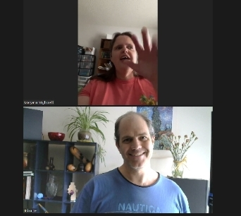
If you have any questions or need more information, please contact us.
Email Brian: bbe@poetryforpersonalpower.org Text Brian: 303.264.4862
Email Maryann: maryannmigs@gmail.com Call or text Maryann: 720.284.2318
To reserve your space in this afternoon of fun please contact both Brian and Maryann by email by Wednesday evening July 20 th
We look forward to playing together.
Brian and Maryann
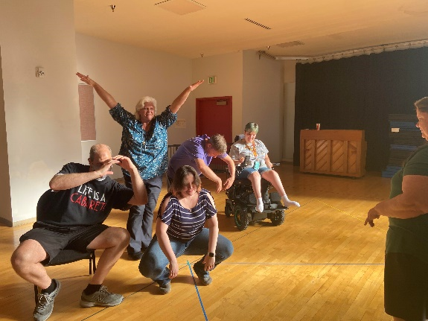 Photo description; 7 people in improv class w Phamaly on 7.11.22 forming 'a popsicle stick'. "I'm the logo" "I'm the drip" etc. Different playful interactive positions, one has mask, one teacher observing, one in powerchair, some arm(s) extending, some crouch/kneeling.

