**CONVENTION BULLETIN 1!**

**THE BLIND OF COLORADO LIVING THE LIVES WE WANT!**

[**THE NATIONAL FEDERATION OF THE BLIND**](http://www.nfbco.org/)

[**OF COLORADO**](http://www.nfbco.org/)

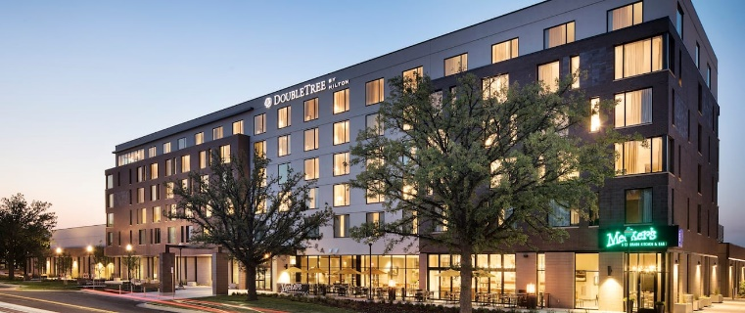

***68th ANNUAL STATE CONVENTION***  
***October 27 through October 30***

The 68th Annual State Convention will kick off with a BANG on Thursday October 27 in Greeley, Colorado with an interactive and inspiring seminar on knowing our history and building our future and your chance to play in a mini goalball tournament. If playing goalball is not for you, don’t worry, we are providing audio description so spectating will be more fun than ever. The programming will continue all weekend long with exhibitors, informative and inspiring presentations during general sessions, additional breakout seminars including meetings of several of our special interest divisions, interactive and exciting social events, and much more! Make plans to join us Friday night for a LIVE Murder Mystery Dinner Theatre! Bring your best sleuthing skills and we will provide the heavy hors d’oeuvres and cash bar!

Once again, our convention will be hybrid so we hope you join us in person but if that does not work best for you and your health, you can still be eligible for door prizes by paying the registration fee of $20. Stay tuned for a full convention agenda slated to be released in early October.  We will also be sending updates throughout the rest of the summer.

**THE NFBCO CONVENTION HOTEL:** Our 2022 convention will be held at the DoubleTree by Hilton Greeley at Lincoln Park, located at 919 7th St., Greeley, Colorado, 80631.  Our convention hotel is one block from the Union Colony Civic Center in downtown Greeley. Local attractions like the Moxi Theater and Doug's Diner are in walking distance, and it's two miles from the University of Northern Colorado. Relax in the indoor pool and outdoor hot tub. Every stay starts with a warm chocolate chip cookie. When you add in over 300 of your favorite blind friends you have one FANTASTIC NFBCO convention!

**HOTEL ROOM RATES:** The NFBCO room rate is $109 a night.  There is no limit on room occupancy.  Reservations MUST be made by Friday, September 23.

To reserve your room, call the hotel reservation line at 844-570-7816 and use group code “NFB”. Please contact Lisa Bonderson, at 303-504-5979 if you have any issues making a reservation.

**[Click here to reserve your room online.](https://group.doubletree.com/94k3rf)**

**TRANSPORTATION:**

NFB of Colorado will again be providing chartered bus service to and from Greeley. Buses will leave the Colorado Center for the Blind Thursday morning around 10:30am or so. Stay tuned for the exact departure time once details have been finalized. You must RSVP Lisa Bonderson at [lkb@labarrelaw.com](mailto:lkb@labarrelaw.com) if you intend to ride the provided transportation.

We will put out the word when convention registration has gone live, and we will provide a link to register on our new NFB of Colorado website.

Following you will find the convention registration and meal pricing structure:

**Pre-registration fees:  BEFORE October 14**

$20 registration

$0.00 Friday reception

$25 Friday luncheon  
$25 Saturday luncheon  
$40 Saturday banquet

$0.00 Sunday breakfast

**Total:  $110.00**

**Registration fees:  AFTER October 14**

$25 registration

$0.00 Friday reception

$30 Friday luncheon  
$30 Saturday luncheon  
$50 Saturday banquet

$0.00 Sunday breakfast

**Total:  $135.00. You save $25 by pre-registering.**

**FOR MORE CONVENTION INFORMATION CONTACT:**

Jessica Beecham via email at [jbbeecham@gmail.com](mailto:jbbeecham@gmail.com) or Lisa Bonderson by phone at (303) 504-5979.