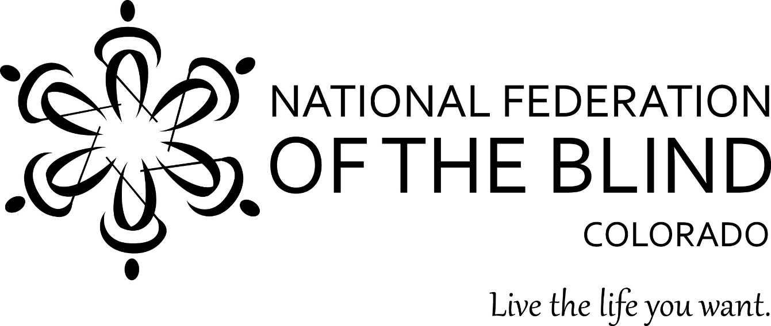

**The National Federation of the Blind of Colorado Roadshow**

**is coming to Colorado Springs!**

Resources! Collective wisdom! Demonstrations and opportunities!

WHERE: Avenue 19, 19 N Tejon St, Colorado Springs Colorado

WHEN: June 18, 3 pm

Citizens who are blind, have low vision or are somehow connected to people who are blind are warmly invited to this one-of-a-kind roadshow! We will be highlighting and demonstrating simple technologies to increase opportunity and brighten the lives of blind and low-vision people. Learn about NFB NEWSLINE, accessible prescription labels, local instructional resources, and more. We will share stories of successful blind and low-vision people throughout this region. We want to serve you by being a connector to valuable empowering resources. We want to hear your story. Come share in the collective wisdom of the National Federation of the Blind. Together with love, hope, and determination, we transform dreams into reality. Light refreshments provided. Who is welcome? Who will benefit? Students, parents, all who have lost sight or are losing sight, blind and low vision people looking for jobs, blind and low vision seniors, teachers, instructors, and counselors working with blind students or adults. Information packed and fun. Please join us. If you have questions contact Kevan Worley 303-929-2369, or [kevan@nfbco.org](mailto:kevan@nfbco.org). At 6 pm immediately following this interactive seminar you are invited to stay for the monthly meeting of the National Federation of the Blind of Colorado Downtown COS Chapter. Be sure to catch dinner at one of the sensational Avenue 19 eateries. Pizza, sandwiches, vegan, mac and cheese, burgers, salads, gyros and more! Plan to join us at 3 pm, Avenue 19, Tuesday, June 18th.  Please! Feel free to share with others!