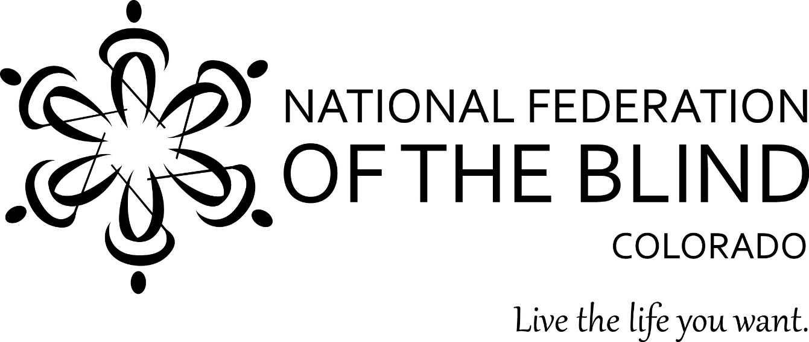

**The National Federation of the Blind of Colorado Roadshow**

**is coming to a city near you!**

**Join us at the Rawlings Public Library, Brett Kelly Room 2**

**100 E. Abriendo Avenue, Pueblo**

**Saturday October 5 from 1:30pm to 4:30pm**

Resources! Collective Wisdom! Demonstrations and Opportunities!

Citizens who are blind, have low vision or are somehow connected to people who are blind are warmly invited to this one-of-a-kind roadshow! We will be highlighting and demonstrating simple technologies to increase opportunity and brighten the lives of blind and low-vision people. Learn about NFB NEWSLINE, accessible prescription labels, local instructional resources, and more. We will share stories of successful blind and low-vision people throughout this region. We want to serve you by being a connector to valuable empowering resources. We want to hear your story. Come share in the collective wisdom of the National Federation of the Blind. Together with love, hope, and determination, we transform dreams into reality.

Who is welcome? Who will benefit? Students, parents, all who have lost sight or are losing sight, blind and low vision people looking for jobs, blind and low vision seniors, teachers, instructors, and counselors working with blind students or adults. Information packed and fun.

If you have questions, contact Jim Beal at 719-232-7663.