Independence Skills Fair for Blind Youth

October 30, 2025 | 4 PM - 8 PM

Westin Hotel, Westminster, CO

Ready to Show the World What You Can Do?
Being blind doesn't mean being helpless. It's time to learn the skills that will make you unstoppable.

🍳 MASTER THE KITCHEN
Learn to prep meals safely and independently. Yes, that includes using knives without losing fingers! Discover the cooking techniques that will impress your friends and give you the confidence to feed yourself (and maybe your family too).

🤖 EXPLORE CUTTING-EDGE TECH
Get hands-on with the latest assistive technology that's changing everything, from the Monarch multiline braille display to Meta smart glasses to the latest and greatest iPhone apps.

🧭 NAVIGATE WITH CONFIDENCE
Master orientation and mobility techniques that will take you anywhere you want to go. Learn to identify surfaces, navigate obstacles, and move through the world with total confidence.

⠃ DISCOVER WHY BRAILLE STILL ROCKS
Think Braille is old-school? Think again. Learn how this timeless skill gives you an edge in our digital world - and have fun making personalized Braille cards and games.

🎯 RECREATION & ACTIVITIES
Get active with adaptive games and activities. There might be some beep ball action if we can swing it - stay tuned for the final lineup of fun stuff!

Plus: FREE DINNER AT MOD PIZZA!
After mastering new skills, we'll walk together to nearby MOD Pizza for dinner and conversation. Because learning makes you hungry, and good food makes everything better.

TAUGHT BY EXPERTS WHO GET IT
Every instructor is blind and has mastered these skills themselves. They've been where you are, faced the same challenges, and figured out what works. Your teen will learn from mentors who understand exactly what it's like and know how to keep everyone safe while having fun.

WHO: Blind students ages 12-18

COST: Completely FREE

FORMAT: Hands-on stations with small groups

RESULT: Real skills. Real confidence. Real independence.
This isn't about what you can't do. It's about discovering everything you CAN do.

🎟️ Scan QR Code or Follow This Link To Register
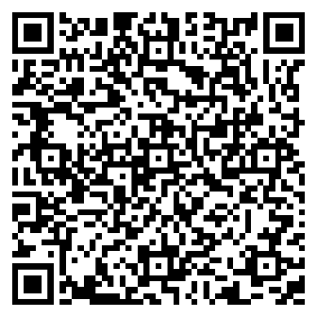
https://bit.ly/nfbcoif

Hosted by the National Federation of the Blind of Colorado
Questions? Call Tim at 720-338-7797.
Your independence starts here. Your adventure begins October 30th.

