Independence Skills Fair for Blind Youth

October 30, 2025 | 4:00 PM - 8:00 PM

Westin Hotel, Westminster, CO

Are you tired of people assuming you can't do things?

Want to learn skills that'll blow people's minds?

Ready to hang out with other blind teens who totally get it?

THEN THIS IS FOR YOU!

🔥 LEARN TO COOK WITHOUT CUTTING YOUR FINGERS OFF
Finally! Someone who'll actually teach you knife skills instead of wrapping you in bubble wrap. Make food that doesn't suck and impress literally everyone.
🤖 PLAY WITH THE COOLEST TECH EVER
• Smart glasses that describe everything around you (Seriously cool AI stuff)
• Braille displays that show graphics (Way more advanced than you think)
• Apps that make daily life way easier
🧭 NAVIGATE WITH CONFIDENCE
Learn O&M techniques and tips that'll help you get around more independently.
⠃ BRAILLE ISN'T DEAD (SERIOUSLY)
It's actually pretty useful when you know how to use it right. Plus, you get to make cool stuff.
🎯 GAMES & MAYBE BEEP BALL
Because learning is way better when it doesn't feel like school.

THE BEST PART?
Every person teaching you is blind too. They're not talking theory - they actually live this stuff and know all the tricks that work in real life.
Plus we're going out for pizza after! Because hanging out with people who understand you + good food = perfect day.

It's completely FREE. No catch. Just show up and level up.
🎟️ Scan this QR code or follow this link to register:
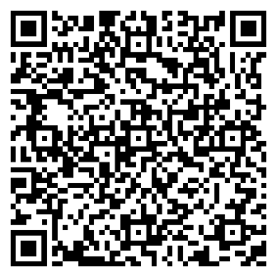
https://www.eventbrite.com/e/independence-skills-fair-for-blind-youth-tickets-1670764564789
Hosted by the National Federation of The Blind of Colorado
Questions? Call Tim at 720-338-7797.
Stop letting other people decide what you can and can't do.
October 30th is your day to prove them wrong.

