Independence Skills Fair for Blind Youth

October 30, 2025 | 4 PM - 8 PM

Westin Hotel, Westminster, CO

Ready to Show the World What You Can Do?
Being blind doesn't mean being helpless. Learn the skills that will make you unstoppable.
🍳 KITCHEN MASTERY - Safe cooking techniques and knife skills that build real independence
🤖 CUTTING-EDGE TECH - Hands-on with Monarch Braille Display, Meta RayBan Smart Glasses, and essential apps
🧭 CONFIDENT NAVIGATION - Orientation & mobility techniques for getting anywhere you want to go
⠃ BRAILLE LITERACY - Discover why this timeless skill still gives you an edge today
🎯 ADAPTIVE ACTIVITIES - Games, recreation, and maybe some beep ball action!

TAUGHT BY BLIND EXPERTS WHO'VE MASTERED THESE SKILLS
Plus FREE dinner at Dave & Buster’s afterward!
WHO: Blind students ages 12-18 | COST: 100% FREE
This isn't about what you can't do. It's about discovering everything you CAN do.

🎟️ REGISTER NOW
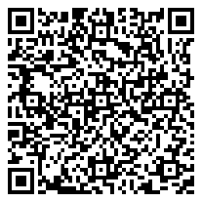
Scan to register or visit: https://bit.ly/nfbcoif
Hosted by National Federation of the Blind of Colorado
Your independence starts here. October 30th.

