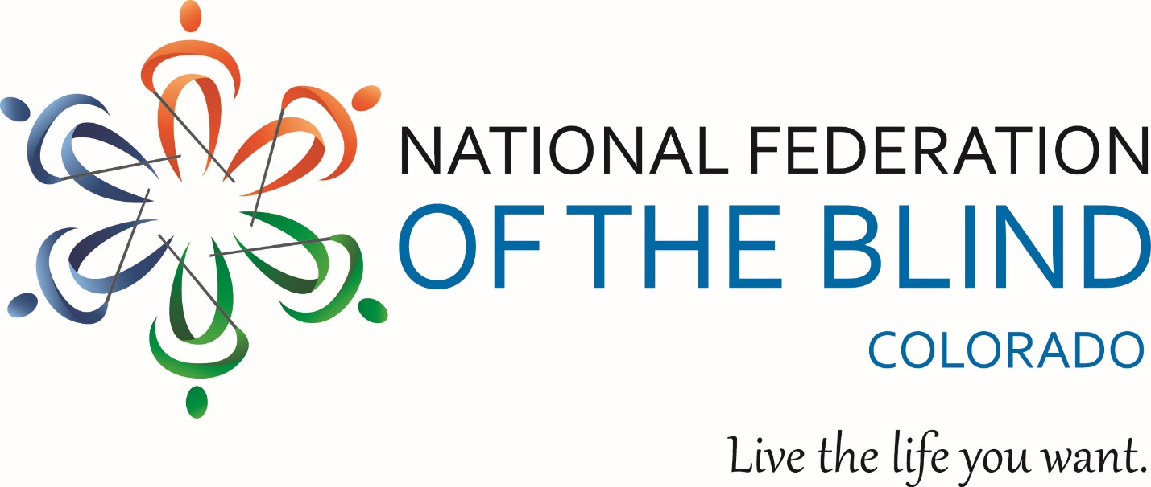
The National Federation of the Blind of Colorado invites your organization to sponsor our 2026 State Convention, November 5–8 at the Denver Marriott South at Park Meadows in Lone Tree. As the largest gathering of blind Coloradans in the state, the convention brings together over 300 attendees for four days of general sessions, breakout seminars, exhibitor booths, and community celebrations.

Sponsorship connects your organization with an engaged, statewide audience while directly supporting NFBCO’s mission to advance the independence, equality, and opportunity of blind Coloradans. While sponsors and exhibitors are welcome to keep their tables open during all general sessions and breakouts, this year, the dedicated exhibit hall hours will be on Friday from noon – 2 PM. Historically, we have found highest trafficked times are Friday afternoon and Saturday morning to give sponsors extended visibility throughout the weekend. The sponsorship levels and benefits available for 2026 are outlined below.

Title Sponsor – $10,000
- Year-round sponsor profile listing on the NFBCO website with link to sponsor site
- Year-round promotion in The Blind Coloradan blog
- Year-round recognition in NFBCO press releases and promotional materials
- Dedicated 10-minute presentation during General Session
- Option to host a breakout session
- Dedicated speaking greeting at Friday brunch
- Convention banner featuring sponsor logo
- 15 complimentary convention registrations
- 15 Friday brunch and Saturday luncheon tickets
- 15 NFBCO Banquet tickets with special recognition
- Premium exhibitor table with dedicated Friday hours (12:00 PM – 2:00 PM)
- Full-page ad in the convention agenda
- Special recognition throughout the convention

Platinum Sponsor – $7,500
- Logo placement on Convention banner
- Sponsor profile listing on NFBCO website with link
- Five-minute presentation during General Session
- Option to host a breakout session
- Greeting opportunity at Friday brunch
- Full page ad in the convention agenda
- 10 complimentary convention registrations
- 10 Friday brunch and Saturday luncheon tickets
- 10 NFBCO Banquet tickets
- Exhibitor table with dedicated Friday hours (12:00 PM – 2:00 PM)

Titanium Sponsor – $5,000
- Logo placement on Convention banner
- Option to host a breakout session
- Greeting opportunity at Friday brunch
- Half page ad in the convention agenda
- 8 complimentary convention registrations
- 8 Friday brunch and Saturday luncheon tickets
- 8 NFBCO Banquet tickets
- Exhibitor table with dedicated Friday hours (12:00 PM – 2:00 PM)
- Sponsor profile listing on NFBCO website with link

Diamond Sponsor – $3,000
- Logo placement on Convention banner
- Greeting opportunity at Friday brunch
- 6 complimentary convention registrations
- 6 Friday brunch and Saturday luncheon tickets
- 6 NFBCO Banquet tickets
- Exhibitor table with dedicated Friday hours (12:00 PM – 2:00 PM)
- Half page ad in the convention agenda
- Sponsor profile listing on NFBCO website with link

Gold Sponsor – $1,000
- Greeting opportunity at Friday opening session
- 4 complimentary convention registrations
- 4 Friday brunch and Saturday luncheon tickets
- 4 NFBCO Banquet tickets
- Exhibitor table with dedicated Friday hours (12:00 PM – 2:00 PM)
- Quarter page ad in the convention agenda
- Sponsor profile listing on NFBCO website with link

Silver Sponsor – $500
- 3 complimentary convention registrations
- 3 Friday brunch and Saturday luncheon tickets
- 3 NFBCO Banquet tickets
- Exhibitor table with dedicated Friday hours (12:00 PM – 2:00 PM)
- Quarter-page ad in the convention agenda
- Sponsor profile listing on NFBCO website with link

Convention Exhibitor – $275
- 2 complimentary convention registrations
- 2 Friday brunch and Saturday luncheon tickets
- 2 NFB Banquet tickets
- Exhibitor table with dedicated Friday hours (12:00 PM – 2:00 PM)
- Exhibitor name/logo in the convention agenda
- Exhibitor listing on NFBCO website with link

NOTE
The National Federation of the Blind of Colorado is not responsible for any merchandise left unattended at tables.

