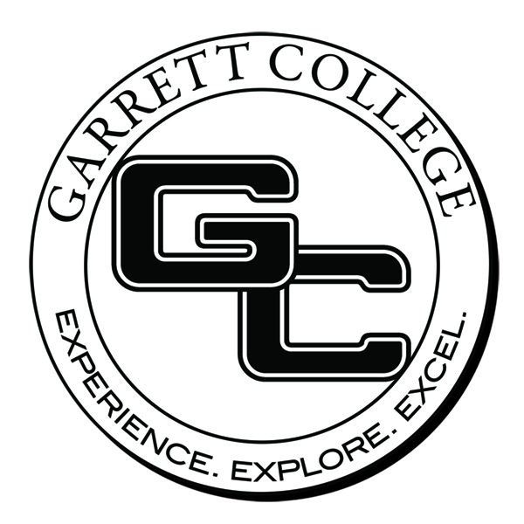
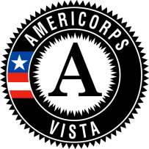

Position Title
Maryland-DC Campus Compact AmeriCorps VISTA serving at Garrett College

Status
Full-time, 12-month term of service

Organization Description
AmeriCorps VISTA (nationalservice.org/vista) is a federal service program designed specifically to fight poverty. AmeriCorps VISTA members are passionate and committed to their mission to bring individuals and communities out of poverty. Members focus their efforts to build the organizational, administrative, and financial capacity of organizations that fight illiteracy, improve health services, foster economic development, and otherwise assist low-income communities. Since 1997, Campus Compact VISTA programs have grown to more than 600 VISTA members working on campuses and in communities across 34 state Campus Compact programs.

The Maryland-DC Campus Compact (mdccc.org/americorps) is a non-profit membership association of public, private, 2- and 4-year colleges and universities. MDCCC provides leadership to colleges and universities in Maryland and Washington, D.C. by advocating, supporting, and encouraging institutional participation in academic and co-curricular based public service and civic engagement programs. MDCCC strengthens the capacity of member institutions to enhance student learning and to meaningfully engage with communities. MDCCC AmeriCorps VISTAs placed at higher education institutions across the Maryland-DC region encourage and promote the expansion of service and quality campus-community partnerships.

Garrett College provides accessible, quality education in a supportive environment to a diverse student population. We offer associate degrees and certificate programs as well as continuing education to meet the transfer, career, workforce development, and lifelong learning needs of our students and the community. We are committed to the ongoing development of engaging, innovative, and sustainable curricula, programs, and initiatives that are responsive to a changing world.

Position Description
The Maryland-DC Campus AmeriCorps VISTA serving at Garrett College will be engaged in the Garrett College Students in Need Group VISTA Project.

Member Duties
The Garrett College MDCCC AmeriCorps VISTA member will develop, implement and assess the Food Pantry program, as well as build and strengthen partnerships with community agencies. The MDCCC AmeriCorps VISTA member will also plan and facilitate the workshop series in conjunction with the food pantry. Another task for the MDCCC-VISTA member will be to advertise and market the program to Garrett College students, faculty, and staff who may benefit from the program. The MDCCC AmeriCorps VISTA member can also expand the current program from one day per week to additional days, based on an assessment of needs for our community. The MDCCC AmeriCorps VISTA member will also track donations, volunteers, and budgets and help assess the growing needs of the program.

Preferred Characteristics and Qualifications
- Organization, including time management, record keeping and the ability to plan and implement program initiatives
- Well-developed written and oral communication skills
- Computer Literacy (Microsoft Office Suite)
- Creativity
- A willingness to work with college students, faculty and staff
- Assessment (ability to research options for designing a survey instrument and analyze results)
- Self-starter, willingness to ask questions and seek clarification
- Ability to work both collaboratively and independently
- Demonstrating enthusiasm for public service and civic engagement

Required Qualifications
- Must be 18 years or older
- Must be a U.S. citizen, U.S. national, or lawful permanent resident alien of the U.S.
- Able to serve full-time for 365 days
- Ability to pass a criminal history background check
- Bachelor’s Degree

Benefits
- Segal AmeriCorps Education Award ($5730) or post-service stipend ($1500)
- Student loan forbearance or deferment while in service
- Modest living allowance
- Relocation allowance
- Life insurance
- Health Benefit
- Childcare (if eligible)
- Federal jobs non-competitive eligibility for one year after service
- Professional development opportunities
- Access to the network of VISTA & VISTA alumni (170,000 strong)
- Office space equipped with computer and telephone

Office Location
Garrett College (Learning Center) – McHenry, MD

Applications
Final candidates will be selected by April 24, 2014. For best consideration, please submit your application no later than April 6, 2015.

Application Link
https://my.americorps.gov/mp/listing/viewListing.do?id=59323&fromSearch=true

To Apply
Candidates for this position are requested to electronically submit an application through the AmeriCorps VISTA portal application link (above). The successful candidate will be subject to a pre-employment background check.

Contact
Kym Newmann
Garrett College
Student Life Office
687 Mosser Rd.
McHenry, MD 21541
Kym.newmann@garrettcollege.edu
301-387-3749

