**National Federation of the Blind of CT**

@ New Britain Stadium

***Catch the Future Stars of the Major Leagues!***

# Saturday, July

**20, 2013**

***Game Time: 7:05 PM Gates Open: 5:35 PM***

New Britain Rock Cats (Minnesota Twins) vs.

Binghamton Mets (New York Mets)

National Federation Of The Blind Of Connecticut Fundraiser & Fun Night At The Rock Cats!

Tickets Are *Only* $10! Portion Of The Proceeds Raised Will Benefit National Federation Of The Blind!

Come Out & Show Your Support For National Federation Of The Blind Of Connecticut!

Experience The Fun & Excitement Of Rock Cats Baseball With Family & Friends!

**Children 4 & Under Are Free!**

Please cut here

National Federation Of The Blind @ New Britain Stadium July 20, 2013 Gates Open: 5:35 PM Game Time: 7:05 PM

|  |  |  |  |  |  |
| --- | --- | --- | --- | --- | --- |
| Type | Price |  | Number |  | Total |
| Reserved | $10.00 | X |  | = |  |

*Parking is an additional fee at the game.*

***Double A Affiliate of the Minnesota Twins!***

Name:

Address:

Phone:

Email:

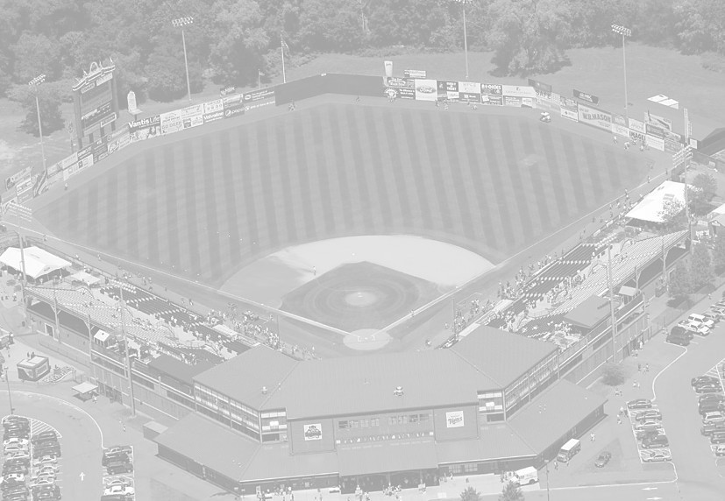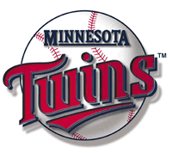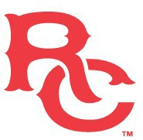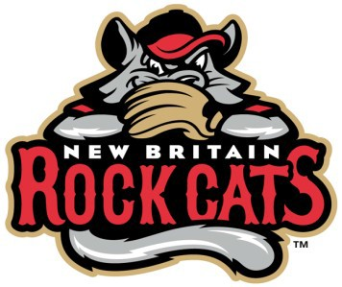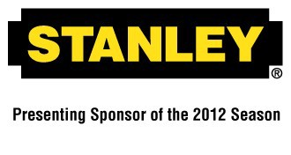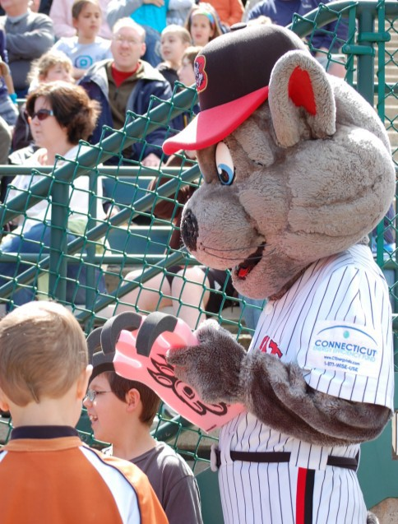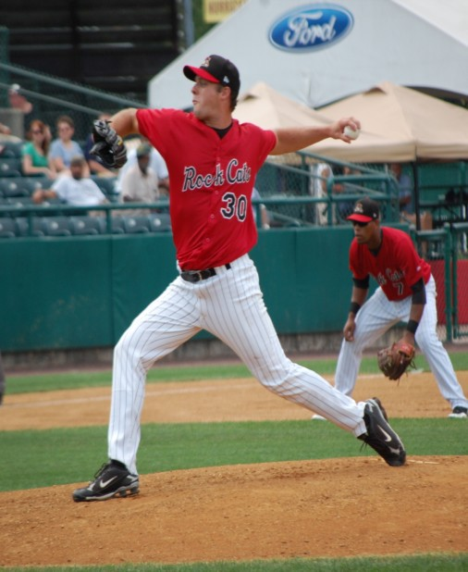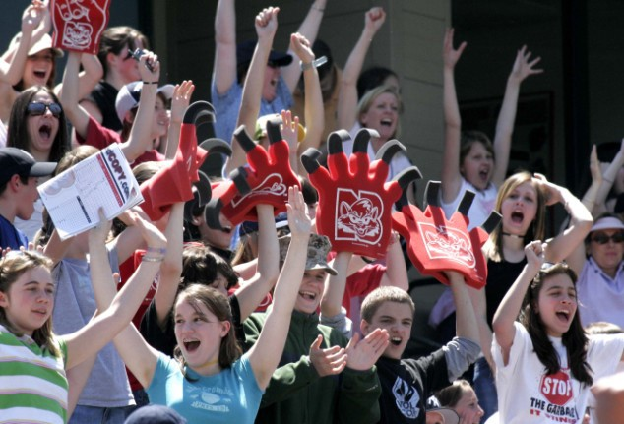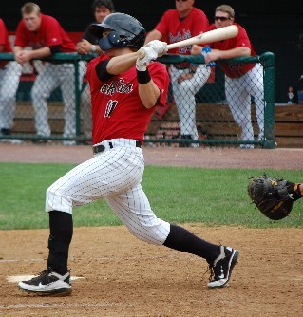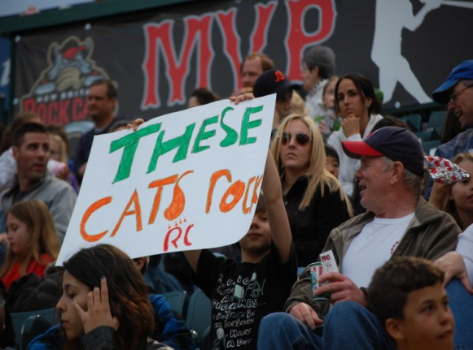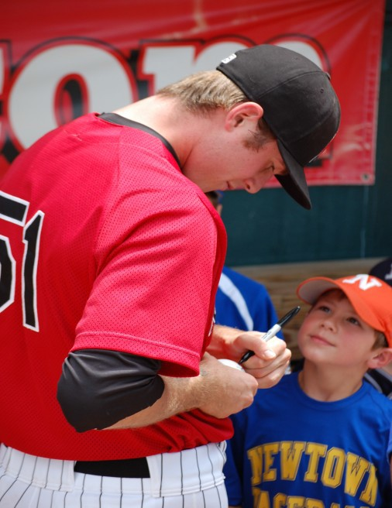

RSVP by 7/6! Please return your form and payment to Rob Palaski at the address below: 65 Glenwood Drive/Plainville, CT 06062

**Note “Rock Cats Tickets” on envelope front/Checks payable to National Federation of the Blind of CT**

Questions? Please contact Rob at 860-518-2081 or [palaski65@comcast.net](mailto:palaski65@comcast.net)