Learn CPR at Hartford City Hall!
July 15, 2013, 9:30a & 11a

Join Hartford in learning to save a life!
*At this free event you will learn CPR in just 30 minutes, and will receive a CPR training kit to take home!

*This is not a certification course

Project Partners & Advisors: American Heart Association – Conn. Capital Region Council of Governments Center for Resuscitation Science
City of Hartford
Department of Health & Human Service
Hartford Fire Department Hartford Hospital
Hartford Police Department
St. Francis Hospital & Medical Center
UConn Health Center
Supported by: Travelers

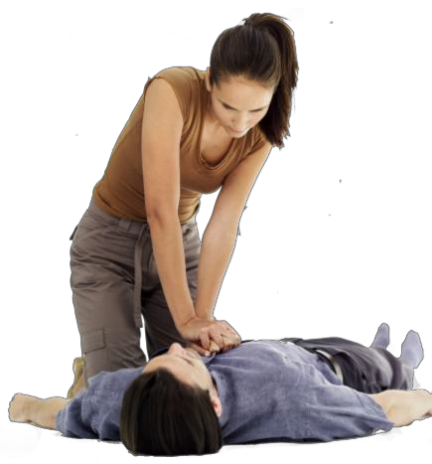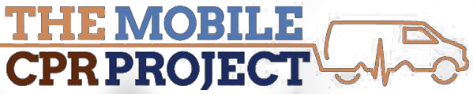

More information email: kelsey.sheak@uphs.upenn.edu

