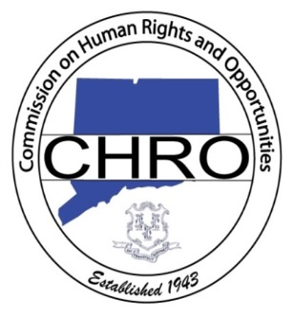Waterbury CT, March 27, 2014, 5:00 p.m. to 7 p.m. - The State of Connecticut Commission on Human Rights will host an informational session at Waterbury City Hall**,** 235 Grand Street, (Aldermanic Chamber) Waterbury, CT

**AGENDA**

5:00 Registration & Light Refreshments

5:10 Welcome and Introduction

5:15 Discrimination defined

5:20 Protected classes

5:30 Intake—the Process

1. Assistance provided by a CHRO Intake investigator
2. Mail in complaints

5:35 Proper drafting of a CHRO complaint

1. The parties
2. Identifying the correct Respondent or multiple Respondents
3. Background information
4. Concisely stating the allegations of discrimination
5. Untimely allegations
6. Continuing violations

5:45 Investigation

1. The process
2. Identifying witnesses
3. Providing documents
4. Duty to cooperate with the investigation
5. The role of the investigator
6. The findings of fact and conclusions made by the investigator
7. Surviving the process of investigation/Appeal

6:05 Alternatives to Full Investigation

1. Early legal intervention
2. Directed Investigation
3. Public Hearing
4. Release of Jurisdiction (involuntary)

6:15 The Public Hearing Process

* 1. Hearing Conference
  2. Settlement Conference
  3. Production
  4. Objections
  5. Witness and Exhibit Lists
  6. Pre-Hearing Conference
  7. Hearing

6:30 Questions and Answers