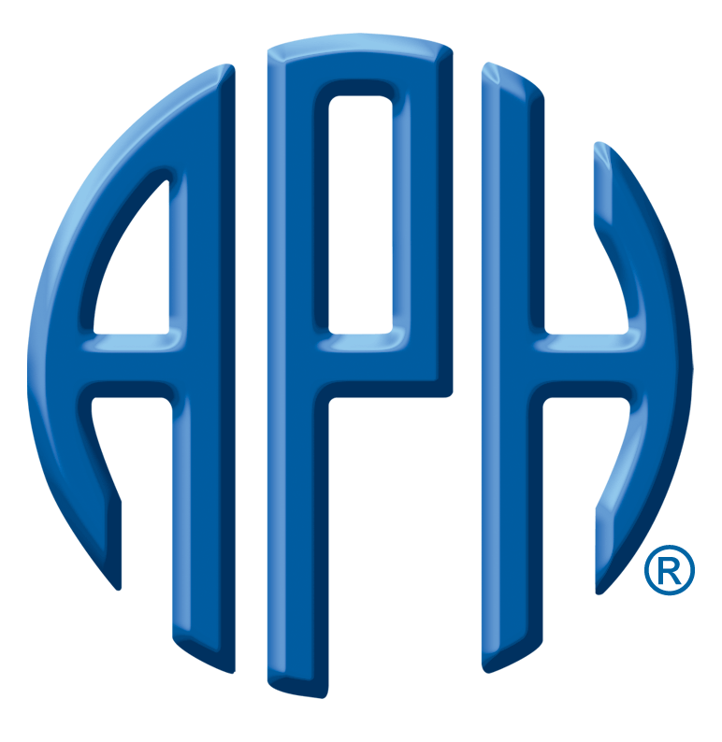
King's Daughters & Sons Gift

For Immediate Release
CONTACT: Roberta Williams, (502) 899-2357 (office), rwilliams@aph.org

Low-cost Refreshable Device to be Available in 2016

Louisville, Kentucky (August 27, 2014) - American Printing House for the Blind (APH) is pleased to announce that the Transforming Braille Project, for which it serves the CEO function, has reached a new plateau. Beginning in 2012, APH and eighteen other non-profit organizations http://www.transformingbraille.org/faq/#faq_03 concerned about the high cost of refreshable braille devices began a quest to create a low-cost option by forming an international consortium to work on the issue.

Recently, Orbit Research LLC http://www.orbitresearch.com/ and the Transforming Braille Group LLC http://www.transformingbraille.org/ announced an agreement to produce a low-cost refreshable braille display.

According to a release sent out by Transforming Braille Group, “The objective of the project is to produce a stand-alone 20-cell refreshable braille display for $300 (or £200) which will bring refreshable braille within the reach of children in developing countries and will provide libraries in developed countries with a viable alternative to hard copy braille. The product will be launched at CSUN (California State University, Northridge Center on Disabilities Annual International Technology and Persons with Disabilities Conference) in 2016.

The display is designed to work through USB and Bluetooth connectivity with 'smart' phones and tablets. It is not intended to compete with high specification refreshable braille displays already on the market, primarily used in education and employment, but is intended to bring braille displayed e-books to a wide audience at an economical price.”

Of the project, Larry Skutchan, CEO of Transforming Braille Group LLC and Technology Project Manager at APH, said, “Dramatically reducing the cost of refreshable braille is one of the most effective ways to increase literacy for people who are blind. Between this new refreshable braille display and the advent of free or low cost screen readers like NVDA, anyone can afford to participate in the electronic text revolution we all now take for granted. While the impact to people in less developed countries is most dramatic, even braille readers in more prosperous countries, like the United States, can afford to read without the help of government subsidies. Since the device works both independently and connected to computers and smart phones, it is possible to distribute documents with a commonly available SD card. The simple user interface is analogous to that of an electronic book reader, except that instead of a screen, it uses refreshable braille. This project truly transforms braille.”
-MORE-
“We’re excited to participate and lead this global effort for braille literacy,” said Tuck Tinsley III, APH President.

About the American Printing House for the Blind:
The American Printing House for the Blind, a 501(c) (3) non-profit organization, is the world's largest nonprofit company devoted solely to researching, developing, and manufacturing products for people who are blind or visually impaired. Founded in 1858, it is the oldest organization of its kind in the United States. Under the 1879 federal Act to Promote the Education of the Blind, APH is the official supplier of educational materials for visually impaired students in the U.S. who are working at less than college level.

APH manufactures textbooks and magazines in braille, large print, recorded, and digital formats. APH also makes hundreds of educational, recreational, and daily living products including computer software and an array of assistive technology items.

The American Printing House for the Blind, Inc. is located at 1839 Frankfort Avenue in Louisville, Kentucky. For more information, call (502) 895-2405 or log on to www.aph.org

Contact: Roberta Williams, 502-899-2357 or rwilliams@aph.org

-END-

