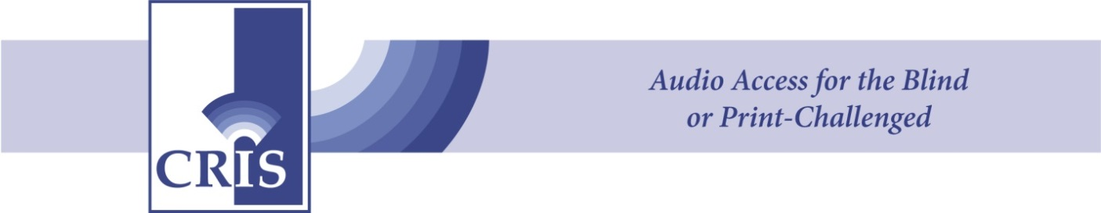

**CRIS Radio’s Educator of the Year**

**Who is eligible:** Any instructor/teacher who provides special educational services to children and/or adults within the state of Connecticut who are blind or print-challenged due to a physical, emotional, learning or intellectual visual disability.

**Nomination Period:** Now through Friday, **March 6, 2015**

**Who Can Nominate:** Any teacher, parent, student, supervisor, or community member may nominate a teacher

**Nomination:** Please write a brief essay explaining the reasons the nominee is worthy of being recognized for his or her **outstanding work** with children and/or adults who are blind or print-challenged. Testimonials from students and parents are welcome. The testimonials and/or essay should include the following: identify nominee’s place of work and town [school/agency/facility]; description of the educator’s capacity to inspire and increase learning and adaptation of students with special needs; and details on how the nominee improves the educational experience for his or her students.

**Application:** Entries (Essay, testimonials and nomination form) may be emailed to [info@crisradio.org](mailto:info@crisradio.org) or mailed to:   
CRIS Radio  
ATTN: Educator of the Year  
315 Windsor Ave.  
Windsor, CT 06095

***The winner will be recognized at the CRIS Radio’s 5th Annual Dining & Dancing in the Dark gala on the evening of Saturday, April 18, 2015 at The Bond Ballroom, Hartford, Conn.***