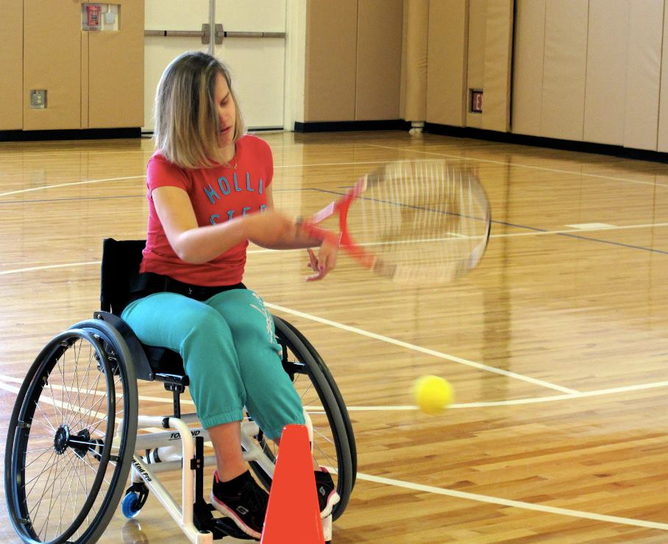

Learn to Play Tennis

For Children & Adults with Visual Impairments

Chapter 126 Sports & Fitness

Saturday April 11th

11 a.m. – 1:30 p.m.

One Saturday every month students from Yale will be coming to coach FREE clinics. This is a great opportunity to meet new friends and learn how to play the game! For more information call Stacia Cardillo at 860-769-3824