[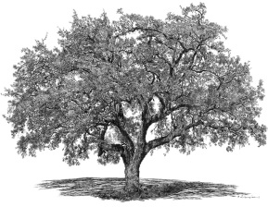](http://www.google.com/url?sa=i&rct=j&q=&esrc=s&frm=1&source=images&cd=&cad=rja&uact=8&ved=0CAcQjRw&url=http://www.bigtreestudio.com/liveoakcounty.html&ei=Up7nVIe-I4y_sQTN6YDoDg&bvm=bv.86475890,d.cWc&psig=AFQjCNGu8j-g5Kj8bV-AcpC8jLjetcAM1A&ust=1424551888460684)

**8th Annual Abilities Walk & Roll – Wednesday, July 22, 2015**

**PLEDGE FORM**

**Walker/Roller______________________________________ Phone_________________________________________**

**Address____________________________________________________________________________________________**

**Email_____________________________________________ $ GOAL________________________________________**

|  |  |  |  |  |
| --- | --- | --- | --- | --- |
| **First Name** | **Last Name** | **Phone No.** | **Email Address** | **Amt. ($) Sponsored** |
| **1.** |  |  |  |  |
| **2.** |  |  |  |  |
| **3.** |  |  |  |  |
| **4.** |  |  |  |  |
| **5.** |  |  |  |  |
| **6.** |  |  |  |  |
| **7.** |  |  |  |  |
| **8.** |  |  |  |  |
| **9.** |  |  |  |  |
| **10.** |  |  |  |  |
| **11.** |  |  |  |  |
| **12.** |  |  |  |  |

Please make checks payable to the “New Britain Commission on Persons with Disabilities”. Pledges must be received by July 21, 2015 at 4 p.m.

Please send or bring pledges to the New Britain Parks, Recreation, and Community Services Department, 27 West Main St., City Hall Room 302, New Britain, CT 06051. Thank you for your support of persons with special needs.