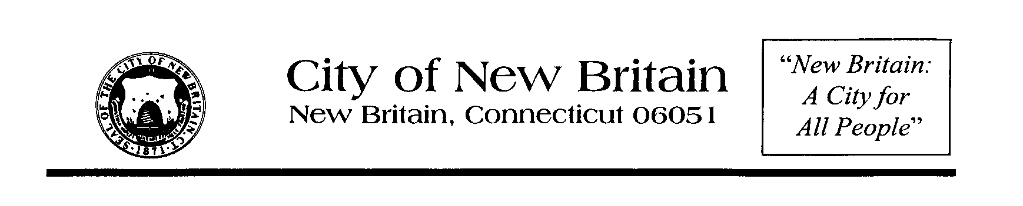

NEW BRITAIN PARKS, RECREATION, AND COMMUNITY SERVICES DEPARTMENT

March 5, 2015

Dear Friends:

On behalf of Mayor Erin E. Stewart, the Commission on Persons with Disabilities, and the Parks, Recreation, and Community Services Department, you are cordially invited to help us celebrate the “**8TH ANNUAL ABILITY/DISABILITY AWARENESS CELEBRATION**” that will take place at Walnut Hill Park in New Britain on **Wednesday, July 22, 2015**.

This is a special year for us as we are celebrating the 25th Anniversary of the signing of the ADA, the Americans with Disabilities Act. Our celebration is two-fold. We begin with our **8th ANNUAL ABILITIES WALK & ROLL**. This is a very special event for our Commission. This event was created for people of all ability levels. We hope to create and foster awareness of people with special needs. The **ABILITIES WALK & ROLL** is a one-mile walk/roll around beautiful Walnut Hill Park. We encourage participants, their families, friends, and caregivers to participate with us. We give everyone who attends a free tee-shirt. We also have free raffle prizes and refreshments. The **ABILITIES WALK & ROLL** steps off at 5:30 p.m.

This year, as an additional fundraiser, we are encouraging able‑bodied individuals to gather sponsorships for their participation in the walk. If you or someone you know would like to do so, please have them complete and return the attached **Pledge Form** listing people who are sponsoring them along with the donation pledges they have collected to us by July 21st.

Immediately following the walk, there will be a variety of entertainment including clowns, caricatures, a stilt walker, inflatables, and a live concert. This entertainment is being sponsored by the New Britain Parks, Recreation, and Community Services Department.

We need your help since there is no government funding for our event. We are dependent on generous folks like you. Would you or your business/organization consider making a donation to the Commission on Persons with Disabilities? All monies raise are used for this event. All sponsors will be listed on the back of the tee-shirt. We would also welcome “gift certificates” from your store/restaurant to use as raffle prizes. We also sponsor an informational fair with booths displaying products and services for persons with disabilities. If you or your organization would like to help us celebrate by walking/rolling with us on July 22nd, please join us. We will be on the west side of the Darius Miller Music Shell at Walnut Hill Park. If you would consider becoming a sponsor, please complete and return the enclosed Sponsor **Registration Form.**

Thank you for your consideration and your anticipated sponsorship of this important event. Thank you for recognizing those with special needs, as well as those who support and care for them. The Commission on Persons with Disabilities is committed to providing persons with disabilities equal opportunities to participate in all activities. We are very excited about this year’s event. Please, won’t you consider helping us? Let’s make the **8th ANNUAL ABILITIES WALK & ROLL** a very memorable event.

Should you have any questions, please call me at (860) 826-3368 or email me at [mkeyes@newbritainct.gov](mailto:mkeyes@newbritainct.gov)

Thank you for your support!

Very truly yours,

Maureen G. Keyes

Maureen G. Keyes

Disability Services Specialist