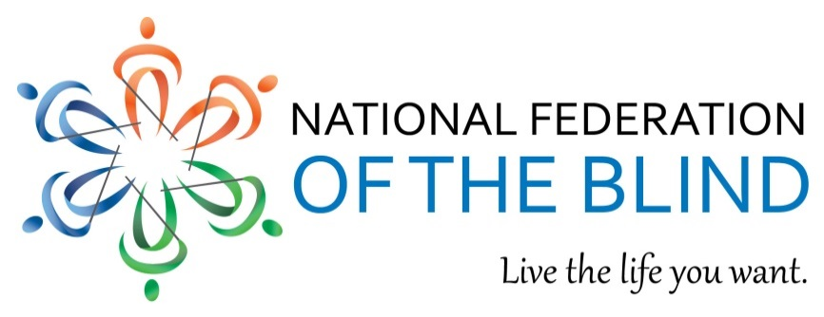

The Marrakesh Treaty to Facilitate Access to Published Works for Persons Who Are Blind, Visually Impaired, or Otherwise Print Disabled (“Marrakesh Treaty”)

An international copyright treaty will give blind Americans access to millions of
published works and improve the distribution of books across the globe.

Millions of Americans are being denied access to published works.
Despite the ability to convert print books into accessible formats like Braille, audio, and digital copies, over 95 percent of published works are unavailable to people with print disabilities. Literacy and equal participation in society are critical elements of a fulfilling and independent life, but until uniformity is built into the international copyright system, blind Americans will be excluded from accessing works. A blind student seeking to learn Spanish will likely struggle to find an accessible format; a work printed in English may have already been converted into an accessible format overseas, but because copies are not exchanged across borders, domestic entities might need to make a duplicate copy or just might deny access altogether by failing to reproduce the work.

An uncoordinated legal approach prevents the cross-border exchange of accessible books. Unlike the United States, where copyright code includes the Chafee Amendment and other exceptions, two-thirds of the world’s nations do not have domestic copyright laws that permit making copies for the blind, limiting the number of works available in an accessible format. Moreover, many countries consider distribution of accessible copies an infringement as well, and even amongst nations that permit distribution, limitations vary. Instead of exchanging books across borders, works are needlessly duplicated, and circulation is significantly limited.

The Marrakesh Treaty was adopted to achieve this goal. On June 27, 2013, a diplomatic conference convened by the World Intellectual Property Organization, (WIPO) in Morocco adopted the Marrakesh Treaty with outspoken support from the US delegation. The treaty, signed by the US on October 2, 2013, currently has eighty-two signatories and has been ratified by fourteen countries. Because the treaty calls for contracting parties to adopt copyright exemptions similar to those found in US law, the administration is developing a ratification package that should call for only a sleek, narrow set of modifications.

The Marrakesh Treaty has broad stakeholder support. Blind people should have full and equal access to all works that enrich lives, further education, and share critical information; the treaty balances this priority with the interests of rights holders. WIPO’s adoption of the Marrakesh Treaty was supported by American-based companies, the international publishing community, legal experts, and blindness advocates. The treaty will have tangible benefits for all involved.
Mark Riccobono, President | 200 East Wells Street at Jernigan Place Baltimore, MD 21230 | 410 659 9314 | www.nfb.org
The Marrakesh Treaty calls for contracting parties to provide in their national copyright laws for a limitation or exception that allows for the:

Reproduction of works, by an authorized entity, for the purposes of converting them into accessible format copies exclusively for beneficiary persons.

Distribution of accessible format copies exclusively to beneficiary persons.

Import of accessible format copies, for the purposes of making them available domestically.

Export of accessible format copies, for the purposes of making them available to a beneficiary person in another country.

Remove Barriers to Access of Published Works.
Support ratification of the Marrakesh Treaty.

For more information, contact:
Gabe Cazares, Government Affairs Specialist, National Federation of the Blind
Phone: (410) 659-9314, Extension 2206, Email: gcazares@nfb.org

National Federation of the Blind
Mark Riccobono, President | 200 East Wells Street at Jernigan Place Baltimore, MD 21230 | 410 659 9314 | www.nfb.org

Treaty to Facilitate Access to Published Works for Persons Who Are Blind, Visually Impaired, or Otherwise Print Disabled, June 28, 2013 http://www.wipo.int/edocs/mdocs/diplconf/en/vip_dc/vip_dc_8_rev.pdf.
World Health Organization, Fact Sheet, Visual impairment and blindness, http://www.who.int/mediacentre/factsheets/fs282/en/ last modified August 2014.
World Blind Union, FAQ Sheets on UN and Human Rights Instruments, Marrakesh Treaty to Facilitate Access to Published Works for Persons who are Blind, Visually Impaired or Otherwise Print Disabled, http://www.worldblindunion.org/English/resources/Pages/Global-Blindness-Facts.aspx last modified March 2014.
LaBarre, Scott. “Literacy Without Borders: The Road to Marrakesh,” Braille Monitor, August/September 2013. “Originally I had planned on a double major in government and Spanish. Ultimately I dropped that Spanish major precisely because I could not get access to Spanish novels and other materials.” https://nfb.org/images/nfb/publications/bm/bm13/bm1308/bm130811.htm.
17 U.S.C. § 121.
World Intellectual Property Organization, WIPO-Administered Treaties webpage http://www.wipo.int/treaties/en/ShowResults.jsp?treaty_id=843, Last modified on October 8, 2015.
Association of American Publishers, Statement on Completion of WIPO Treaty, Press Release, June 27, 2013. http://publishers.org/press/112/.
International Publishers Association, Closing Statement by the International Publishers Association, 27 June 2013. http://www.internationalpublishers.org/images/stories/copyright/statements/closing_statementFinal.pdf.
American Bar Association, Resolution 100, August 11, 2014. http://www.americanbar.org/content/dam/aba/administrative/mental_physical_disability/2014_hod_annual_100%20Marrakesh.authcheckdam.pdf
National Federation of the Blind, National Federation of the Blind Joins Stevie Wonder and World Blind Union Calling Upon International Negotiators to Conclude Successful Treaty for the Blind and Print Disabled, Press Release, June 24, 2014. https://nfb.org/national-federation-blind-joins-stevie-wonder-and-world-blind-union-calling-upon-international.

