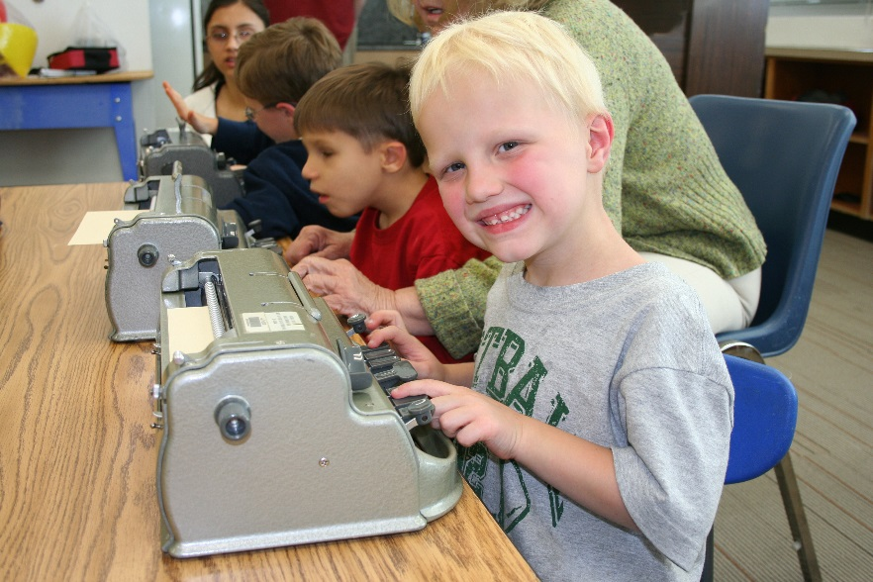

**SAVE THE DATE**

**BELL Academy**

**B**raille **E**nrichment for **L**iteracy & **L**earning

**The National Federation of the Blind of CT**

**Is Ringing The BELL Again This Year!**

**August 8 – 12, 2016**

Beth Rival, State Coordinator

Location:

First Church Of Christ

250 Main Street, Wethersfield, Connecticut

The National Federation of the Blind of CT will once again host a week-long Braille Enrichment for Literacy and Learning (BELL) Program in 2016! Our BELL Program will be held in the central Connecticut area from August 8th through the 12th for children ages 5 to 12 years old. In addition to Braille crafts and other fun hands-on projects, games and a field trip to the Dinosaur State Park, children will learn vital independent living skills. Our BELL Program helps build self-confidence and positive attitudes because successful, blind people will facilitate the majority of the lessons.

Please help spread the word about our BELL Program this summer! We need to raise awareness about Braille! We need to bring blind children together for a fun week! For more information, any questions, or to help with our 2016 BELL Program, please contact Beth Rival, coordinator or Ellen Schumann, teacher, through our Community Outreach Office at 860-289-1971 or info@nfbct.org.