2016 Public Meetings

Tuesday, March 22
5:00 p.m.-6:30 p.m.
CENTER FOR DISABILITY RIGHTS
369 Highland Street
West Haven, CT

Wednesday, March 30
5:00 p.m.-6:30 p.m.
New Park Office and Conference Center
151 New Park Avenue
Hartford, CT
Hartford Room

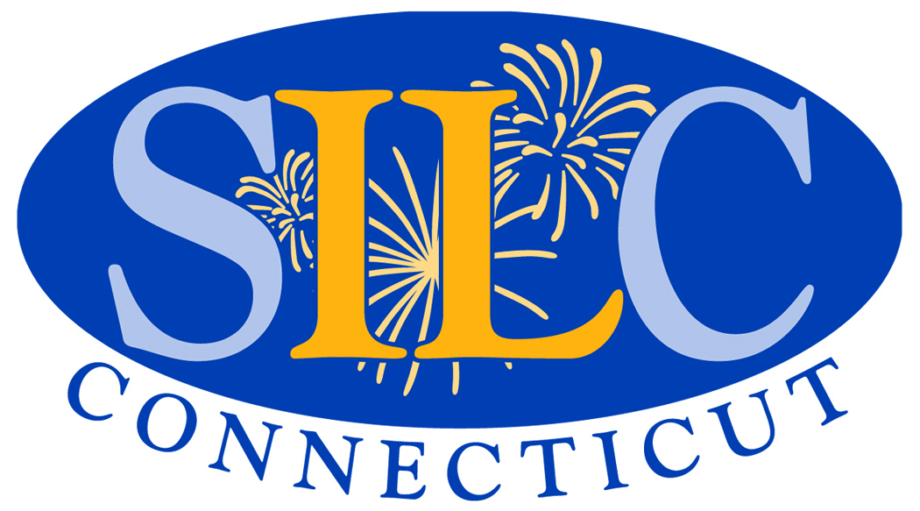

CT State Independent Living Council
Public Meetings for the
2017-2019 State Plan for Independent Living

Attend a meeting to give your input into the 2017-2019 State Plan for Independent Living. Let us know your ideas and thoughts on the independent living needs for people with disabilities and the use of federal independent living funds.
- What barriers exist that prevent people with disabilities from living independently?

- Can you assist us in identifying unserved and underserved populations?

- What services should be provided statewide?

Interpreter services will be provided. To register or for more information, please call (860) 523-0126 or e-mail Debbie Melaragno at deb@ctsilc.org.

151 New Park Avenue, Ste. 121-123
Hartford, CT 06106 www.ctsilc.org
860-523-0126

