**FOR A**

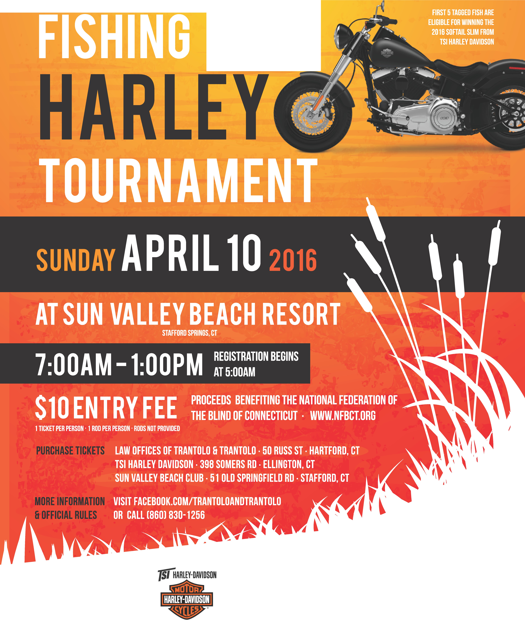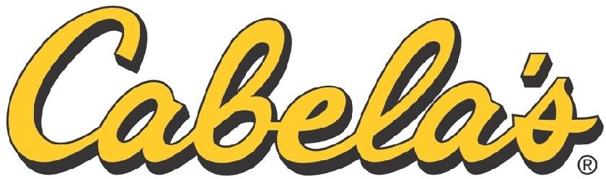

**W.;J Trantolo L!U&Trantolo,LLC**

WOR L D'S FOR EMOST OUTFITTER

SUN VALLEY RESORT

.

*·§ltf»·*

-

.

•

NATIONAL FEDERATION

OF **THE** BLIND

CONNECTICUT