National Federation of the Blind of Connecticut
at New Britain Stadium
Catch the Future Stars of the Major Leagues!
Fireworks after the Game
Saturday, August 19, 2017
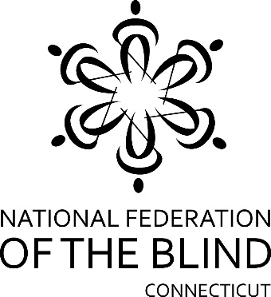

National Federation of the Blind of CT Fundraiser
Game Time: 6:35 PM
Gates Open: 5:30 PM

New Britain Bees vs. Bridgeport Bluefish
vs.
Southern Maryland Blue Crabs

& Fun Night at the New Britain Bees

Tickets are only $13.00. A Portion of the proceeds raised
will benefit the National Federation of the Blind of CT!

Come out & show your support for the
National Federation of the Blind of CT!

Experience the fun & excitement of Bees baseball with family & friends@!

National Federation of the Blind of CT Fundraiser at New Britain Stadium
July 30, 2016 Gates Open: 5:30 PM Game Time: 6:35 PM
Children 4 & under are free. Parking is an additional fee at the game

Name: ___________________________________________________________
Address: __________________________________________________________
Phone: _____________________ E-mail: ________________________________
RSVP by July 16th! Please return your form with payment to Rich Ireland, NFB of CT, 477 Connecticut Blvd, Ste 217, East Hartford, CT 06108
Note “New Britain Bees Tickets” on the envelope/Checks payable to: NFB of CT
Questions? Contact Rich at 860-747-5646 or rirelendjr@aol.com

