National Federation of the Blind of Connecticut
at New Britain Stadium

Catch the Future Stars of the Major Leagues!
Fireworks After the Game!
Saturday, August 19, 2017
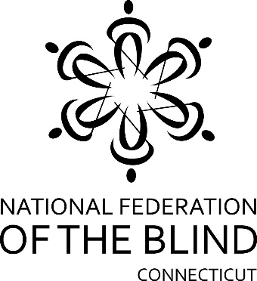
Game Time: 6:35 PM
Gates Open: 5:30 PM

New Britain Bees
vs.
Bridgeport Bluefish

National Federation of the Blind of CT Fundraiser
& Fun Night at the New Britain Bees

Tickets are only $13! A Portion of the proceeds raised
will benefit the National Federation of the Blind of CT!

Come out & show your support for the
National Federation of the Blind of CT!

Experience the fun & excitement of Bees baseball with family & friends@!

National Federation of the Blind of CT Fundraiser at New Britain Stadium
August 19, 2017 Gates Open: 5:30 PM Game Time: 6:35 PM
Children 4 & under are free. Parking is an additional fee at the game

Name: ___________________________________________________________
Address: __________________________________________________________
Phone: _____________________ E-mail: ________________________________
RSVP by August 5th! Please return your form with payment to Rich Ireland, NFB of CT, 477 Connecticut Blvd, Ste 217, East Hartford, CT 06108
Note “New Britain Bees Tickets” on the envelope/Checks payable to: NFB of CT
Questions? Contact Rich at 860-747-5646 or rirelendjr@aol.com

