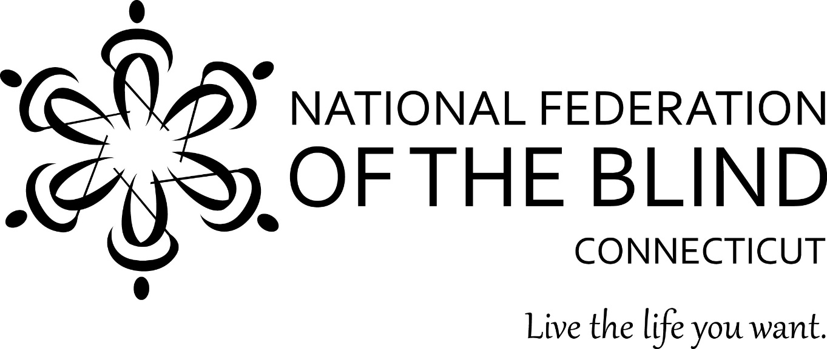
2017 Annual State Convention
November 3, 4, and 5, 2017
Courtyard by Marriott
63 Grand Street
Waterbury, CT
President: Gary Allen
National Federation of the Blind of Connecticut
www.nfbct.org
Facebook: National Federation of the Blind of Connecticut
Convention Hashtag: #NFBCT17
National Representative: Mark Riccobono,
President, National Federation of the Blind
The National Federation of the Blind of Connecticut knows that blindness is not the characteristic that defines you or your future. Every day we raise the expectations of blind people, because low expectations create obstacles between blind people and our dreams. You can live the life you want; blindness is not what holds you back.
Dog Relief Area: There is a grassy lawn outside the hotel’s main entrance on Grand Street. There are trash cans near the entrance.
Drawings for our 50/50 and Basket Raffles will take place at the banquet. Tickets will be on sale throughout the day on Saturday until the time of the drawings.
50/50 raffle tickets are $1 each or 6 for $5.
Basket Raffle tickets are $5 per envelope of 10 tickets.
Door Prizes: Door prizes will be awarded throughout the convention. To be eligible, you must be registered and in the room when your name is drawn.
The Connecticut Association of Guide Dog Users (CTAGDU) will be selling Ghirardelli chocolate PAW POPS for $3.00 each throughout the convention until supplies last. We usually sell out of PAW POPS ever year.
Get on the PAC Plan: The Pre-Authorized Contribution (PAC) Plan has come to be an ever-more important part of financing our movement. According to the chairman of the NFB’s PAC committee, Scott LaBarre, the Federation has raised more than ten million dollars over the years through the PAC Plan. The PAC Plan allows members, affiliates, chapters, and others to make recurring monthly donations by direct withdraw of funds from a checking account or a charge to a credit card. Because of the costs associated with operating the program, the minimum donation is $5.00 a month and there is no restriction on how much you donate. Please see Marie Beaulier to sign up at the convention to begin a new PAC contribution or to make changes to your current contribution. Your donation will help the blind live the lives we want.

Friday November 3, 2017:
All events will be held in Salon 2 of the Clock Tower Ballroom
JOB SEMINAR
1:00 p.m. - 1:20 p.m. Comments from Mark Riccobono, President of the National Federation of the Blind
1:20 p.m. - 2:00 p.m. An overview of Department of Labor Services, including services that partners provide (Heidi Sulewski from the Department of Labor and Jill Larmett from the Department of Rehabilitation Services).
2:00 p.m. - 2:30 p.m. - Resume tips (Heidi Sulewski)
2:30 p.m. - 3:15p.m. - A panel discussion (Sue Burton, an employment consultant from the Department of Labor, Suzanne Westhaver from the State Department of Human Rights and Opportunities (who is successfully working), Chelsey Duranleau who teaches Braille and technology at BLIND, Inc, and Sarah Elizabeth Carabetta who has employed blind and low vision clients from the Bureau of Education and Services for the Blind.
PRESIDENT’S MEETING
5:00p.m. - 6:00p.m. Mark Riccobono, President of the National Federation of the Blind will meet with the State President and Chapter Presidents.
5:00p.m. - 6:00p.m. Nathanial Wales, Treasurer of the National Federation of the Blind will meet with the Chapter Treasurers.
DINNER & EVENING ACTIVITIES
6:00p.m. - 7:30p.m. Dinner will be in the same room as the Job Seminar. Attendees will order off of the menu at their own expense.
7:30p.m. – 10:00p.m. Pool party and Bingo.
10:00 p.m: We will show the movie “Do You Dream in Color?” in the Waterbury Meeting Room.
This will be a time for friends to get together and socialize, catch up, relax and have fun. Bingo will be held in the same room as the Job Seminar, not in the pool area.

Saturday Morning, November 4, 2017
Morning Session & Lunch will be held in Salons B & C.
8:00 a.m. Registration & Continental Breakfast
9:00 a.m. Call to order; NFB Pledge.
9:05 a.m. Opening Ceremonies Invocation
Welcome from the Waterbury Chapter (Josephina Martinez)
Convention arrangements/announcements
Nominating Committee Report
9:10 a.m. Low Viz Guide (Joe Roberts)
9:20 a.m. National Report: Mark Riccobono, President, National Federation of the Blind
10:00 a.m. Josephina Martinez will talk about Blind Camp.
10:10 a.m. What's New at the Bureau of Education and Services for the Blind? Brian Sigman, Director, Bureau of Education and Services for the Blind.
10:30 a.m. Aira: Explore Your World. Edward Shaham, Former President of the National Federation of the Blind of Connecticut
10:40 a.m. Gordon Reddick, Director, Library for the Blind & Physically Handicapped
10:55 a.m. Chapter 126 Fitness break
11.00 a.m. Jim McCollum, Legislative Coordinator, National Federation of the Blind of CT
11:15 a.m. President's Report: Gary Allen, President, National Federation of the Blind of Connecticut
11:25 a.m. Esther Levegnale will talk about her experiences skiing and going on cruises
11:35 a.m. Trantolo and Trantolo presentation
11:45 a.m. Anne West and Marie Beaulier will speak about HAM radio
12:00 p.m. National Centers Panel: Chase Cummins, alumni, Louisiana Center for the Blind; Chelsey Duranleau, BLIND, Inc; Brian Martin, alumni, Colorado Center for the Blind.
12:30 p.m. Adjourn and Lunch.

Saturday Afternoon Events:
Division meetings: Salon A
1:00 p.m. – 2:00 p.m: The Connecticut Association of Guide Dog Users will hold their annual meeting.
2:00 p.m. – 3:00 p.m: The Connecticut Association of Blind Students will hold their annual meetings
Vendor Fair: 1:00 p.m. – 4:00 p.m. Clock Tower Ballroom
This is a chance for attendees to meet some of the speakers as well as vendors who did not get a chance to speak in the morning. You will be able to purchase their items or get information about their services. A vendor list is on the back page
Car Show: 1:00 p.m. – 4:00 p.m. Roof-top level of the hotel parking garage.
Many people who have lost their sight still have a passion for cars. So, on the top parking lot area of the parking garage, there will be several vehicles of various ages where our members as well as members of the public will be allowed to touch, feel, in some cases even sit in the cars and reminisce about the particular cars with the owners.
Seminars: Waterbury Meeting Room
1:00 p.m. – 2:00 p.m. Mobility Seminar
2:00 p.m. – 3:00 p.m. Storm Chasing
2:00 p.m. – 4:00 p.m. Chapter Presidents will create unique Mystery box to be used at outreach tables. A mystery box is a device that can be used to demonstrate the importance of touch.
Saturday Evening, November 4, 2017:
Salon C
5:00 p.m. Social Hour/Cash Bar in The Bistro
6:00 p.m. Banquet Dinner
Maryanne Melley will be our Master of Ceremonies.
Invocation
Introduction of head table.
Woodward Award Presentation
Keynote Address-Mark Riccobono President, National Federation of the Blind.
June Rose Killian Memoriam: Esther Levegnale
Ellen Bedford Memoriam: Nathanael Wales
Brenda Somerset Memoriam: Anne Walsh and Marie Beaulier
Presentation of 2017 NFB of Connecticut Scholarships
Basket Raffle Drawing
50/50 Raffle Drawing
Cash Bar will follow the Banquet in The Bistro.

National Federation of the Blind of CT
Business Meeting Agenda
Saturday November 5, 2017
Salon C

8:15 a.m: Full Breakfast
Chapter building with Mark Riccobono
Roll Call
Elections: we will have elections for two board members and the secretary position
Secretary’s Report
Treasurer’s Report
Reports:
SRC-
BCAC-
BESB-
Committee Reports:
Birdies for Charity: Debbie and George Reed
PAC Plan: Marie Beaulier
Vehicle Donation Program: Kimberly Tindell
NFB-Newsline: Gary Allen
Federationist: Maryanne Melley
Coccomo Grants: Esther or Mary Silverberg
2018 National Federation of the Blind of Connecticut Convention.
Convention committee
Chapter News: At-Large, Central CT, East of the River, Hartford, Middletown, Shoreline, Southern CT, Stamford, Waterbury.
Washington Seminar-
Adjournment at noon

Vendor List
Bureau of Education and Services for the Blind (BESB)
Guiding Eyes: Kathy Rooney
The Crafters Division: Leonard Schlenk
Non-24: David Campbell
Diabetic Division/Pack Plan: Marie Beaulier
Newsline: Jim McCollum and Gary Allen
Perkins School for the Blind: Kate Katulak
Jehovah’s Witnesses: Sue Shepard
Celphies Cell Phone Products: Ross Biernick
State Department Human Rights and Opportunities (CHRO): Suzanne Weshaver
Chapter 126: Taylor Deegan
Library for the Blind and Physically Handicapped: Gordon Reddick
Candles for a Cause: John Mendonca
Low Viz Guide: Dan Roberts
Blind Inc. /Louisiana Center for the Blind: Chelsey Duranleau
Qunnnipiac Student Group

