REGISTER TODAY

2018 Candidates’ Forum on Disability Issues:

A non-partisan forum for federal

and statewide candidates

Thursday October 11, 2018
Forum: 3:00-6:00 p.m.
Reception: 6:00-8:00 p.m.
Red Lion Hotel Cromwell, 100 Berlin Rd., Cromwell, CT
Register at:
2018 Candidates' Forum on Disability Issues
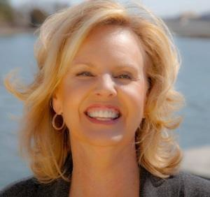
Diane Smith, Moderator
A New York Times bestselling author, Emmy award winning journalist, documentary producer and speaker, Diane Smith is a media veteran. Diane has been on the air in CT for over 25 years and teaches Communication at the University of New Haven.

Funders
- CT Council for Developmental Disabilities
- CT Cross-Disability Lifespan Alliance
- CT State Independent Living Council
- Disability Rights Connecticut
- University of Connecticut Center for Excellence in Developmental Disabilities

For more information or to become a forum sponsor, please contact:

Melissa.Marshall@snet.net

