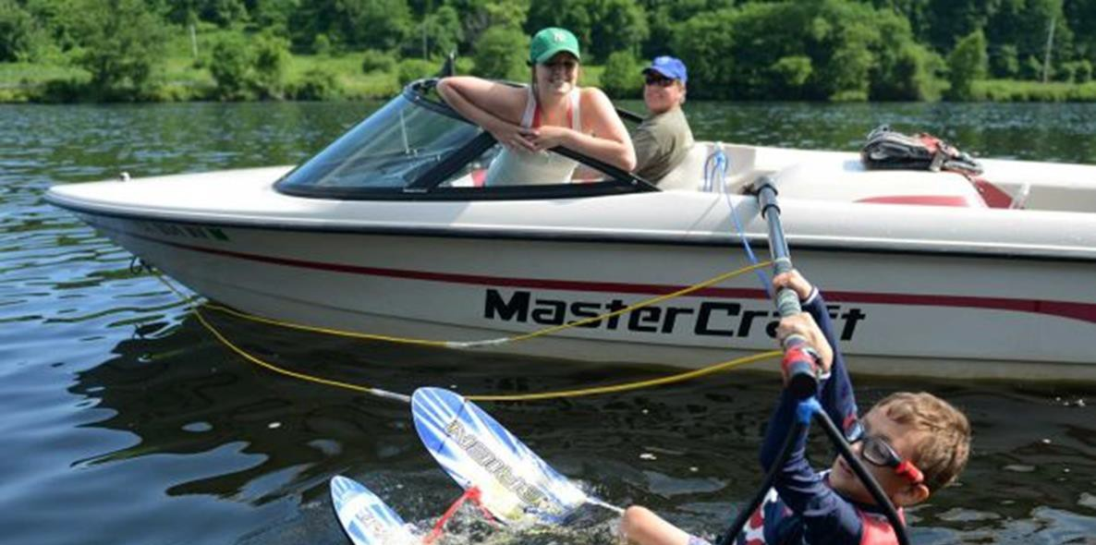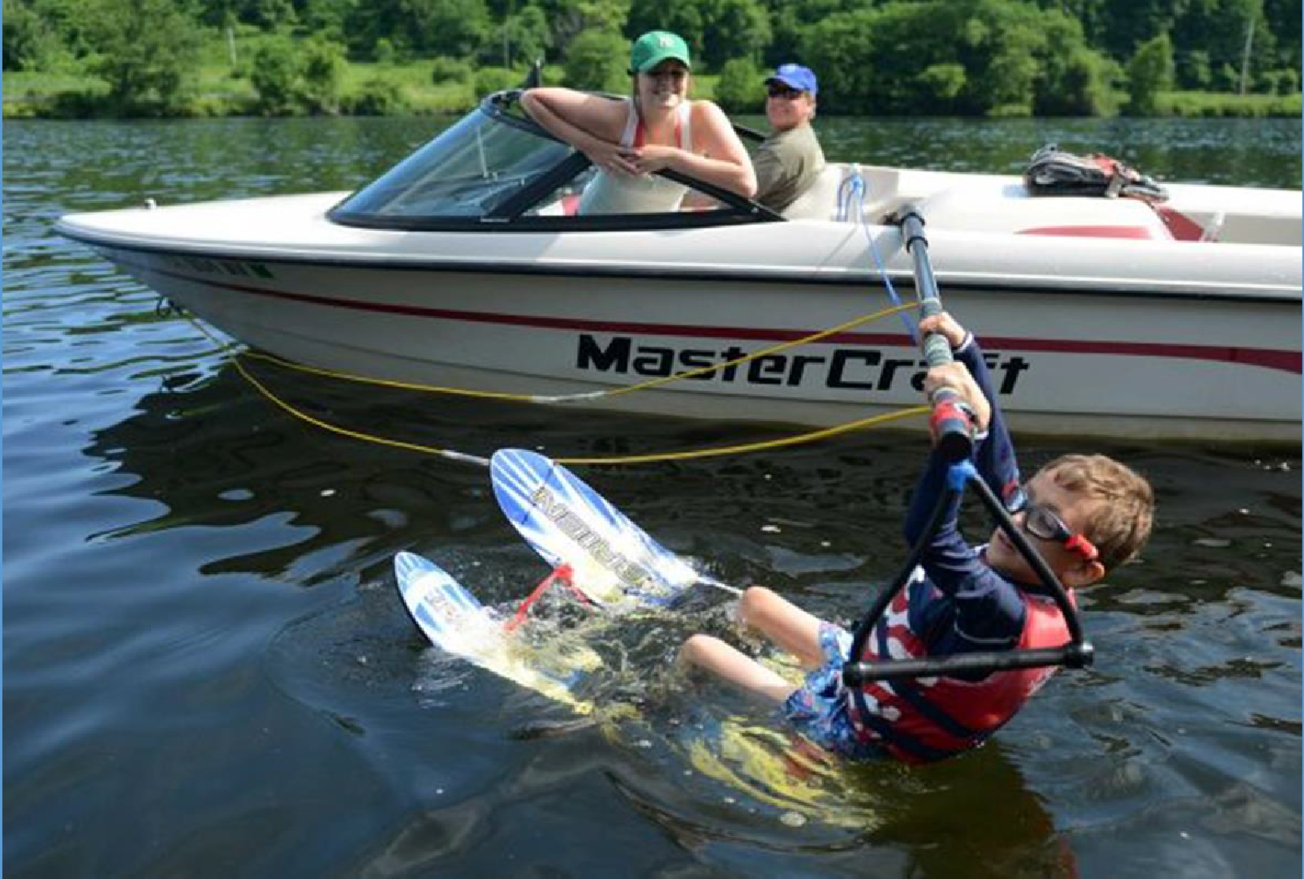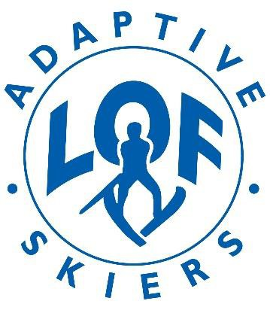June 26-27, 2019 - Newtown, CT

Adaptive Water Sports Event for the Blind and Visually Impaired
A multi-day water sports event designed for visually impaired and blind kids, ages 6-17. Specializing in adaptive water sports for more than 27 years, LOF Adaptive Skiers will teach both beginner and intermediate waterskiing and wakeboarding at this event. This program is free of charge.
Enrollment is Limited, so please register early to ensure a spot.

For registration information, call or email us at:
(203) 426-0666 - LOFskiers@gmail.com
LOFAdaptiveSkiers.org

