THE
FEDERATIONIST
In Connecticut

Winter 2019

Executive Editor: Melissa Carney

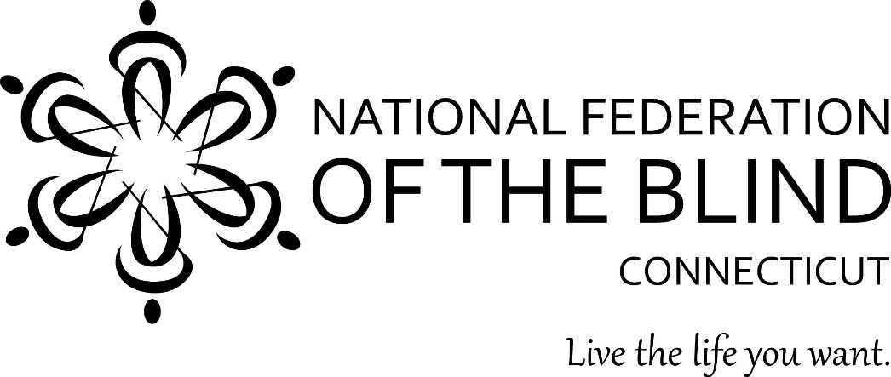

NATIONAL FEDERATION OF THE BLIND OF CONNECTICUT
111 Sheldon Road, Unit 420
Manchester, CT 06045

Table of Contents
1: From the Editor, Melissa Carney
2: Sight through My Eyes: The Power of Outreach and Community
3: From Stigma to STEM
4: Venturing into Uncharted Waters
5: The Philosophy of a Device
6: Chapter Meeting & Division Information

From the Editor
Melissa Carney
Executive Editor, The Federationist

Happy New Year to all of our Connecticut affiliate members! It seems like just yesterday that we entered into 2019 with hopeful ambitions, the taste of resolutions on our tongues, and the thrill of new paths ahead. It also seems as if we just awoke from the heat of summer and crisp fall air with winter already upon us. Some feel that 2019 was too short, that they were unable to accomplish everything they set out for. However, the most precious moments in time are often the smallest. These slivers of life represent stories worth telling. From an aspiring engineer, to a blind philosopher, outdoor adventurer, and community advocate, we explore what made 2019 unique to a handful of individuals. Perhaps you will read these articles and adopt these endeavors as your own in the coming year. Despite the changing seasons and passing decades, there is time yet to go out on a limb and swing a bit until you find your rhythm.
Please enjoy the following articles about the captured and treasured memories and opinions of your fellow NFB members. If you would like to submit your own piece of writing to the next issue of the Federationist, send it my way. This publication cannot exist without the support of our CT NFB family. I want to hear your stories, your successes, your struggles, and everything in between.
Please sit back, relax, and enjoy the latest issue of the Federationist!
Feel free to direct any suggestions, questions, or concerns to Melissa Carney, Executive Editor, at ctabs.president@gmail.com.

Sight Through My Eyes: The Power of Outreach and Community
By Rob Palaski

On August 10, 2019, the Central Connecticut Chapter of the National Federation of the Blind held an awesome outreach project. It was different from a lot of others because it was a picnic. This does not sound different. However, the different part was that we all invited family, friends and loved ones. The simple reason for this was to help them become aware. Many people in our lives have never known another blind person besides us. Therefore, they don’t have the full understanding of what it means to be blind and live day to day in our shoes. We thought that by getting them to interact with others, it would give them a different perspective. I believe that not only was it a very fun afternoon but also a big learning experience not only for them but for us. We were also able to learn a bit about ourselves and that we can teach them. I think that one thing that they learned was that the word helping does not mean doing it for you. Do we need help sometimes? Of course, we do and so does everyone. If someone needs help, they should not be afraid to ask.
There was food, fun and quite a bit of socializing. There was so much food but surprisingly most of it was eaten! Hey, that’s what picnics are for, right? With everyone there was about 35 people there. The weather could not have been any better and the pavilion at Norton Park in Plainville was perfect. We were right next to another party who had a food truck that made tacos which I thought was a very cool idea and of course, the ice cream truck was around for a while, too. I hope that this becomes a tradition and we can continue to do this for many years to come. This was an outreach project that I totally appreciated.

From Stigma to STEM
By Lizzy Cappelli

My name is Lizzy Cappelli, I am currently a senior in high school and want to tell all of you about my incredible summer with the National Federation of the Blind. I cannot thank this organization enough for allowing me to explore engineering and STEM without sight. This organization hosted a program known as NFB EQ to introduce visually impaired students to science. Through this program, I was able to learn about structural engineering through hands-on work. This included using a 3D Plexiglas cube with tape conveying technical drawing, sensational blackboards which turn pen lines into tactile drawings, braille rulers, as well as woodworking. Yes, and you read that right, 30 blind students learned how to use woodworking tools. Plus we used this knowledge to create our scale model “Place of Their Own”.

Throughout the program we attended classes and one of these included going over woodworking tools such as a miter box, and balsa wood. If you are familiar with miter boxes you may have noticed that there are notches to place your knife in to cut the wood. These notches are apparent visually, but also tactilely. You can also hear if your knife is cutting the wood or metal based on the sound it makes, or if it squeaks after cutting for a little meaning your wood snapped often resulting in a rough cut.

Although woodworking was a major part of this program, we also talked with visually impaired engineers. This included someone who works with the Army Corp of Engineering, a civil engineer who works with transportation and traffic, as well as someone who works with single-cell and multi-cellular organisms in biomedical engineering. We also worked with many more amazing mentors, instructors, and professors from the University of Utah. Overall we were able to take advantage of the knowledge these incredible people have and learn how the visually impaired speakers succeed in a competitive environment, and the techniques they have used.

Lastly, I would like to share my takeaways from this program beyond learning. As previously stated the NFB believes blind people are just as capable as sighted people with the right training, and support. After spending a week with incredible mentors, and teachers, I have come home with new perspectives. One of these includes that it’s alright to access materials without sight. It is often thought that when you are disabled that you should use everything you have left to get through life and succeed in the world, I realized this was not the case. For many years I have been focused on accessing material through large print since it is the closest thing to 'normal' that I can use. Yet, when I explored the tactile diagrams and braille rulers, I gained a stronger understanding of what I was working with. This idea that you have to use your remaining vision in my case fell apart. I realized that it is alright to accept that I am legally blind and that I can and should access materials in a way that allows me to excel the most although it may not be the closest thing to what’s considered normal. In conclusion, I cannot thank the NFB enough for giving me the resources to learn about engineering and STEM and the ability to be a part of an amazing community.

Venturing Into Uncharted Waters
By Deb Reed

On probably the best weather day in June, four NFB of CT members from the Central Chapter embarked on an outdoor adventure! Thanks to an organization called LOF Adaptive Skiing founded by Joel Zeisler, we got to experience kayaking! The place was Lake Zoar, located in Sandy Hook, Connecticut. Joel started this organization in 1992, making both water skiing and snow skiing accessible for handicapped individuals. Although we were not interested in those particular sports, he graciously created a kayaking experience for us. We all sat in tandem kayaks with a sighted partner. Each volunteer had some connection with the blind as well as people with other challenges. They had a good understanding of our needs which meant a lot.

It was early in the morning and the sun felt warm, just right. After strapping on a snug life vest, I settled down into the kayak with my partner Ben in the back. The person in the back does most of the work and can control the direction of the tandem kayak more easily. That sounded good to me since it was my first time. As the water started out calm, with a slight breeze, I found it easy to synchronize my paddle strokes with Ben’s. He was quick to point out that I could just relax whenever I wanted to and let him do the work. I took him up on that offer several times in the hour and a half we spent on the water. The sounds of the birds singing, the fresh air and the scents of the wildflowers, all made for a very calm and peaceful experience. A family of swans was spotted, with mom and dad and three babies.

The four of us agreed we loved kayaking and wanted to do it again sometime. We all felt it gave us feelings of freedom, peacefulness, calmness and confidence! I would recommend the sport as an enjoyable one for the blind.

The Philosophy of a Device
By Alan Daniels

At one time, devices referred to somewhat sinister methods an individual would use to accomplish a somewhat dubious end. The word "device" now refers to a thing that is animate and can be touched. There are many devices today, just as there were traditionally many devices for accomplishing an end. These physical, mechanical and electronic devices have differences and similarities to each other. We tend to think that anything that is electronic in nature today has a "computer" in it. I don't have the knowledge to differentiate in what has a CPU, rom, ram, and so on.

The common theme is, "They control our lives." We decry the loss of "bricks and mortar" as we purchase "online." Have you recently found anything that was impossible to buy "online," and had to resort to a "bricks and mortar'" establishment? It would be highly unlikely that that would happen. I'm sure the reverse is true many times over. How many times have you heard, "You can get it online."

It appeals to our adverse nature. "Mom and pop" find it hard to get an even break. We have to resort to assistance to commerce in order to operate business nowadays. And, there again, is another business to impede the growth of business. The government agencies dealing with business can be toxic to business itself. If it is levying another fee, tariff or tax, beware prospective entrepreneurs! Once a business is established, it falls prey to those factions that depend upon a healthy business atmosphere. And, make no mistake, it is not a healthy business atmosphere unless you are so blessed with income that far surpasses the cost of operation. True, an "online" business can operate with low overhead, but you are not out in the public and unfortunately the hyperspace marketplace is an enormous frontier. If you have a product that is renowned for its longevity you may have one advantage. But, "Hands on" can give an advantage to any business. Shipping costs are to be figured in when buying online. I tend to come down on the side of bricks and mortar, so a picture on a tiny screen is not a great selling point. The "fast" deal is an advantage for either side. Actual visual contact, touch, sound, smell and sometimes taste are factors that weigh heavily in favor of the bricks and mortar.

The words espoused by a 20th century philosopher, Marshal McCluen, ring true. "The medium is the message." Who are the people that predict the sales and marketing trends of the future? I propose that they are marketing people who have some knowledge of scientific developments. Or, are they scientists who have some knowledge of marketing? Maybe the futurists are both of these.

You can bet, however that they have an excellent knowledge of copyright and patenting laws. Did the button industry shiver when the zipper was invented? I'm sure they did, but we still have buttons and frequently they have a direct advantage over zippers. Once a zipper jams, it usually means the garment is inoperable as intended. When we lose a button, it is far from the end of that garments utility. How many devices today can be repaired out of the thousands and millions of electronic devices we encounter each year? Even now we are trying to recover the precious materials from discarded electronic equipment. A bricks and mortar store can survive if it is found to provide a much needed service and is accessible to the public. It takes a clever entrepreneur to set up a successful business. The bigger the business and its reputation, as well as the capital behind it, the more routine the forethought is. True, they consider the traffic, the items, and the demand of the public, but there usually is little concern for the personality and likability of the general operation. That is another point highly in favor of "mom and pop." People will go out of their way to patronize a business they like. Unfortunately, the big business can pull some under handed tricks to effect the demise of a healthy small business. Again I must say the vote is with the consumer. We have a contrary nature that says, the bigger business is the better buy, not so always. Cast your vote very carefully when you are in the marketplace. And, remember, when you are online you are most definitely in the market place.

The Connecticut Association of Blind Students advocates for equal access to course materials, both on a local and national stage, organizes social events to foster a supportive community, and encourages its members to obtain greater confidence in their abilities. Every member of the Connecticut Association of Blind Students has the opportunity to network with other successful blind individuals, speak on shared interests and aspirations, and challenge themselves to become leaders. We hope to guide and mentor visually impaired high school and college students through the adversity they face on a daily basis. For more information, contact Melissa Carney at ctabs.president@gmail.com

If you are a guide dog user or are interested in the Connecticut Association of Guide Dog Users, please contact the NFB of CT at 860-289-1971 or info@nfbct.org

CHAPTER MEETING INFORMATION

Central Connecticut Chapter Greater Hartford Chapter
Deb Reed, President Gary Allen, President
860-973-3679 860-607-6774
Meetings: Meetings:
2nd Saturdays at noon 3rd Saturdays at 11:00 AM
Plainville Library Wethersfield Public Library
56 East Main Street, Plainville 515 S. Deane Hwy, Wethersfield

Shoreline Chapter Southern Connecticut Chapter
Shonda Rosetta, President Marchele Davis, President
860-951-6107 203-314-5298
Meetings: Meetings:
3rd Saturdays at 1:00 PM 2nd Saturdays at 1:00 PM
Adoni Spiritual Formation Center Fowler Memorial Building
446A Blake Street, 1st floor, 45 New Haven Ave, Milford
New Haven

Southwestern Connecticut Chapter Greater Waterbury Chapter
Phil Magalnick, President Josefina Martinez, President
203-912-5783 203-578-6471
Meetings: Meetings:
1st Saturdays at 11:00 AM 2nd Saturdays at noon
1:00-1:30PM: help with technology Silas Bronson Library
Stamford Government Center 267 Grand Street, Waterbury
4th floor cafeteria
888 Washington Blvd, Stamford

At-Large Chapter Meetings via Conference Call
Jim Cronin, Coordinator
860-593-7063
Meetings:
3rd Wednesdays at 8:00 PM
Call 605-313-4834; access 433706#
Caller is responsible for any long distance charges

