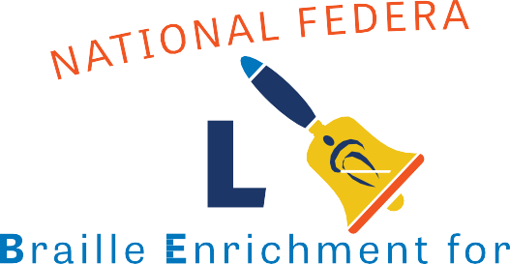Attend NFB BELL® Academy In-Home Edition!
The National Federation of the Blind is offering three summer virtual programs of the NFB BELL Academy to prepare blind and low-vision children to grow into confident and independent blind people by enhancing their education.

Take advantage of this opportunity for your child to connect with blind role models and more by registering for one of the following sessions:

- June 1, 2020 through June 12, 2020
- June 22, 2020 through July 3, 2020
- July 27, 2020 through August 7, 2020

Each registered student will receive the materials to complete all lessons alongside their parent/ guardian via mail. Each day during the two-week session,
there will be two opportunities to connect via web or phone with an experienced teacher. This gives students and families the chance to ask ques-
tions and get to know each other.

Limited space available. Learn more and register now at nfb.org/bell

